Certificate of Achievement

The Canadian Tenpin Federation presents this certificate to

«Name»
of the «Association» Tenpin Bowling Association
in recognition of «HisHer» «Award»
during the 2023-2024 season
«Date»

Blaine Boyle,
President
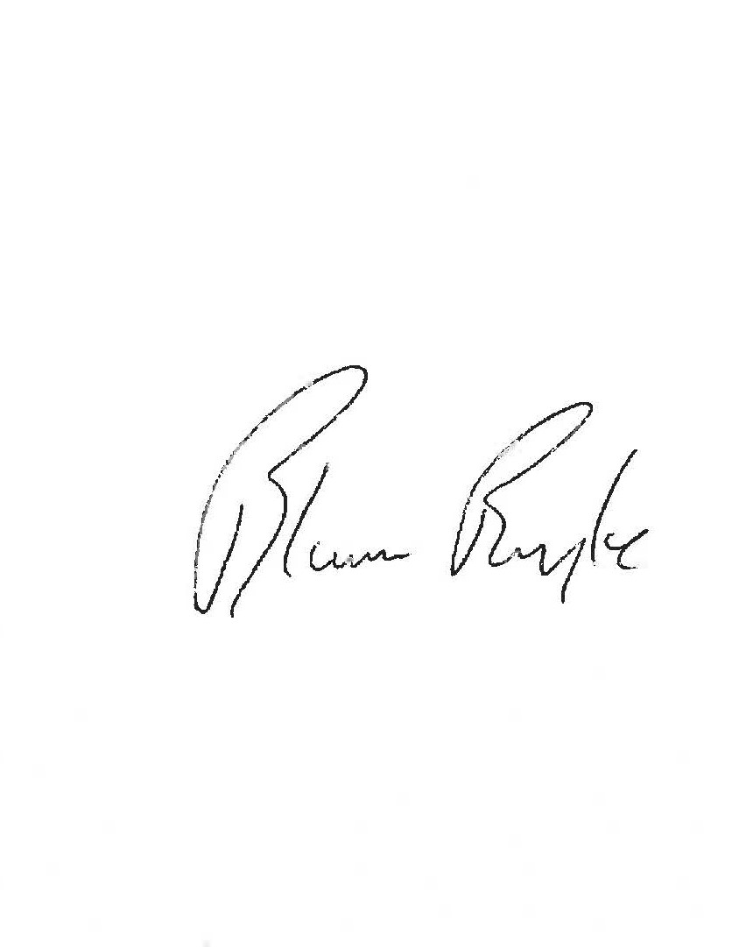

Elaine Yamron
Elaine Yamron
President

