Computer Lane Monitor T.M.

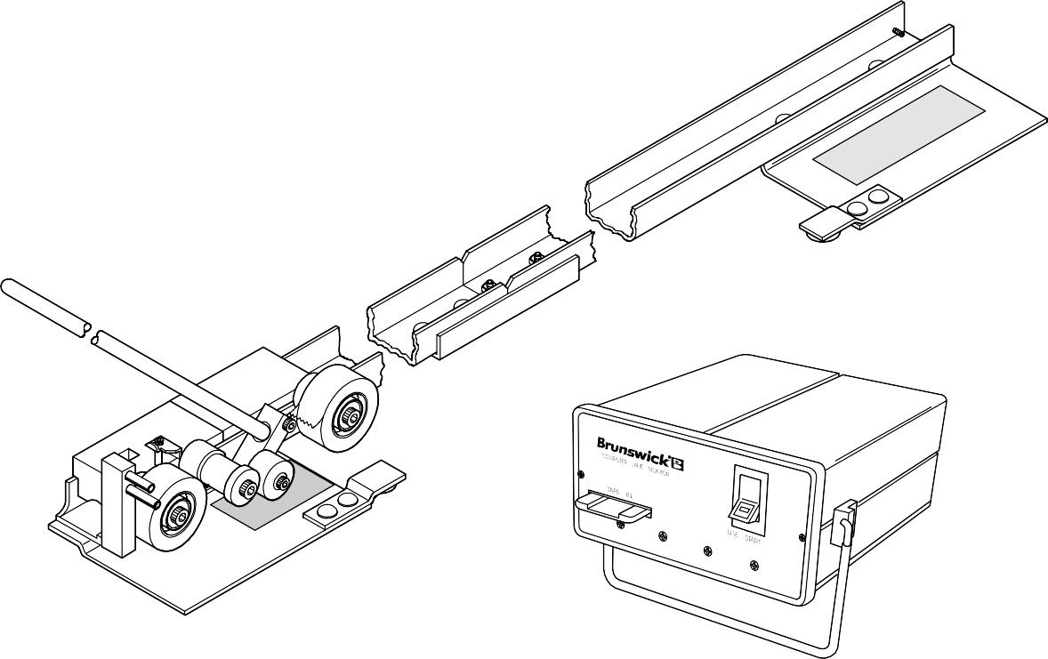

HOW TO MAKE A TAPE AND
HOW TO READ A TAPE

April, 2003 SP03-8

General Description
The Brunswick Lane Monitor System is designed to permanently record and read the amount of dressing present on a lane surface, provided the dressing contains an ultraviolet-sensitive additive in compliance with the Canadian Tenpin Federation (CTF)specifications. The system has two separate components; the Recorder and the Optical Reader.
American
Bowling Congress (A.B.C.)

RECORDER - Part No. 61-860155-000
The Lane Monitor Recorder consists of an aluminum track, two sliding tape carriages and a wooden push rod. See Figure 1. The device accepts one roll of special 1" wide transparent tape on each carriage. The applicator carriage is pushed from one side of the lane to the other, adhering a length of tape to the lane surface.

The dressing from the lane is absorbed by the adhesive in the tape. When the lifter carriage is then pushed across the lane, it lifts the first length of tape and laminates it to a second length of tape. The dressing, preserved be- tween the two layers of tape, can then be measured by the Optical Reader.

The Recorder is supplied with two rolls of UV pick-up tape, one roll of white lane edge marking tape, assembly tools, etc. in a sturdy padded carrying case.

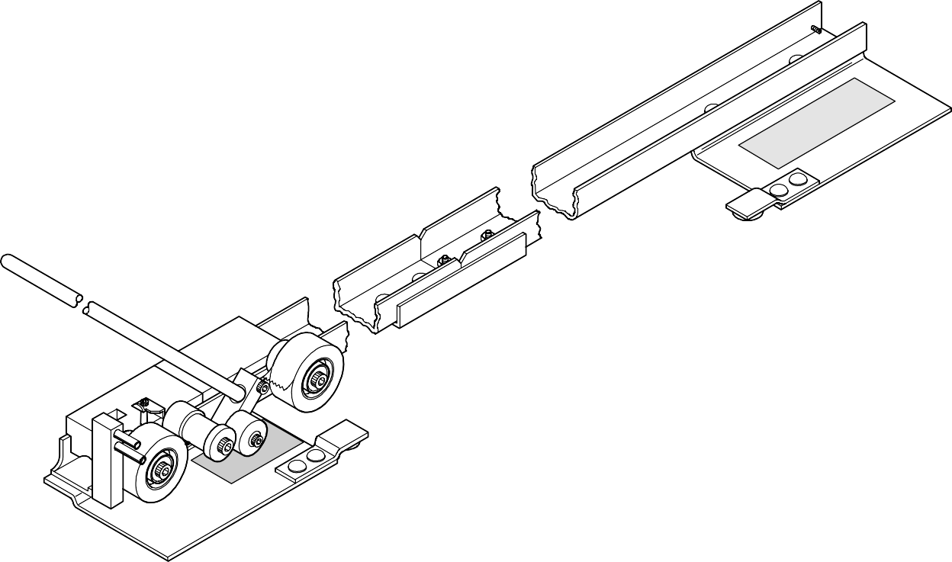

U.S. PATENT NO. 4,487,788
Figure 1 - Lane Monitor Recorder

OPTICAL READER - 61-860225-000, 61-860225-220
The Computer Lane Monitor Optical Reader and supplied software connects to your existing IBM compatible PC to automate your lane reading. This device exposes the dressing in the tape to ultraviolet light, causing it to fluoresce if the required additive is present. See Figure 2.

The Reader then electronically measures and displays the intensity of visible light emitted by the additive in the dressing. The laminated transparent tape, produced by the Recorder, is fed into the Optical Reader where it is automatically advanced as a sensor reads the values of the entire lane width. The electronic readings are sent to the connected computer where the relative distribution of dressing across the lane is displayed both graphically and digitally on the computer screen.

The Optical Reader package includes the software program to create a data base to restore and compare lane dressing information to manage optimum lane conditions. Calibration kit is included along with the power cord and computer data cable.

U.S PATENT NO. 4,437,010
Figure 2 - Computer Lane Monitor Optical Reader

Lane Monitor Recorder

ASSEMBLY AND ADJUSTMENT
- The Recorder is shipped with the track separated into two sections. Assemble the two sections using two 1/4" nuts on the studs shown in Figure 3.

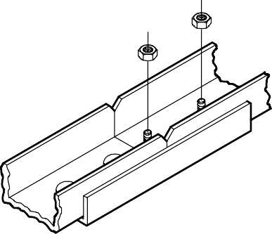

1/4" NUTS
Figure 3 - Recorder Assembly

- See Figure 4. Loosen the two Allen head bolts on the anchor post and pivot it up from the storage position to the vertical operating position. Retighten the screws.

- Use the two bolts shown in Figure 4 to adjust the device for lane width. Both plates should be left off the lane and level with the lane edge. In general, it is not necessary to adjust the Recorder to each lane as long as the adjustment is wide enough to accommodate all the lanes, and the track is kept square to the edge of the lane.
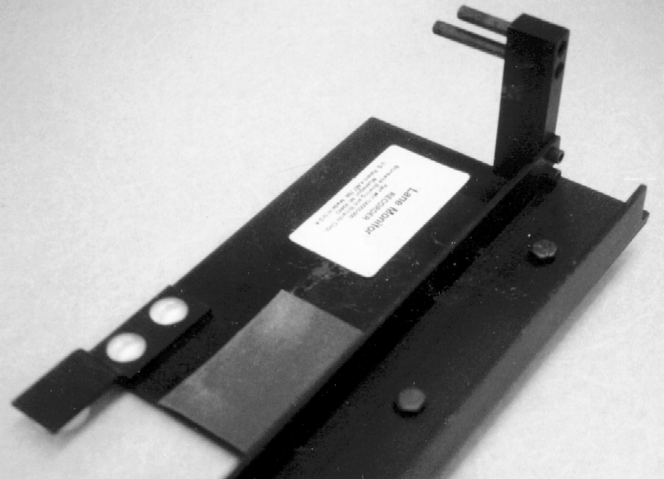

ANCHOR POST

LOOSEN ALLEN HEAD SCREWS TO POSITION ANCHOR POST ASSEMBLY

BOLTS USED TO ADJUST LANE WIDTH IF REQUIRED
Figure 4 - Lane Width Adjustment

STORAGE AND HANDLING
- The tape applicator carriages should be kept in the carrying case when not in use.

- The track assembly may be left assembled between uses while inside the bowling center., provided it is kept where it cannot be dropped or bent.

- When transporting the entire Recorder outside the building, always disassemble and pack in the original foam-lined case.

THREADING
- Mate the carriages as shown in Figure 6 on the next page.

- Place a roll of the included, special 1" wide transparent tape that complies with A.B.C. speci- fications on each of the two outer rollers. Be sure the roll is not distorted and that is fully seated against the shoulder of the hub. If the tape core is loose, put enough tape on the hub to get a tight fit.

  - Lift the mated carriages from the track.

  - Referring to Figure 5, pull some tape from the REAR ROLL. Bring it under and around the TAPE GUIDE and lay it back over the REAR ROLL from which it came.

  - Next, pass tape from the FRONT ROLL underneath the RUBBER ROLLER and over the TAPE GUIDE so that the two tapes match up exactly and adhere together.

  - Pull the mated tapes over the TAPE GUIDE, cut off the excess and make a large loop. Reach over the TOP ANCHOR PIN, hook the loop on the LOWER ANCHOR PIN, and remove slack by pulling on the loose end. See Figure 5.

ADHESIVE SIDE
DOWN ADHESIVE SIDE
DOWN
RUBBER ROLLER
REAR ROLL OF 1" TAPE
TAPE GUIDE
FRONT ROLL OF 1" TAPE
LOWER ANCHOR PIN
APPLICATOR CARRIAGE
LIFTER CARRIAGE
LOOSE END
TOP ANCHOR PIN
Figure 5 - Threading Diagram

OPERATION OF THE RECORDER
CAUTION: The Recorder is a precise machine and must be handled with care. Due to the slippery coating on the carriages, they are liable to slide out of the track without warning if they are not held securely while being transported. If dropped, check tape reels for alignment, and straighten or replace bent pivot bolts.

- Be sure the rubber roller is dry and free of dressing. If not, clean with rubbing alcohol.

- Lay the Recorder across the lane in the first reading location with the anchor post assembly on the ten-pin side of the lane.

- Place the mated carriage assembly in the track with the lifter carriage tight against the anchor post. The tape reels and the rubber roller will be on the starting plate. See Figure 6.

- Place a one-inch square of thin paper tape on the outer edge of BOARD NO. 1 to mark the TEN-PIN EDGE of the lane as shown in Figure 6. The LANE NUMBER, SAMPLING LOCA- TION, and DATE may be marked on this paper in advance. Note: 3M brand #658 Post-It tape, sold as Brunswick part no. 61-100057-000 is include and recommended for use with the Computer Lane Monitor automatic positioning feature.

CAUTION: Do not cover any part of BOARD NO. 2.

If tape is not available, a one inch square of THIN white paper may be substituted.

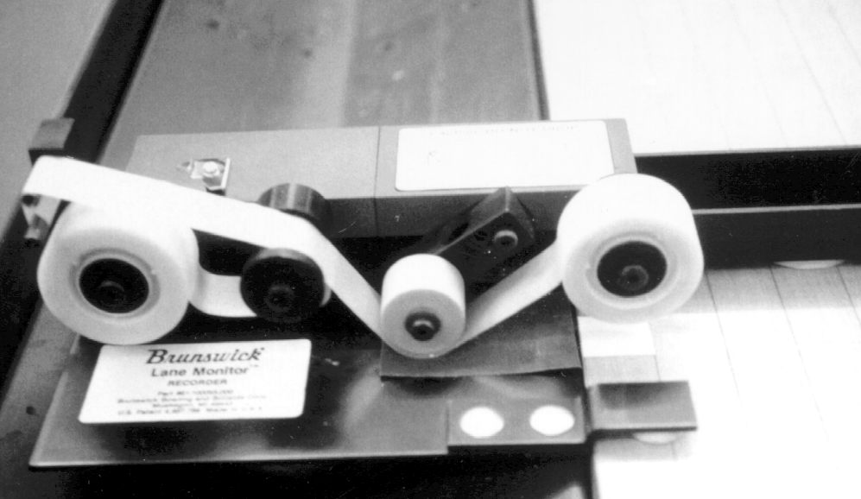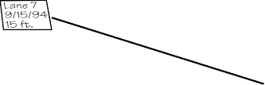

DO NOT COVER ANY PART OF BOARD NO. 2

PAPER TAPE LANE EDGE MARKER AND RECORD

RUBBER ROLLER
Figure 6 - Recording Sample Information

- Insert the wooden push-rod into the hole on the pivot arm of the applicator carriage and slowly push the carriage across the lane. This will cause a length of transparent tape to be adhered to the lane surface. See Figure 7.

CAUTION: Hold the rod at the correct angle (approximately 45°). Too high or too low may cause problems. See Figure 7.
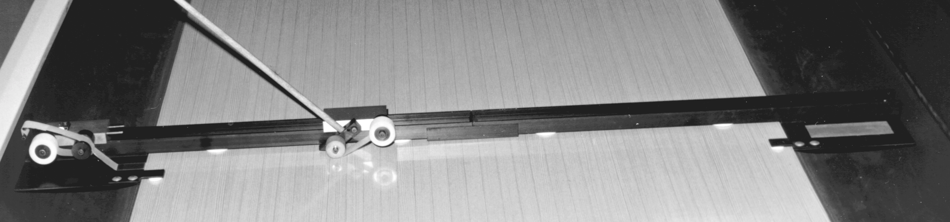
SLOWLY PUSH APPLICATOR CARRIAGE ACROSS LANE
LENGTH OF TRANSPARENT TAPE IS ADHERED TO LANE
HOLD ROD AT APPROXIMATELY 45° ANGLE
Figure 7 - Slowly Push Applicator Carriage, Adhering Tape to the Lane

- Insert the push-rod into the recess on top of the lifter carriage and slowly push the carriage across the lane (Figure 8) until it fully mates with the applicator carriage.
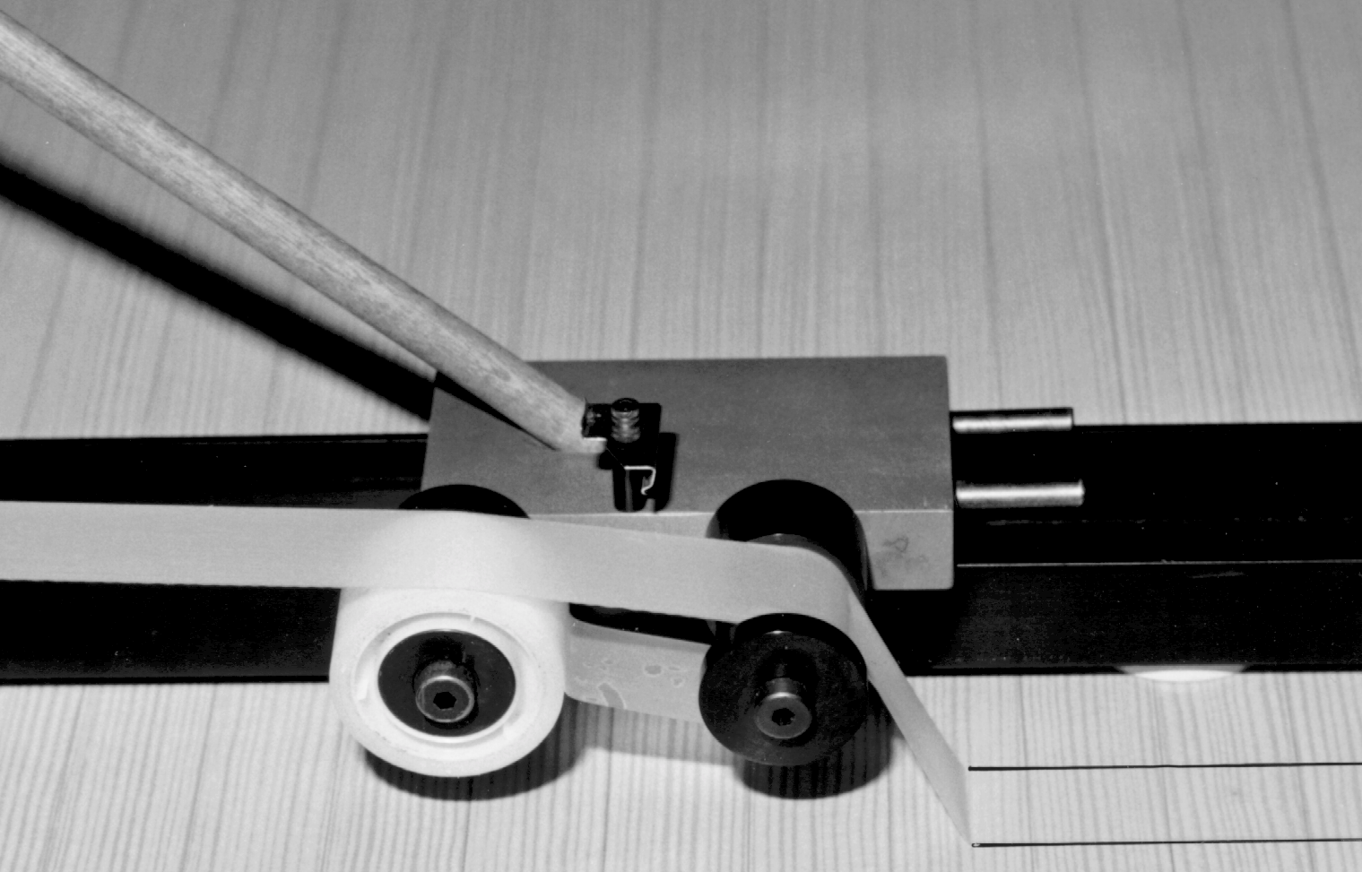
TAPE LAID DOWN BY APPLICATOR CARRIAGE
DOUBLE THICKNESS OF TAPE
SLOWLY PUSH LIFTER CARRIAGE ACROSS LANE
Figure 8 - Slowly Push Lifter Carriage Across Lane Until It Fully Mates with Applicator Carriage

The tape should now be a double thickness and suspended above the lane with the adhe- sive sides together. Figure 9.

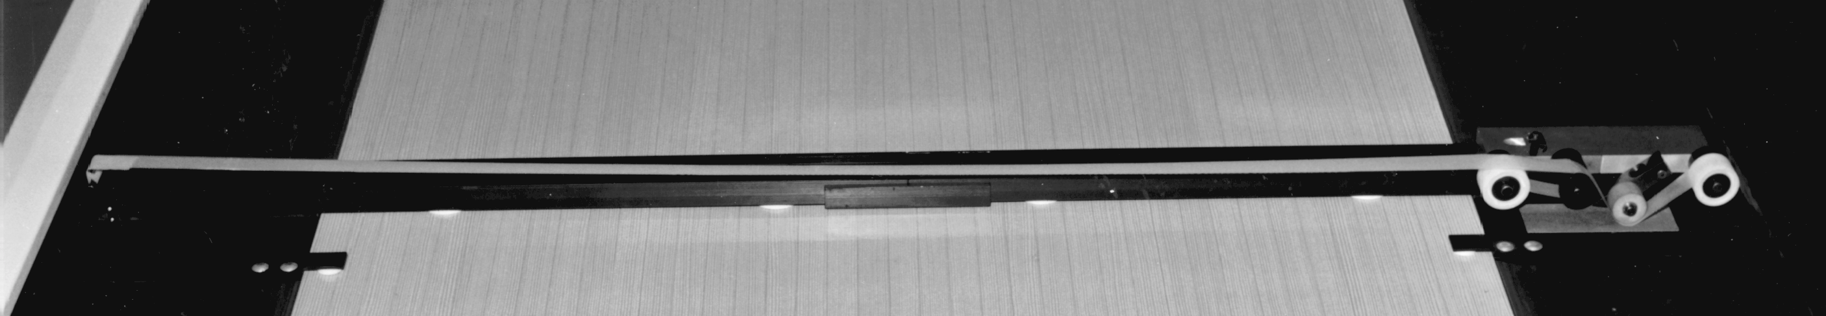
DOUBLE THICKNESS OF TAPE IS SUSPENDED ABOVE LANE

LIFTER CARRIAGE MATED WITH APPLICATOR CARRIAGE
Figure 9 - Double Thickness of Tape Suspended Above Lane

- Raise the doubled tape slightly, nick it with the taped cutter, and tear it across

- Raise the torn end upward at a 45° angle to free the tape from the anchor post, being careful to keep the tape clear of the lane surface.

- PICK UP the mated tape carriages and return them to the starting position.

CAUTION: If the rubber wheel makes direct contact with the dressed lane, it will have to be cleaned before the next use.

- Repeat steps 1-9 at subsequent reading locations.

CAUTION: Store sample tapes in a container to protect them from being folded or crushed. The ideal storage form for a tape is to roll it in a 2 to 3" diameter circle and use a paper clip to hold together. This will greatly improve the preparation for reading a tape.

NOTE: DO NOT allow the Recorder frame to move along the lane as the tape carriages are pushed across the lane. This is the main cause of misalignment and mis- matching of the tape strips. If the tape sample has more than 1116" of adhesive exposed along the edges or has excessive wrinkles, it may not feed properly through the Optical Reader. Discard poor tape samples and reposition the Recorder frame a few inches from the original reading to make a new tape sample.

Computer Lane Monitor Optical Reader

NORMAL STORAGE AND OPERATING CONDITIONS
MINIMUM NOMINAL MAXIMUM
Operating Voltage (110V) 90 VAC110 VAC 125 VAC Operating Voltage (220V) 200 VAC 220 VAC 240 VAC Operating Current 210 MA Operating Temperature 60°F 70° F 80° F
Storage Temperature 0°F 70° F 165° F Relative Humidity 10% 90%

NOTE: Use 1 Amp 250V fast blow fuse only (AGCI Part No. 11-685001-000 or 3AG Part No. 11-685053-000).

STORAGE AND HANDLING
- The Optical Reader is designed to operate within a wide range of conditions which should be observed. (See Normal Storage and Operating Conditions chart above.)

- To reduce the need for maintenance or repair, minimize exposure of the unit to water, dirt, metal filings, and salt-laden air.

- Protect unit from shock and vibration. Although the lane monitor has been designed to be as rugged as possible, it is still a delicate test instrument and can be damaged by severe shock. Excessive rough handling, exposure to water spray or extreme temperatures should be avoided.

PRECAUTIONS FOR USE
- If cold, allow the Optical Reader to acclimate to room temperature before operation.

- Operate within the recommended line voltage limits.

- Set the Reader on clean, hard, flat surface.

- Keep foreign material out of the lane monitor, especially the tape path. Make sure sample tapes are clean and free from excessive tape adhesive and/or lane dressing. Foreign material on the tapes will accumulate on the drive roller and more frequent cleaning will be required.

- Keep rollers clean. Periodic cleaning of the drive and idler rollers will ensure trouble free operation. Cleaning should be performed after approximately 100 tapes., depending on condition of the tapes and operating conditions. Storage in a clean dry place will help ensure proper operation.

- If the Optical Reader does not appear to operate properly, be sure instructions have been followed before concluding that service is required. Refer to Troubleshooting Section in this manual for problems, cause and solutions.

- Disconnect power before checking fuse or servicing the Computer Lane Monitor Reader.

- If electronic repairs are required beyond areas covered in the Troubleshooting Section, the Optical Reader should be returned to Brunswick Bowling for service or repair. Contact your sales person for proper return assistance.

USER FAMILIARIZATION
1. With the Computer Lane Monitor Optical Reader turned off, locate the switches, indicator light, cable connection, tape slots, and fuse location. See Figure 10.

NOTE: 220 V power cord is not supplied with a wall outlet connector.

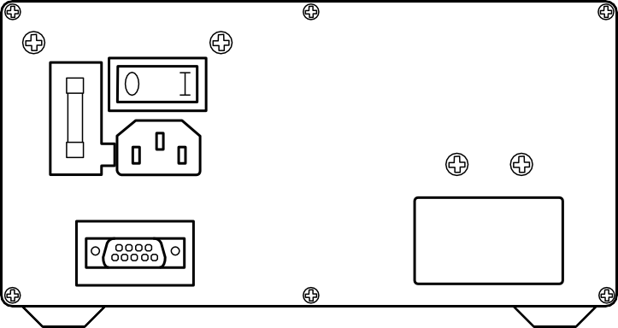"TAPE IN" SLOT
"U.V. START" INDICATOR LIGHT

"U.V. START SWITCH

HANDLE

POWER "ON/OFF" SWITCH

BACK PANEL OF READER

FUSE ACCESS DRAWER

POWER CORD CONNECTION

COMPUTER SERIAL DATA CABLE CONNECTION PORT
"TAPE OUT" SLOT

Figure 10 - Computer Lane Monitor Optical Reader Familiarization

SAMPLE TAPE PREPARATION FOR OPTICAL READER
- Proper sample tape preparation is very important to assure trouble free operation of the Computer Lane Monitor. The initial end of the sample tape is most critical for proper feeding of the Optical Reader.

  - Select a good smooth section of tape 6" to 10" ahead of the lane edge marker with no exposed adhe- sive.

  - It is recommended that an extra layer of 1" wide transparent tape (Brunswick part no. 11-900070-000) be placed across the end of the tape sample as shown in Figure 11. The cross direction of this extra layer helps to stiffen the end of the tape from its natural curl.

  - Cut the end of the tape sample as shown in Figure 11 to create a good tape leader.

TEN-PIN SIDE LANE EDGE
6" TO 10"
CUT END OF TAPE AT SLIGHT ANGLE (5 TO 20°) REMOVE FRONT POINT AS SHOWN
TRIM ANY EXPOSED ADHESIVE OVERHANGING ALONG BOTH EDGES

LANE EDGE MARKER
TEN-PIN SIDE LANE EDGE
6" TO 10"
LANE EDGE MARKER
PLACE EXTRA LAYER OF TAPE ACROSS A SMOOTHLY MATCHED SECTION OF TAPE 6" TO 10" AHEAD OF LANE EDGE MARKER
Figure 11 - Preparing Tape Leader Portion

CAUTION: A. If the two tapes are mismatched, trim along both edges to remove the overhang removing any exposed adhesive on the 6" leader. Do not trim nar- rower than 718" or tape may not follow inner slot.

    - Severely curled tape should be straightened out before insertion into the Reader. Forming the tape into a "V" shape across the width of the tape may help it to remain straight. Leave no lumps, curls or wrinkles at the end of the leader.

    - If there is dressing on the outside surfaces of the tape, especially the leader, it must be completely removed before insertion into the reader.

- If sample tape leader is shorter than 6" or if the very end is damaged, a new extension can be put on the front of the leader.

CAUTION: At least 3" of the original tape must be left in front of the lane edge marker for a valid reading since the reader sets the zero value 1 to 2" in front of the lane edge marker.

  - Press together two 6" lengths of transparent tape, leaving the last 1" separated.

  - Insert the sample tape, as shown in Figure 12, into the separated area of the new leader extension and carefully press the extension onto the original leader.

  - Knead the overlap firmly so the assembly will stay together during use. Trim the end off 6" from the lane edge marker as shown in Figure 11. Trim the overhanging edges of exposed adhesive.

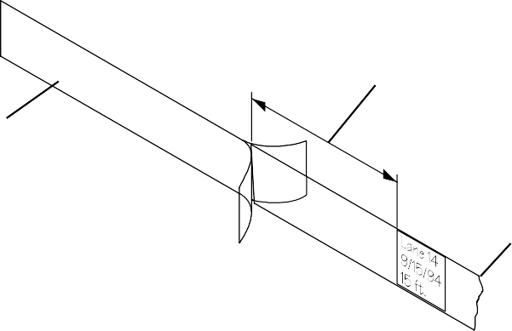

3" MINIMUM LENGTH OF ORIGINAL LEADER
6" EXTENSION
2 PIECES OF TAPE PRESSED TOGETHER

SAMPLE TAPE
Figure 12 - Leader Extension

- If a sample tape does not have a lane edge marker between the layers of transparent tape, place a 1" square piece of the supplied white, lane edge marker material (Brunswick part no. 61-100057-000, 3M brand #658 Post-It tape) onto the outside of the tape sample over the board no. 1 position on the ten-pin side. Firmly press the edges of the marker to make sure it is firmly attached to the tape sample.

- If a sample tape has a lane edge marker between the layers of transparent tape that is not the recommended thin white, 1" square material, it will be necessary to use the Manual Option of the "Read Tape" command explained later in this manual.

NOTE: A tape sample with only a 3-314" leader can be used without adding a leader extension by using the Manual Option of the "Read Tape" command.

"READ 1APE" OP1ION - AU1OMA1IC

- Select the "Read Tape" option to read and display the value of a new tape sample. There are two options with the "Read Tape" menu. Use the "Automatic" option if you have the proper lane edge marker explained on page 12. Otherwise, use the "Manual" option. The "AUTOMATIC" option will automatically control the tape drive roller motor to position the tape and advance it while it reads the entire tape length. The "MANUAL" option is explained in the next instruction section. Choose the desired option from the screen shown in Figure 19.

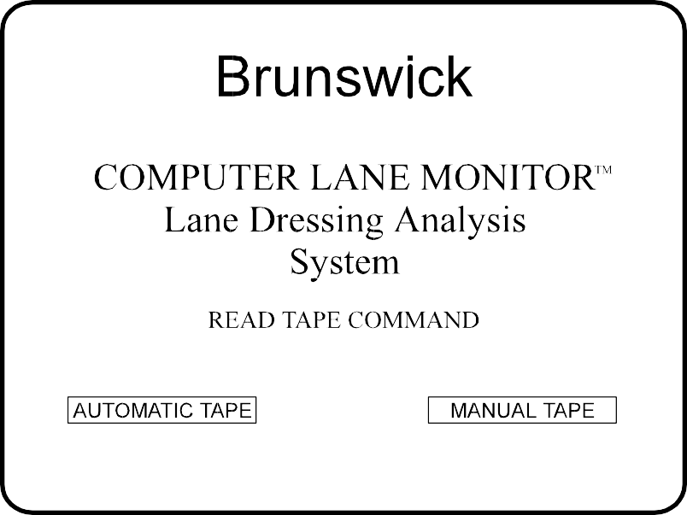CAUTION: Make sure there is no tape sample already in the Optical Reader when you select a "Read Tape" option. The Reader takes an empty slot reading to check the calibration before each tape sample is read.
Figure 19 - "Read Tape" Options

NOTE: If you have not read and followed the instructions on Sample Tape Preparation for Optical Reader, return to page 12. Make sure that the tape sample has a straight 6" leader with the recommended white lane edge marker.

NOTE: The program prompts you if the last tape was not saved. Type "N" to abort the "Read Tape" option. Then enter the "View Data" option explained later in the instruction steps to select the "current" tape to view and save. If you type "Y", the program will continue to read a new tape into the "current " file and erase the previously read tape file.

- The screen will prompt you to insert a sample tape into the "Tape In" slot of the Optical Reader. The automatic tape drive motor will not start until you have inserted the tape sample leader into the "Tape In" slot of the Optical Reader.

- After the tape drive motor starts, continue to insert the sample tape further into the slot until it contacts the drive rollers and is pulled in by itself. The tape will slowly advance until it finds the lane edge marker. Then it will reverse to take a zero reading from the leader before it advances to quickly read the entire tape length.

TIP: Place a pencil or pen through the center of the tape sample roll to allow it to unroll without twisting before it enters the "Tape In" slot. For best results, grasp the front end of the tape as it exits the rear opening of the Reader and watch for a steady flow of tape.

CAUTION: If the sample tape becomes jammed in the Optical Reader while it is being read, IMMEDIATELY STOP THE TAPE READ OPERATION BY PRESSING THE "ESCAPE" KEY OR TURNING OFF THE POWER TO THE READER! Refer to
the "Clearing a Tape Jam" section in the Service section of this manual.

NOTE: If the Optical Reader can not find the lane edge marker to automatically posi- tion the sample tape, or if the lane edge marker is covering part of the second board, you will need to use the "Manual" tape positioning explained in the next step. You will need to clear the tape from the Reader by selecting the "Move Tape" option of the "Utilities" menu BEFORE selecting the "Manual" option of the "Read Tape".

- The lane dressing analysis graph will be automatically displayed as the end of the tape sample exits the Reader. The digital units of oil for each board position will be displayed in a column on the right of the screen. See Figure 20.

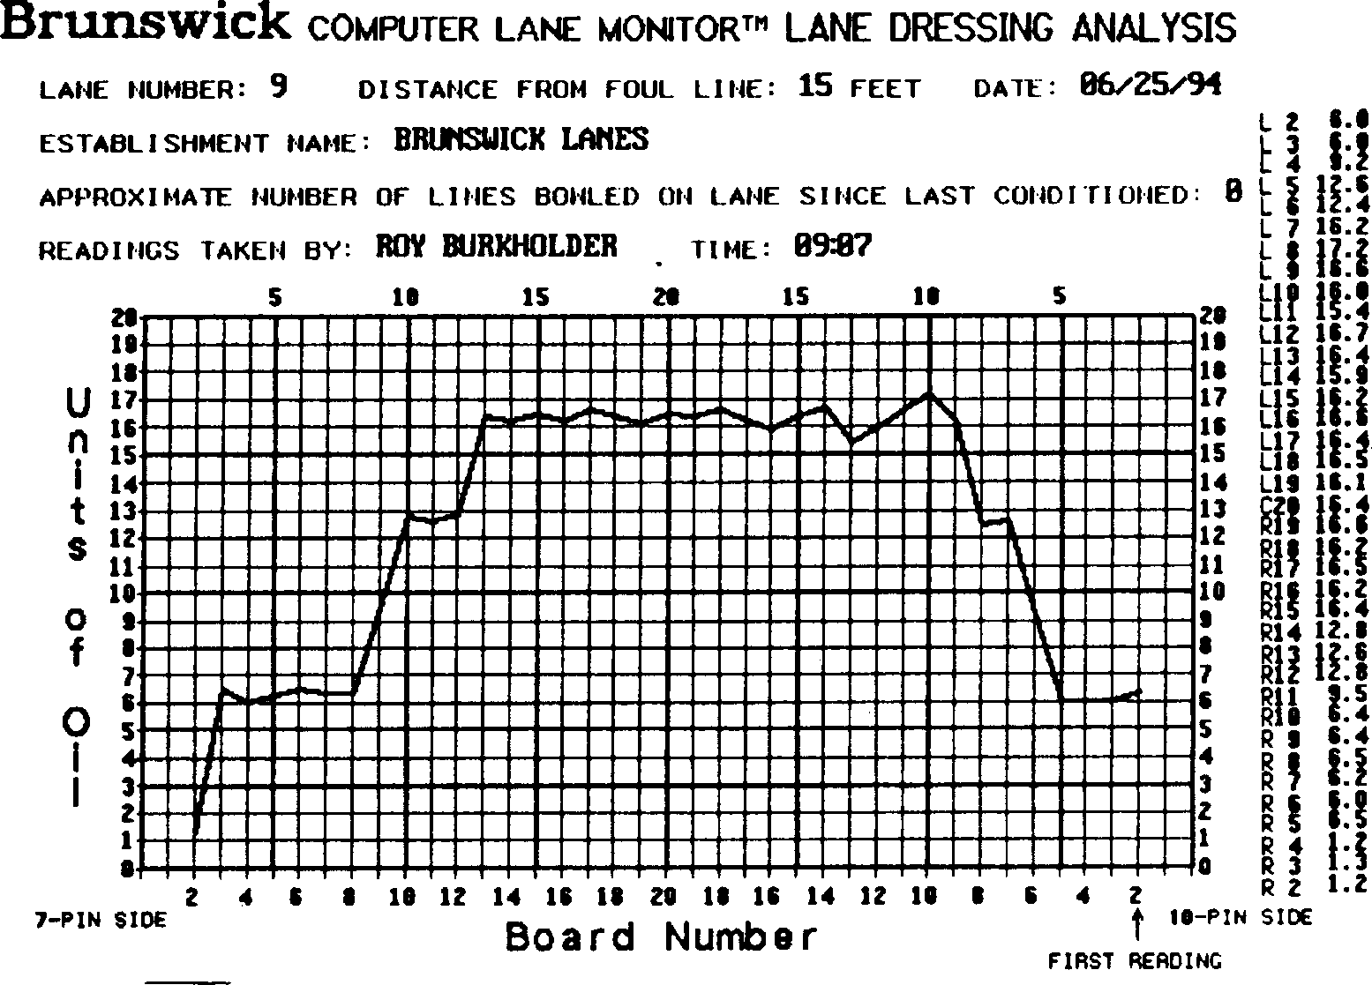

P-<Print> Any Other Key - <Continue>
Figure 20 - Lane Dressing Analysis Graph

- Select the "Save" command shown at the bottom of the screen by pressing the "S" key after checking that the lane no., distance, date, and other statistics are correct. This will assure that the tape file is stored on the data base for later reference. You will then return to the main menu.

NOTE: If the lane statistics are not correct, exit the graph and select the "Enter Data" option to correct the information before saving it. You will be able to return to the same "Current" tape graph to save it or print a copy on paper from the "View Data" option.

"READ 1APE" OP1ION - MANUAL

- The "MANUAL" option of the "Read Tape" program requires the operator to manually posi- tion the tape on the leader to take the zero reading then manually position the tape at the start of the second board (10-pin side) and start the program to advance and read the entire tape length. This option should be used if the sample tape does not contain the recom- mended one-inch square, white lane edge marker. The "Manual" option is not as accurate or repeatable as the "Automatic" option of the "Read Tape" program because of variations in the tape positioning during the Zero Reading and slight shifting of lane edge and board readings.

- 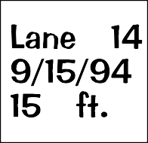Mark two lines on the sample tape as shown in Figure 21. The first line should be 3-1/2" after the 10-pin lane edge with the second line 5-1/2" after the 10-pin lane edge. Figure 21 is shown full scale and can be used as a guide for marking the tape.
SHOWN FULL SCALE
SECOND MARK FOR START OF SECOND BOARD READING
FIRST MARK FOR ZERO READING
3-3/4" TO 6"
LEADER 3-1/2"
5-1/2"
TEN-PIN LANE EDGE

Figure 21 - Preparing a Tape for Manual Read

- After the "Manual" option of the "Read Tape" program is selected, the screen will prompt you to insert the sample tape into the "Tape In" slot of the Optical Reader and position it for the ZERO READING. With a normal sample tape with a 6" leader, the tape positioning is done by inserting the tape until it contacts the rollers and then pressing the indicated arrow keys to cause the drive motor to position the tape so the first marked line (3-1/2" after the 10-pin lane edge) is flush with the front edge of the "Tape In" guide. If the sample tape leader is only 3-3/4" long, the leader may not contact the drive rollers and will have to be held on the 3-1/2" mark by hand.

- Press the <enter> key to take the ZERO READING.

- The screen will then prompt you to position the tape sample at the start of the second board on the 10-pin side. This is done by pressing the indicated arrow keys to cause the drive motor to move the tape until the second marked line (5-1/2" after the 10-pin lane edge) is flush with the front edge of the "Tape In" guide.

NOTE: If the 10-pin lane edge was not clearly marked or if the lane edge marker cov- ered part of the second board, the tape can manually be positioned by noting the value of the tape reading on the screen as the tape is advanced. The lane edge should be the point where the reading starts to increase noticeably above zero. (Advance ~1" further to the start of the second board.) A white lane edge marker will cause a very high reading. Position the tape just beyond these high readings where the values are normal. Because this procedure involves some estimation as to where the second board starts, it may result in readings which are slightly shifted from the true board positions.

- Press the <enter> key to start the program to advance and read the entire length of the sample tape. The program will now proceed as explained in the previous "Read Tape - Automatic Option" instruction section.

