LANE INSPECTION PROGRAM TRAINING MANUAL

Disclaimer:

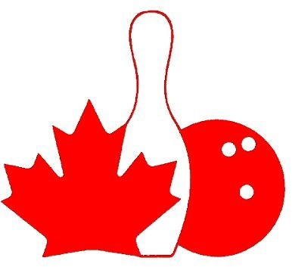

Due to our reciprocal average agreement with USBC many of the reports or manual are either USBC documents or USBC videos. Please refer to the CTF website for the appropriate CTF manual or forms

Lane Inspection Program Training Manual

Contents

HELPFUL DATES 4
CHANGES BEGINNING 2018/2019 SEASON 5
LANE INSPECTION PROGRAM INTRODUCTION 6
SECTION I - PROGRAM BACKGROUND 7
EQUIPMENT STANDARDS 7
SAFETY INFORMATION - GENERAL SAFETY GUIDELINES 7
WALKING ON THE LANES 8
SECTION II - LANE CONSTRUCTION AND MAINTENANCE 9
INTRODUCTION 9
LANE CONSTRUCTION 9
Wood Lane 9
Synthetic Surface 10
Cribbing 10
SECTION III - LANE CERTIFICATION INSPECTION 11
INTRODUCTION 11
WHEN AND WHY? 11
WHO IS RESPONSIBLE FOR INSPECTING THE LANES? 11
WHEN ARE INSPECTIONS DONE? 12
HOW IS AN INSPECTION DONE? 13
REFERENCE MATERIAL 14
THE INSPECTION 16
STANDARD OPERATING PROCEDURE: SOP-CERT-6 19
CTF LANE LEVEL 19
- CALIBRATING THE CTF LANE LEVEL 20
- ZEROING THE CTF LANE LEVEL 21
- MEASURING CROSSWISE TILTS 25
Pin Deck 25
Lanes 27
- MEASURING LENGTHWISE TILTS 29
Pin Deck 29
To see how to measure lengthwise tilts of the lanes, please click here 30
Lanes 30
- MEASURING FLAT GUTTER SLOPE 31
STANDARD OPERATING PROCEDURE: SOP-CERT-7 31
DIAL INDICATOR & SLED 31
- ASSEMBLE THE DIAL INDICATOR AND SLED 32
- ATTACH THE SLED WITH DIAL INDICATOR TO THE CTF LANE LEVEL 35
- MEASURE CROWNS AND DEPRESSIONS 36
TO SEE HOW TO MEASURE CROWNS AND DEPRESSIONS, CLICK HERE 36
- MEASURING DROP OFFS FROM TRAILING EDGE TO LEADING EDGE FOR SYNTHETIC PANELS 41
STANDARD OPERATING PROCEDURE: SOP-CERT-8 43
GUTTER GAUGE 43
- MEASURING THE DEPTH OF THE FLAT GUTTER 44
TO SEE HOW TO MEASURE THE DEPTH OF THE FLAT GUTTER, PLEASE CLICK HERE 44
- MEASURING THE PIT DEPTH 45
- MEASURING THE PIT LENGTH - DISTANCE FROM BACK END OF THE LANE TO THE CUSHION 46
STANDARD OPERATING PROCEDURE: SOP-CERT-9 49
PIT END GAUGE 49
- MEASURING THE KICKBACK PLATE TO KICKBACK PLATE DISTANCE 50
- MEASURING THE LANE WIDTH 52
- MEASURE THE GUTTER WIDTH 55
- MEASURING PIN SPOT LOCATION (FOR NEW WOOD PIN DECK INSTALLATIONS ONLY) 55
- PIN TRIANGLE (FOR NEW WOOD PIN DECK INSTALLATIONS ONLY). 56
MISCELLANEOUS TOOLS 61
FEELER GAUGE 61
TAPE MEASURE 63
- APPROACH LENGTH (MEASURED ON NEW INSTALLATIONS ONLY) 63
- FOUL LINE WIDTH 64
- LENGTH OF LANE SPECIFICATION 65
MISCELLANEOUS INFORMATION 66
- FIBER EDGE STRIPS 66
- PIN SPOTTING 67
SPECIFICATION 67
- TAIL PLANK 69
- FOUL DETECTING DEVICE 70
- TARGETS AND DESIGNS – (MEASURED FOR NEW INSTALLATIONS ONLY) 71
Approaches 71
Lanes 71
Decals and Advisories: 73
- HIGH ROUND GUTTERS 74
- STAMPS OR STENCILS 75
HELPFUL HINTS 76
YOU AND YOUR HELPER 76
ASK THE PROPRIETOR 76
INSPECTING THE CENTER 77
COMPLETING THE REPORT 78
DISCUSS FINDINGS WITH CENTER MANAGEMENT 78
SECTION IV - GUIDELINES FOR INSPECTORS, PUBLIC RELATIONS 78
GUIDELINES 78
IMPORTANT REMINDERS FOR INSPECTORS 80
SECTION V - LANE MAINTENANCE AND CONDITIONING 81
WHY ARE LANES "OILED"? 81
HOW SHOULD OIL BE DISTRIBUTED ON THE LANE? 81
LANE OIL INSPECTION REQUIREMENTS 82
PERFORMING THE LANE DRESSING INSPECTION (SOP) 84
INTRODUCTION 84
VISUAL OBSERVATION 85
TAKE-UP DEVICE AND READER 85
TAPING THE LANE 88
BAD TAPE 94
TO SEE WHAT A BAD TAPE LOOKS LIKE, PLEASE CLICK HERE 94
STORING THE TAPE 94
FOR DIRECTIONS ON HOW TO STORE THE TAPE, PLEASE CLICK HERE 94
READING THE TAPES 94
LANE DRESSING INSPECTION REPORT (LDIR) 96
SECTION VI - GLOSSARY AND WORKING WITH FRACTIONS 97
GLOSSARY 97
WORKING WITH FRACTIONS 100
SECTION VII – VIDEO LINKS 103

Helpful Dates
  - April 1 – Inspections for the upcoming season may begin.

  - May 1 – The Center Certification System closes for the prior season, only inspection information for the upcoming season can be processed online. Only the Center Inspection Coordinator can enter information for the prior season.

  - June 15 – Recommended date to have lane inspections completed for the upcoming season. This gives proprietors time to make corrections and schedule a re-inspection.

  - July 31 – Deadline for all Lane Dressing Inspection Reports (LDIRs) and graphs/tapes to be submitted for the current season.

  - August 1 – New certification season begins.

  - August 31 – Current season’s certification expires. Deadline for the upcoming season inspections.

  - December 15 – Compliant inspections completed after this date will certify the center for the current season and be recognized as the inspection for the upcoming season.

Changes Beginning 2018/2019 Season:
  - The Lane Dressing Inspection Report (LDIR) with graphs/tapes should be submitted to CTF within 10 days of taking tapes.

  - The Center Inspection Report must be signed by the lane inspector, center management, and the Association Manager, and submitted to CTF within 10 days of the inspection.

  - Tilts, Crowns and Depressions will be measured at 5 locations on synthetic lanes. These measurements are to be taken:
    - From each full-size synthetic lane panel.
      - If there are 6 panels, take one measurement from each of the first 5 panels.
    - No closer than 5 feet together
    - Preferably within 3 inches of a screw row, but not directly on the screw caps or panel edges
    - From the regular 3 locations for wood lanes, or the wood portion of multi-surface lanes
    - It’s recommended the measurements be taken at a different distance
each year.

  - Measure from kickback plate to kickback plate, and record the distance between them (adding the thickness of the plates no longer will be required). If no plates are used, you will measure the wood-to-wood distance.

  - For the width of the gutters on each side of the lanes, measure from the outside of fiber edge boards to the kickback plate, at points in line with the rear row of pin spots.

  - Crosswise Tilts, Crowns and Depressions have a maximum allowance of
.030” for new installations only. Inspection must be completed within 14 days of installation. Ideally, the inspection can be done as the installation is being finished so any repairs can be addressed while the crew is still on site.

Lane Inspection Program Introduction

Welcome, and thank you for your interest in the Lane Inspection Program!
This program is designed as a resource for completing proper and successful bowling center inspections. It includes: proper usage of tools, where to get them, and how to fill out the forms.
Since lane certifications are normally scheduled for the summer months, there is significant time between lane certifications; therefore, you are encouraged to review the materials as a refresher from time to time.

Section I
Explains the reasons for conducting yearly lane certifications and important safety procedures to consider prior to beginning an inspection.

Section II
Provides a brief introduction to lane construction and maintenance.

Section III
Provides information on how to conduct certification inspections; there are helpful suggestions to make the job easier and more efficient including:
  - Descriptions of inspection tools
  - Information on how to correctly complete the inspection report
  - Step-by-step instructions for the certification inspection process

Section IV
Reviews inspector guidelines and the public relations aspect of the job.

Section V
Explains why lanes are oiled and provides an overview of the lane dressing inspection procedure including:
- Taping the lane using the take-up device
- How to read the tape

Section VI
Contains a glossary of commonly used terms and a section on working with fractions.

Section I - Program Background

Equipment Standards
Center inspections ensure the lanes and pin-setting equipment meet the standards set by the Canadian Tenpin Federation (CTF). Annual inspections are performed by representatives of a chartered local association.

The annual certification program provides a valuable service to the bowling proprietor. It calls attention to any lane or piece of equipment in need of repair and can show the proprietor where they might see issues in the future.

Lane and equipment specifications are divided into two categories:

- The physical measurements and tolerances which are monitored through the annual certification inspection procedure and the Center Inspection Report
- The application of lane oil in accordance with the requirements of CTF
Rules, monitored through lane dressing inspection reports (LDIRs)

The Lane Inspection program manual is designed to:
  - Provide the training necessary for accurate and successful lane inspections
  - Enhance an inspector’s skills and credibility
  - Improve inspection consistency

Becoming a properly trained lane inspector makes you a valuable asset to the sport.

Safety Information - General Safety Guidelines
Be aware this job contains hazards that could cause injury. Inspecting bowling lanes can be done safely by following these precautions to avoid injury:

As a lane inspector, you need to watch for the following hazards:

  - Somebody turning on the pinsetter while you are in the pit end
  - Slipping and falling on lanes that are oiled
  - Getting splinters while crawling or sliding on lanes
  - Hitting your head on the pinsetter or masking units

You can avoid these dangers if you always follow these safety rules:

  - Notify proprietors well ahead of time so they can have appropriate staffing to oversee your safety
  - Conduct certification inspections at times when no bowling is taking place anywhere in the center
  - Check that all pinsetter machines are disconnected (unplugged) and tagged with a warning notice so no one will turn them on by mistake. If available, use a Lockout / Tag-out security device to prevent machinery from being turned on accidentally. For more information, visit OSHA’s webpage at: https://www.osha.gov/SLTC/controlhazardousenergy/
  - Wear shoes with soft, nonskid soles. Even bowling shoes can slip on an oiled lane
  - Do not carry too many tools on the lanes at one time
  - Wear sturdy clothing, shirts with long sleeves, and full-length pants
  - Avoid wearing loose articles that may become caught in machinery
  - While working in the pin deck, before you stand up be sure you are well clear of the machinery and masking units

Walking on the Lanes
Avoid walking on the lanes as much as possible. Walk on the lanes if you absolutely need to, but take precautions to minimize danger by using the following guidelines:
  - Never walk on the lanes if you are wearing shoes that have hard soles or heels. Soft-sole shoes or sneakers are preferred

  - Be sure to check for anything projecting from the soles, such as nails, stones or thumbtacks, as they will scratch the lane surface

  - Where should you walk?

Ask the proprietor which they prefer:

    - Ball return capping: This is a preferred method by most, but these can also break as it is hollow underneath to allow the ball to return to the bowler.

    - Gutters: Beware that gutters can break if you walk in them due to no support under some sections, so use caution.

Please note:
CTF provides Accident Insurance for Bowling Lane Inspectors. The policy may be found on the CTF Website

Section II - Lane Construction and Maintenance

Introduction
It helps for inspectors to have some understanding of how lanes are constructed and understand the bowling terminology. This section provides that information.

Lane Construction
Basically, there are two types of bowling lanes in use today – wood and synthetic.

Wood Lane
A wood lane is made up of two different species of wood.
Hard Rock Maple is used in the areas of the lane where there is sliding and impacts. This includes:
  - The approach
  - The head panel which is the first 15’ to 17’ of the lane
  - The pin deck which is the last 4’ of the lane
Soft Pine wood is used between the head panel and the pin deck where the ball is just rolling.

A wood bowling lane must be coated with a CTF approved lane finish to seal moisture from the wood and protect it from the constant impact of the bowling ball. This coating takes many forms and each type of material creates a slightly different surface.

The four major finishes used today are:
- Urethane
- Epoxy-urethane
- Water based
- 100-percent solid finishes

Synthetic Surface
Most synthetic lanes today are built from several synthetic lane panels attached to a wood substructure. The synthetic surfaces are high-pressure laminates with a melamine coating that are extremely tough and durable. There is a difference in the actual playing surface between wood and synthetics. CTF certification tests are required before this type of lane can be used in certified play. You should see a CTF Permit Number stamped on each lane panel.

Cribbing
Regardless of the lane surface, every lane is built with a very strong but resilient sub-structure called “cribbing.” This sub-structure allows room for underground ball returns and the lane to “flex” and “bend” like springs on a car.

A wooden lane is firmly fastened to the cribbing by tie-down screws. They are set so they run at an angle, through the sides of the outermost boards, and down into the cribbing.

Synthetic lanes have many different versions. Some are solid panels with synthetic lane material on top and a high grade of particle board support underneath. Some are just synthetic lane panels on top of an old wooden lane. Most synthetic lanes are held down with screws through the top surface along the edge of the lane and along the panel joints. The lane panels are shimmed during installation to create a top surface that is flat, or at least meets the flatness specifications (±.030” at the time of installation which is about the thickness of 3 playing cards.)

Inspectors need to understand that both wood and synthetic lanes can expand and contract due to humidity, age, and ball impacts. This is the reason for yearly lane certification.

If the lane inspector finds the lane no longer meets CTF specifications, the proprietor must be notified that repairs are needed. These repairs will be made by either leveling the synthetic lane or resurfacing a wood lane.

Section III - Lane Certification Inspection

Introduction
The first part of this section explains:
  - When and why lane inspections are needed
  - Lane inspection procedures
  - Various tools and their uses
  - How to be efficiently organized
  - How to complete the forms

The second part explains:
  - Step-by-step instructions

When and Why?
A center that wants to hold any CTF certified competition, including leagues and tournaments, must have all the lanes in their center inspected for certification. An annual inspection is required if the center was certified for the previous season.
A full inspection is required if any of the following has been done:
  - Lanes have been added or replaced
• Synthetic lane panels, or overlays have been installed
• Lanes have been resurfaced or have had major repairs
    - Lanes, lane sections, pin decks, or pinsetters were replaced
    - Approaches, heads or pin decks injected
  - A previous certification has lapsed, or was withdrawn, and the center now wishes to be certified again.

Who is Responsible for Inspecting the Lanes?
The CTF Equipment Specifications and Certifications Manual states “When a bowling center requests certification, the Association Manager shall ensure an inspection is done. The lanes and equipment would be measured and inspected for compliance with physical specifications. In addition, CTF may authorize military personnel to perform annual inspections of bowling centers located within the boundaries of overseas U.S. military installations.”
In summary, it is the responsibility of the local association to designate as many inspectors as necessary to handle the workload. Ultimately, the Association Manager is responsible for making sure the inspection is properly completed.

When are Inspections Done?
All CTF Bowling Center Certificates expire annually on August 31. For new certificates to be issued before the old ones expire, lanes must be inspected well in advance. This will permit bowling centers to do any necessary corrective work without delaying their new certificate.
For annual inspections:
  - The Equipment Specifications and Certifications manual states "Inspections may be made as early as April 1 prior to the start of the (next “winter”) season and no later than August 31 “which could be” after the start of the (next “winter”) season for which the certificate applies.

  - It is recommended to complete the initial annual inspection before June 15. To meet this deadline, the Association Manager should contact all the centers in the area ahead of time and arrange a schedule for inspections.

  - Inspections should not be made prior to any resurfacing or alteration of the lanes scheduled to be completed by August 31 of that season. If a center plans to resurface some or all its lanes before the new season, it makes no sense to do the inspection before that work is done. If a center is resurfacing after August 31, contact the Center Inspection Coordinator for instructions on how to proceed. Email ctf@tenpincanada.com or call CTF Headquarters at 833-381-2830.

  - A certified center that has been inspected after December 15 will be issued a certificate for the current season and also will be renewed effective August 1 of the next season without further inspection.

  - Inspectors may find that some areas in the center require correcting. Centers that need to make corrections are placed on “Pending” status, and must be entered online as “Does Not Meet CTF Specifications.” In
most instances, this means the inspector will need to make a return trip to inspect the repairs that have been made. The inspection should be scheduled so there is minimal interference with the center’s activities.

  - Center Status
    - Certified – Center was inspected and passes all inspection requirements
    - Pending – Center was inspected, needs to make corrections and be re-inspected. (Once corrections are made so the center meets requirements, it will be placed “Certified” status)
    - Not-Certified – Center either has not been inspected, or has been inspected but does not meet CTF requirements and chooses not to make corrections. (Cannot hold certified competition and scores are not recognized.)

How is an Inspection Done?
First, the inspector provides all their own tools, equipment and work clothes. The recommended tools and descriptions can be found beginning on page 19 of this manual.
An inspector should also have:

Towels
A towel is useful for wiping oil or dirt from hands or tools. A towel can also be placed on the lane, if you need to kneel or lie on it.

Inspection forms
Center Inspection Report - The inspector must have at least one copy of the current Center Inspection Report, which can be found on the CTF website

Have extra copies in case of errors, and for inspecting more than 32 lanes.

It is a good idea to work from a draft form, which can then be copied neatly to the final report that will be submitted to the center, Association Manager, and CTF. One neat and clearly legible copy must be completed and signed by the inspector, center management, and the Association Manager.

ALL SIGNED LANE INSPECTION REPORTS ARE REQUIRED TO BE SUBMITTED TO CTF WITHIN 10 DAYS.

  - Clipboard
A clipboard is strongly recommended to keep the forms and other papers at hand.

Note paper
Lined or unlined paper on which the inspector can write figures, notes and comments.

  - Creeper This piece of equipment makes it easier to get in and out of the pits. This is not necessary to do the job but is helpful.

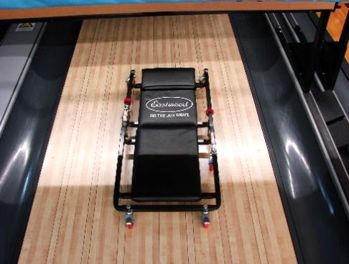

Reference material
The following publications also contain inspection procedures, specifications, rules:
  - CTF Equipment Specifications and Certifications Manual
  - CTF Rulebook

It is suggested these books be taken along whenever an inspection is made, or they may be accessed from tenpincanada.com on a smartphone/tablet with an internet connection.
It also is good for the inspector to have an assistant. The inspector, and ultimately the Association Manager, are responsible for the accuracy and completeness of the inspection report and findings. The assistant’s role is support. They can write notes and record results for the inspector.
The inspector should first meet with the proprietor, introduce themselves and their team, and explain what the inspection will entail. The inspector should give a general outline of how they will proceed and should explain what kind of assistance they will need. This may include turning off, or on, pin-setting machines, opening masking units, turning on lights or foul detection devices, and so on.

The inspector should confirm certain required proprietor-specific information, such as the contact information of the owner and manager.

The inspector should do the following:

  - Find out which lanes, if any, will be used for bowling during the inspection, then decide which lane the inspection will start on. It is neither wise nor pleasant to inspect a lane next to one being used for bowling.

  - It is recommended the inspector invite the proprietor to have at least one employee observe the inspection. They can often see where there are issues, or areas of concern which may eventually lead to problems over time.

  - The inspector should answer any questions the proprietor may have, and then ask permission to begin the inspection. (The inspector is a guest in the center, and must ask the proprietor’s permission before starting work.)

The inspection should be done as quickly as possible, without compromising accuracy, and with minimal interference with the center’s activities. Once all the measurements have been completed, the inspector should review all notes and measurements. This may mean copying facts and figures from the "draft copy" to the “final copy” to be sure everything is clear and complete.

When the inspection has been completed, the inspector should compare the figures on the Center Inspection Report with the specifications indicated on the form. Circle or highlight any measurements that are outside of CTF specifications, this way the proprietor knows what needs to be addressed, then make a list of all areas requiring repair.

The inspector should meet with the proprietor to review the results. The Association Manager will send the center a copy and will send a copy to CTF headquarters.

The inspector should ask the proprietor to notify them or the Association Manager after corrections have been made so that a follow-up inspection may be made.

Finally, the inspector completes the Center Inspection Report by attaching a narrative portion, if necessary, and signing the report. Once signed by both the inspector and center management, the report can be submitted the Association Manager to be signed and processed with CTF.

Electronically processing the data in the online Center Certification Website results in the center being placed in one of two stages of certification status:

Certified
Meaning all measurements were within CTF Specifications

Pending
Meaning some measurements are out of spec and must be corrected before certified status may be granted

If a center is placed on Pending status, the lanes in question need to be corrected and re-inspected. Upon re-inspection, the CTF Center Re- Inspection Report should be completed and shared with the proprietor, Association Manager and CTF. Corrected measurements should be entered through the online Center Certification Website so that the center can be Certified.

Once the Lane Inspection Report or Re-Inspection Report has all three required signatures, the Association Manager is to submit a copy to the center, submit a copy to Canadian Tenpin Federation (6619-193 Street, Surrey, BC V4N 0C1, Attention Center Certifications), and retain a copy of the completed inspection report in the association files for a minimum of two years.

The Inspection
Annual lane inspections:
  - Ensure lanes are within tolerance for consistency from lane to lane. Topography (tilts, crowns and depressions) can alter the ball path over the course of the lane
  - Ensure pin decks are within tolerance. Out of spec pits can affect the pin flight and scoring

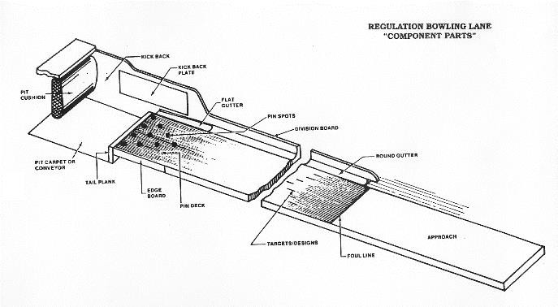

The following inspections/measurements must be completed annually:

  - The stamp or stencil that identifies the resurfacing firm on wood lanes and pin decks, or the CTF Permit number on synthetic lane panels and pin decks
  - The drop between panelized lane sections (synthetic lane panels only)
  - Approach depressions
  - Foul detection devices to ensure they work properly
  - Flat gutter depths, shape and slope
  - Pin-spotting accuracy
  - Fiber-edge strips on the pin deck and tail plank
  - Kickback plate to kickback plate distance
  - The lengthwise and crosswise tilt of the pin decks
  - Crowns and depressions in the lanes surface
  - Crosswise tilt of the lane

For certification of a new center, a center where the previous certificate has lapsed, or an existing center which had major work or replacement of these items, the following items must also be inspected:

  - The length of the approach
  - Approach depressions
  - Width of the foul line
  - Markings, targets, and designs, to be sure they are properly located
  - The length of the lane, from the foul line to the center of the head pin spot
  - Pin spots on the pin deck
  - The depth of the pit
  - The length of the pit
  - The gap between synthetic lane panel sections
  - The round gutters to ensure that they are not too high
  - The width of the lane itself in the pin deck area
  - The width of the flat gutters on either side of the pin deck
  - The lengthwise tilt of the lane (New Centers Only)

Standard Operating Procedure: SOP-CERT-6
(NOTE: SOP-CERT 1-5 are CTF internal Standard Operating Procedures)

CTF Lane Level
Purpose: To measure the Crosswise and Lengthwise tilts on bowling lanes and pin decks.
Equipment:
- CTF 42-inch Lane Level
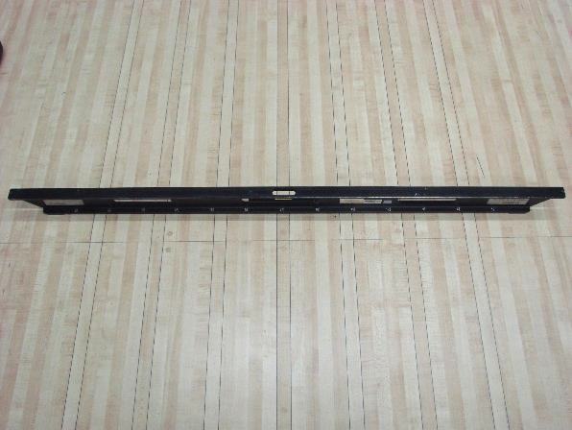

- Feeler gauges
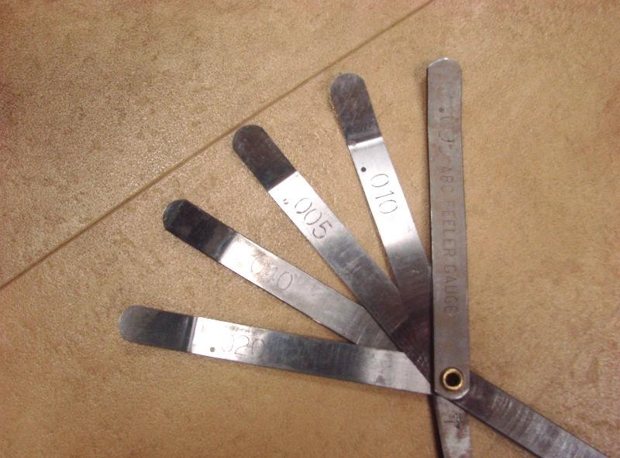

SAFETY NOTE: Ensure that any lanes to be measured are free of oil prior to taking measurements. DO NOT WALK ON AN OILED LANE SURFACE.

Tools:
Both the 42-inch lane level and feeler gauges can be purchased from the USBC Bowling Store. Just go to usbcbowlingstore.com to the section titled “Equipment”.

Procedures:
FYI: The CTF level is 42” or 3-1/2 feet wide (” means inches), and the vial usually states: .012” per foot, thus each line on the level is approximately .040”. Actual amount is 3.5 X .012” = .042”. This will give an approximate amount to get the level bubble close to zero with your feeler gauges.

Calibrating the CTF Lane Level
  - Place the CTF Lane Level (referred to as “level” throughout manual), on the approach side of the foul line, parallel to and up against the foul line.
  - Move the level left or right parallel to the foul line so the feet of the level are on boards that are at equal distances from the center board of the lane.
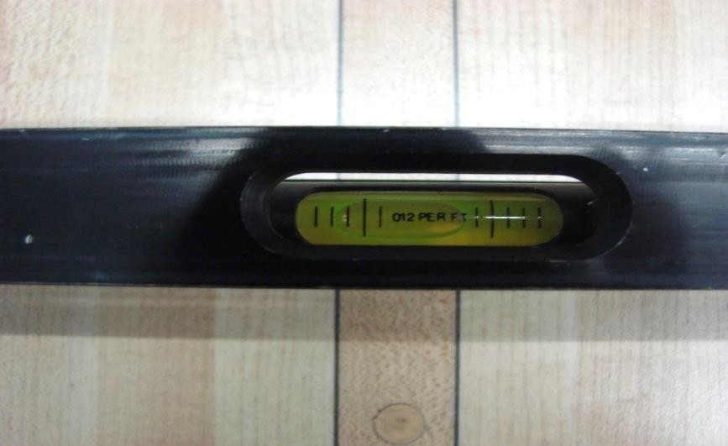
  - Examine the bubble in the vial of the level.

  - If the bubble is not centered between the two centermost graduations on the vial, center it by placing feeler gauges under one foot of the level. Place different combinations of feeler gauge blades under the appropriate foot of the level until the displacement needed to center the bubble is obtained.

  - Pick up the level and turn it 180 degrees without moving the feeler gauges from the approach. The side of the level that was facing the pins should now be facing the approach.

  - Place the level back down on the approach so it is parallel to the foul line with the feet at equal distances from the center board of the lane. Adjust the position of the feeler gauges if needed so they are under the foot of the level and still on the same side of the approach as they were in step 1c.

  - Examine the bubble. If the bubble is centered between the two centermost graduations on the vial continue to step 3a. If not, continue to step 2a.

Zeroing the CTF Lane Level
  - Place the level on the approach side of the foul line, parallel to and up against the foul line.
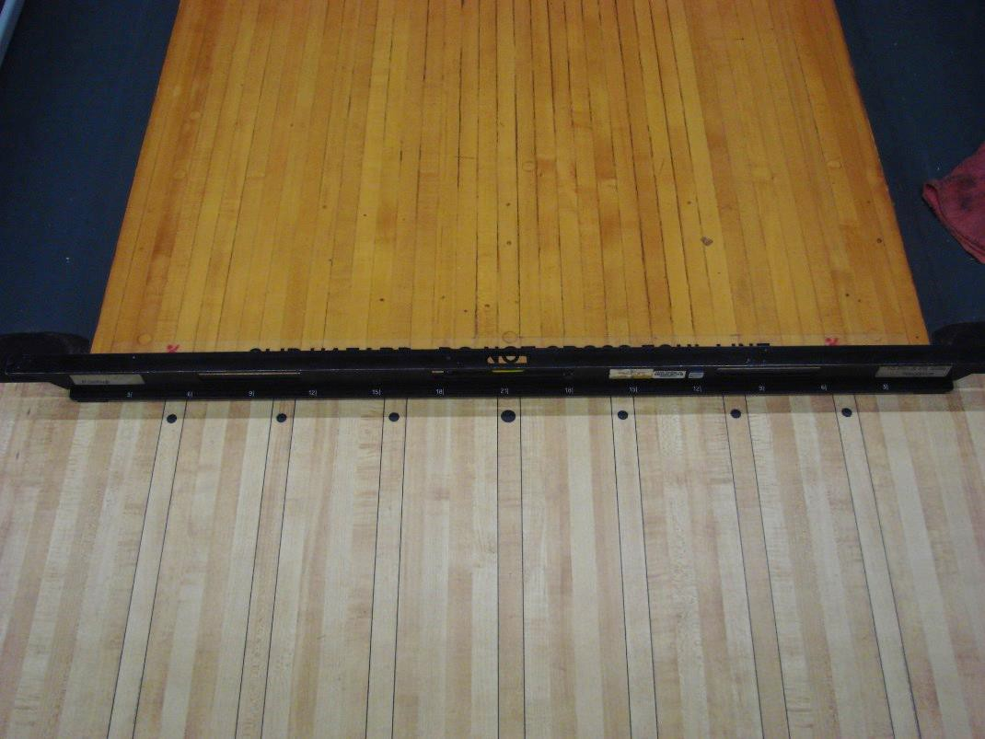

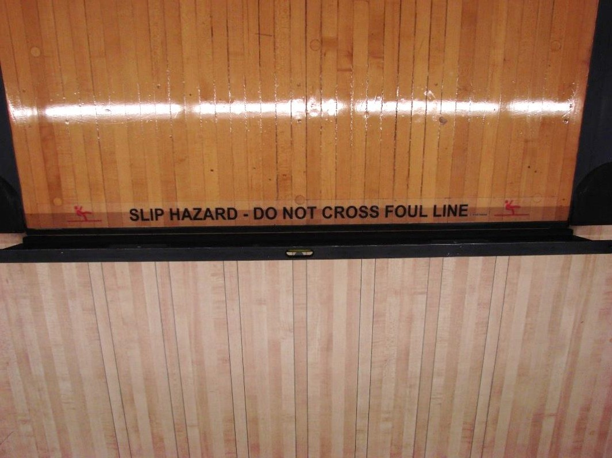

  - Move the level left or right parallel to the foul line so the mark of 21 on the level is centered on the middle dot.
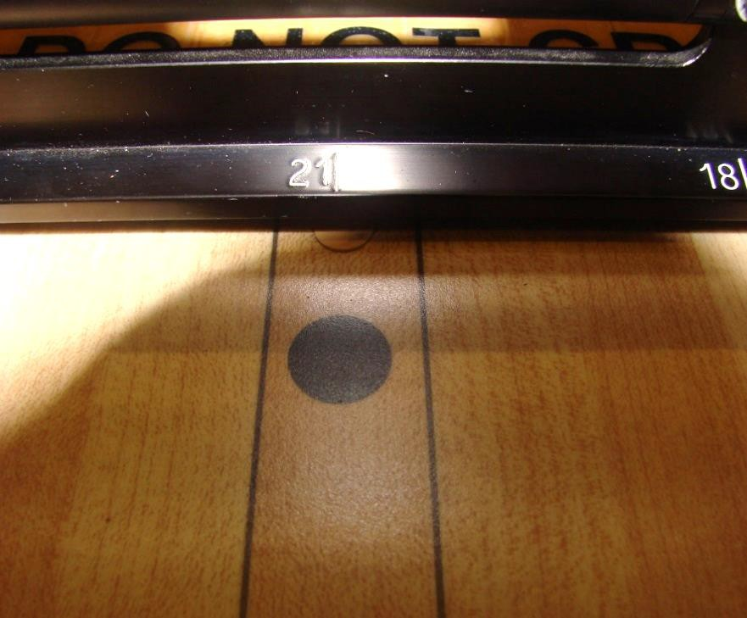

  - Examine the bubble in the vial of the level. If the bubble is not centered between the two centermost graduation marks on the vial, center it by placing feeler gauge under one foot of the level. Place different combinations of the feeler gauge blades under the appropriate foot of the level until the displacement needed to center the bubble is obtained.

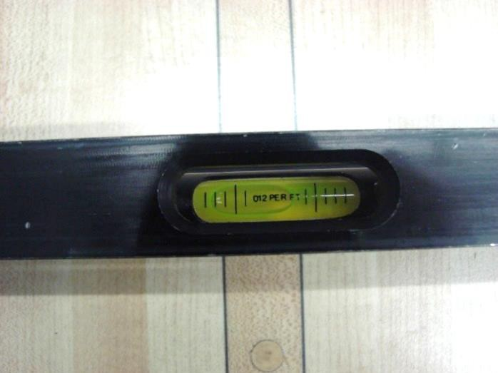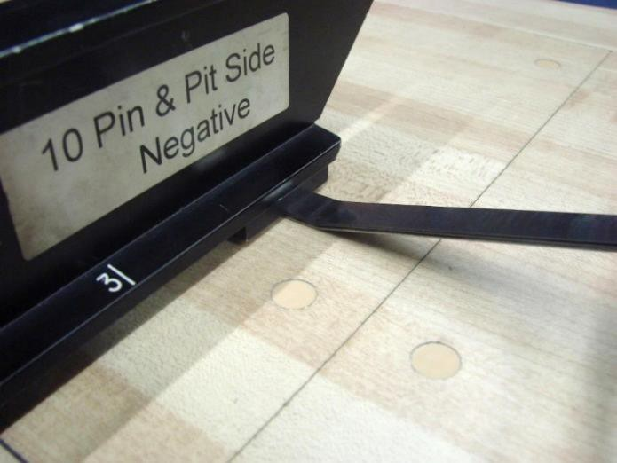

  - Record the amount of displacement obtained by summing the values listed on the individual feeler gauge blades.
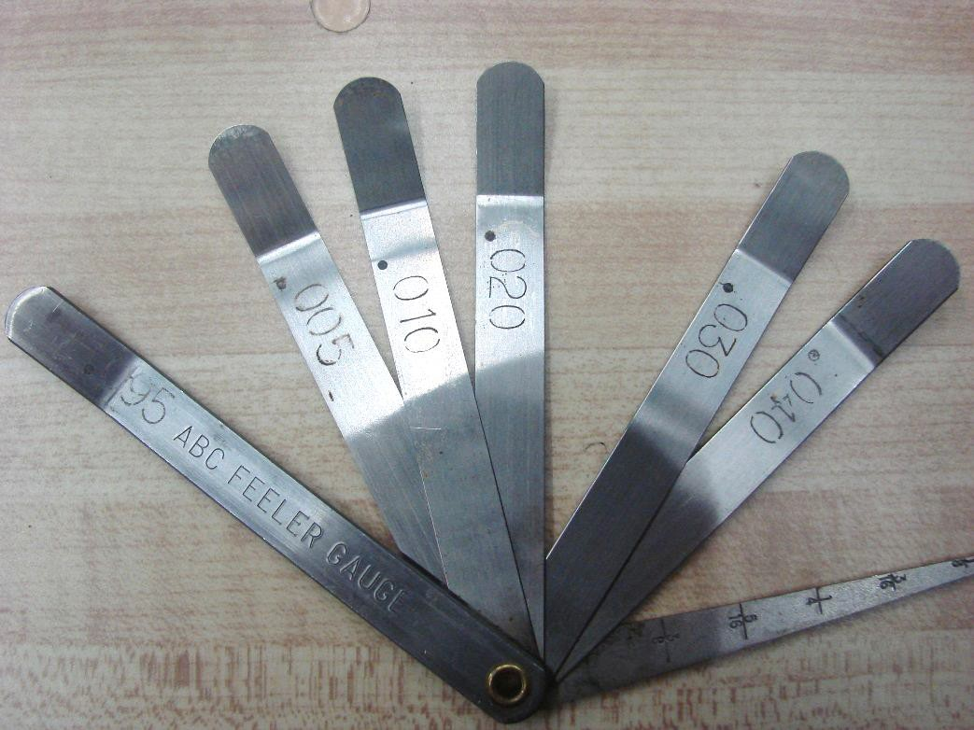

  - Remove the feeler gauges from under the level.

  - Pick up the level and turn it 180 degrees, the side of the level that was facing the pins should now be facing the approach.

  - Place the level back down on the approach so the mark of 21 on the level is lined-up with the middle dot.

  - Examine the bubble in the vial of the level. If the bubble is not centered between the two centermost graduations on the vial, center it by placing feeler gauges under one foot of the level. Place different combinations of feeler gauge blades under the appropriate foot of the level until the displacement needed to center the bubble is obtained.

  - Record the amount of displacement obtained by summing the values listed on the individual feeler gauge blades.

  - Using the recorded values from steps 2d and 2i, subtract the smaller value from the larger value. This is the balance value. Example:
.120” minus .045” equals .075”. The balanced value is .075”.

  - Use the balance value and place that amount of feeler gauge blades under the foot of the level that will bring the bubble in the vial closer to being centered between the two centermost graduations on the vial.

  - Loosen the 11/32” locknuts on the vial and tighten or loosen until the bubble is centered between the two centermost graduations.
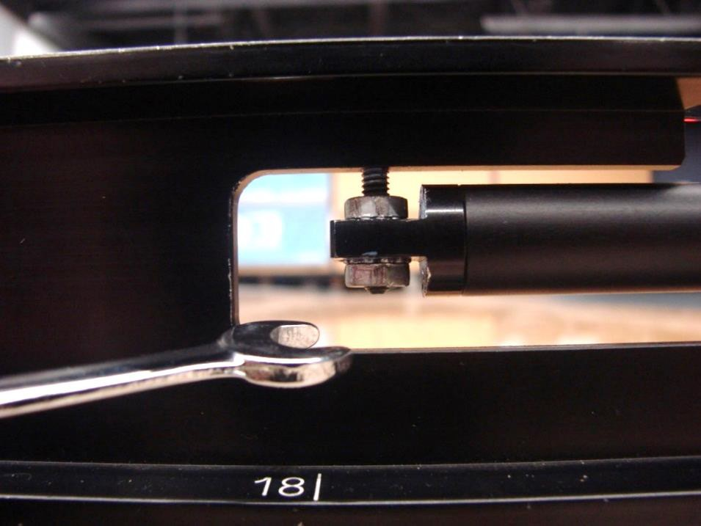

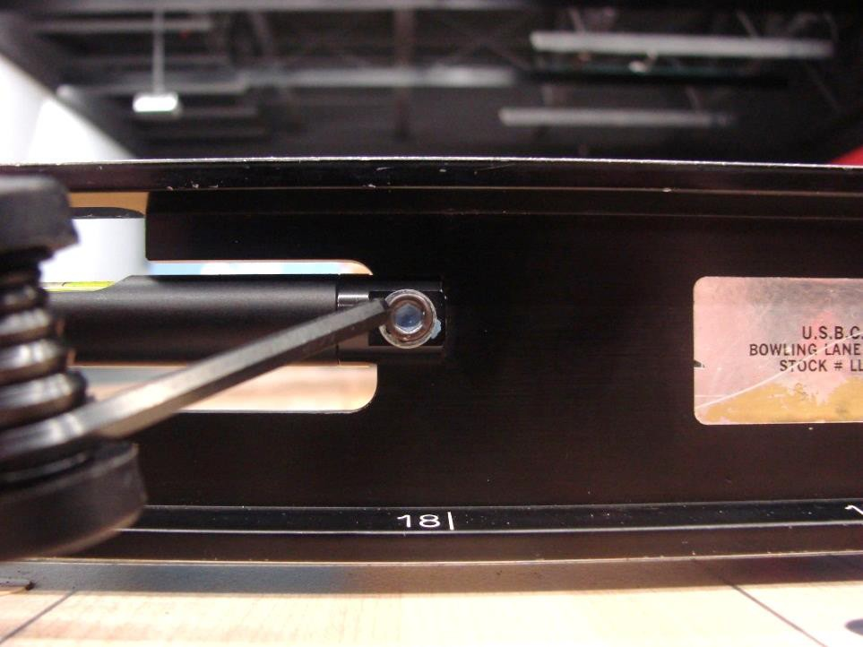
  - Tighten the 11/32” locknuts.

  - Repeat steps 1a-1f to check that calibration was completed successfully.

Measuring Crosswise Tilts
To see how to measure crosswise tilts of a pin deck, please click here.

Pin Deck

Specification: .040” maximum.
  - Place the level on the pin deck so it is on the last row of pin spots (7- pin through 10-pin). If pin spots are raised, or adhesive pin-slide control products are used, take measurement on foul line side of pins pots to avoid obstruction.

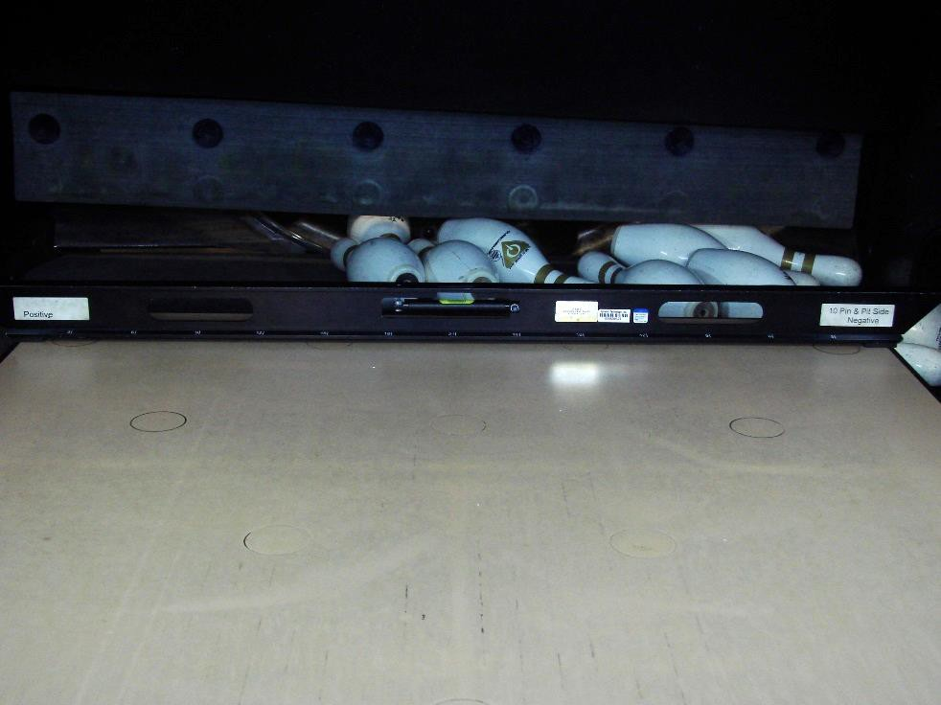

  - Examine the bubble in the vial of the level. If the bubble is not centered between the two centermost graduations on the vial, center it by placing feeler gauges under one foot of the level. Place different combinations of feeler gauge blades under the appropriate foot of the level until the displacement needed to center the bubble is obtained.
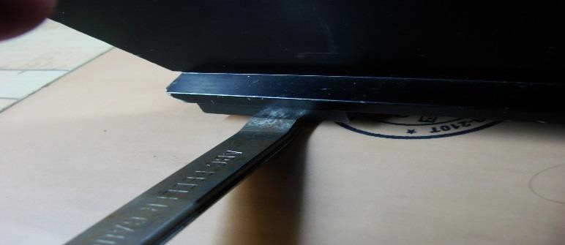

  - Record the amount of displacement obtained by summing the values listed on the individual blades. After recording the value, circle the correct indicator for which side of the lane required the feeler gauges. If the feeler gauges were placed under the foot on the 7-pin side of the deck, circle the “7” in the box; if the feeler gauges were placed under the foot on the 10-pin side of the deck, circle the “10” in the box.

Lanes
To see how to measure crosswise tilts on the lanes, please click here.
Note: Beginning with inspections for the 2018/2019 season, all tilt measurements for the lane are to be taken as follows:

Wood Lanes
  - One measurement from each of the following 3 windows (’ =
feet)
    - 10’-15’
    - 30’-40’
    - 50’-55’

Synthetic Lanes
  - One measurement from each of the first 5 lane panels starting with the first panel from the foul line
  - No closer than 5’ together
  - Preferably within 3” of a screw row, but not directly on the
screw caps or panel edges

Multi-Surface Lanes
  - Where synthetic panels are used:
    - One measurement from each panel, starting from the foul line
    - No closer than 5’ together
    - Preferably within 3” of a screw row, but not directly on the
screw caps or panel edges
  - Where lane is wood
    - One measurement from each of the following 3 windows:
      - 10’ – 15’
      - 30’ – 40’
      - 50’ – 55’

Note: The official or compliance determining measurement is the initial measurement taken within these guidelines. It is not an accepted practice to move a measurement point to gain tolerance compliance.

Best Practice: It is a best practice to move annual measurements within the accepted windows to gain a more complete view of the entire lane. For example, if a measurement is taken at 11 feet this year, it would be a best practice to measure at 12 feet the following year and 13 feet the next.

Specification: .040” maximum. (.030” at time of installation)
- Place the level on the lane at the designated distance where the measurement is to be taken so it spans from gutter to gutter and is parallel to the foul line.
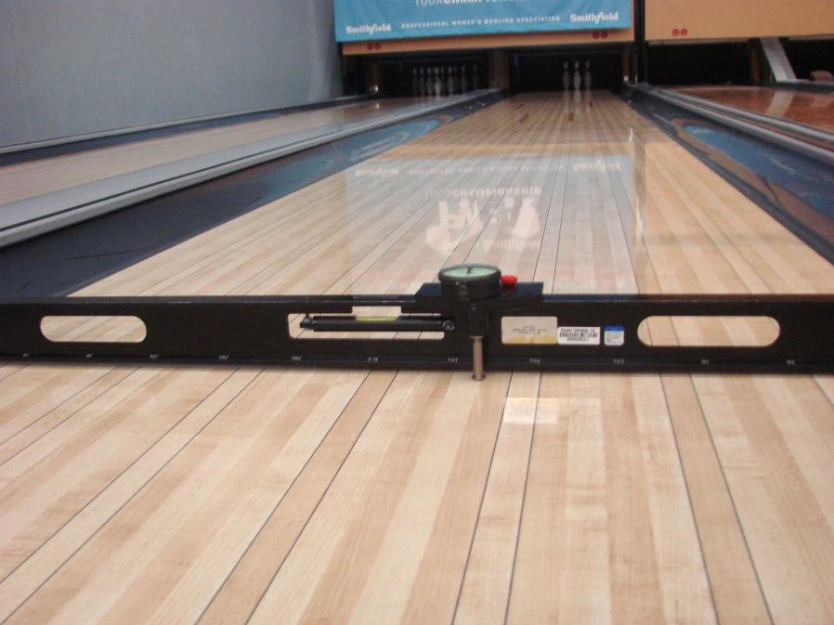

- Examine the bubble in the vial of the level. If the bubble is not centered between the two centermost graduations on the vial, center it by placing feeler gauges under one foot of the level. Place different combinations of feeler gauge blades under the appropriate foot of the level until the displacement needed to center the bubble is obtained.

- Record the amount of displacement obtained by summing the values listed on the individual blades. After recording the value, circle the correct indicator for which side of the lane required the feeler gauges. If the feeler gauges were placed under the foot on the 7-pin side of the lane, circle the “7” in the box; if the feeler gauges were placed under the foot on the 10-pin side of the lane, circle the “10” in the box.

Measuring Lengthwise Tilts
To see how to measure lengthwise tilts of a pin deck, please click here.

Pin Deck

Specification: .187” maximum.
  - Place level between the 4-pin and 7-pin spots making sure the foot of the level is not over the seam where the lane meets the pin deck, and the foot of the level is not hanging over the pin deck at the pit area.
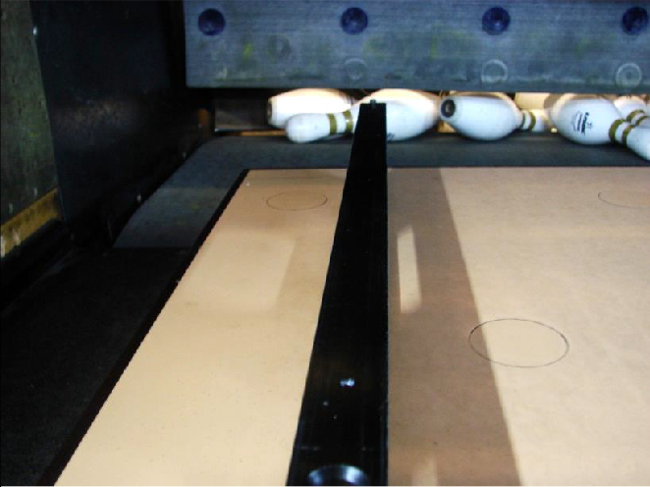
  - Examine the bubble in the vial of the level. If the bubble is not centered between the two centermost graduations on the vial, center it by placing feeler gauges under one foot of the level. Place different combinations of feeler gauge blades under the appropriate foot of the level until the displacement needed to center the bubble is obtained.

  - Record the amount of displacement obtained by summing the values listed on the individual blades. After recording the value, circle the correct indicator for which side of the level required the feeler gauges. If the feeler gauges were placed under the foot toward the front of the deck, circle the “F” in the box; if the feeler gauges were placed under the foot toward the rear of the pin deck, circle the “P” in the box.

  - Place level between the 6-pin and 10-pin spots, making sure the level is not over the seam where the lane meets the pin deck and the level is not hanging over the pin deck at the pit area.

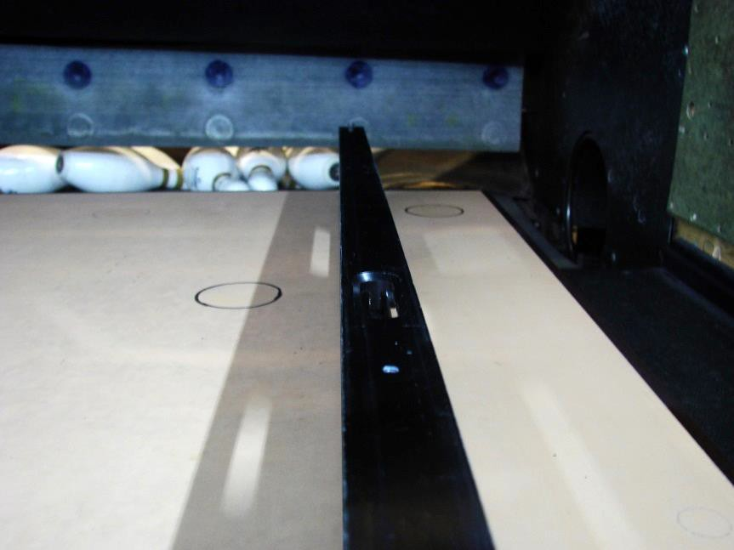

  - Repeat steps from Pits 4b & 4c
To see how to measure lengthwise tilts of the lanes, please click here. Lanes

Specification: .040” maximum. (New centers only)
- Place the level between board 18 on the left side and board 18 on the right side of the lane, parallel to the direction of the boards, making sure the level has not been placed over a seam between lane panels or on a dowel. Lengthwise tilts for the lane are measured at the same distances as your crosswise tilts.

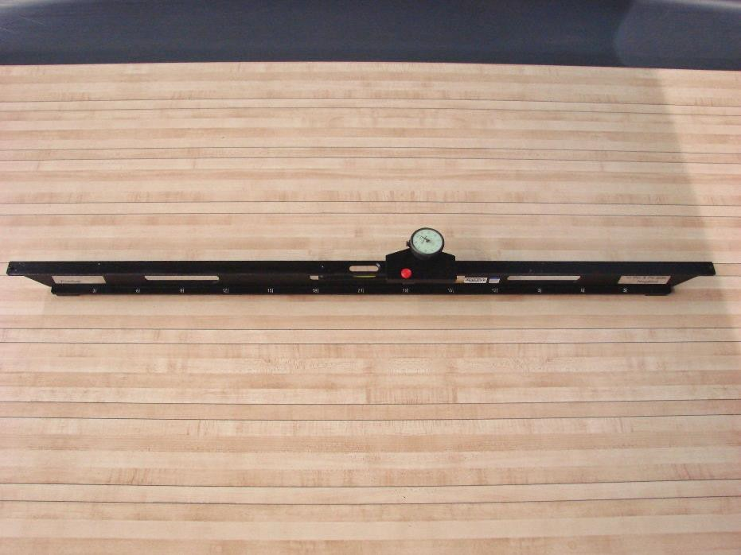
- Record the amount of displacement obtained by summing the values listed on the individual blades.

- Repeat steps 4b & 4c

Measuring Flat Gutter Slope
  - Examine bottoms of gutters on each side of the pit area.

  - Note whether they slope gradually toward pit.

  - If slope is not apparent to your eye, place level in bottom of gutter. If bubble moves toward foul line (i.e. away from pit), slope is toward pit.

Standard Operating Procedure: SOP-CERT-7

Dial Indicator & Sled

Purpose: How to measure:
- The crowns and depressions of a bowling lane
- The approach depressions
- The drop off from trailing to leading edge

Equipment:
- CTF Lane Level
- Dial indicator
- Sled
- Plunger assembly
- Allen wrench
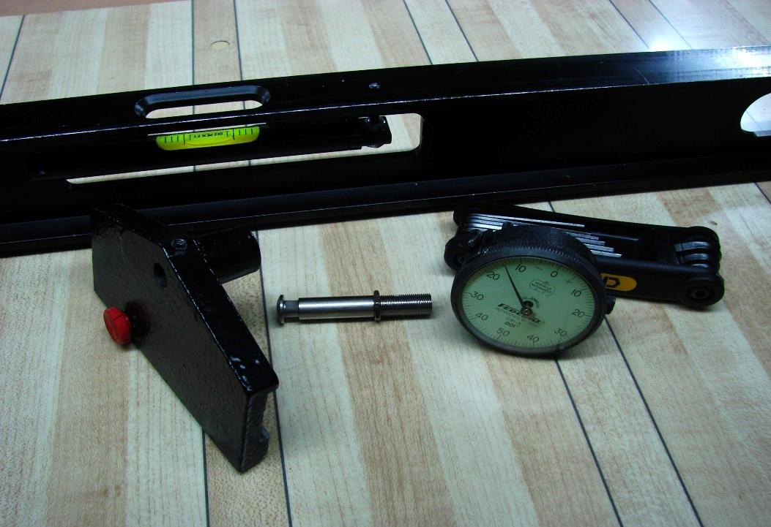

SAFETY NOTE: Ensure that any lanes to be measured are free of oil prior to taking measurements. DO NOT WALK ON AN OILED LANE SURFACE.

Tools:
The lane level, dial indicator, and sled can be purchased from the USBC Bowling Store. Just go to usbcbowlingstore.com, and go to the section titled “Equipment”.

Procedure:

Assemble the dial indicator and sled.
  - Remove all protective packaging materials from sled, dial indicator and plunger assembly.

  - Loosen Dial Indicator set screw on front of sled with appropriate Allen wrench.
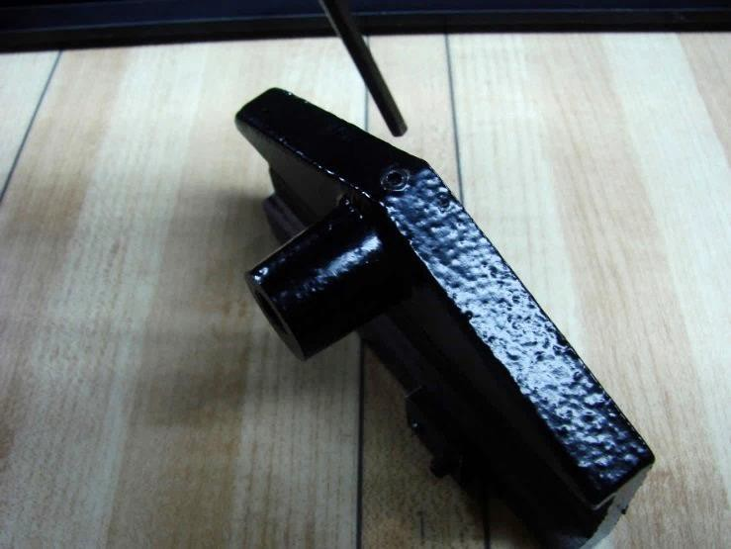
  - Insert the dial indicator stem into the hole on the top of the sled.

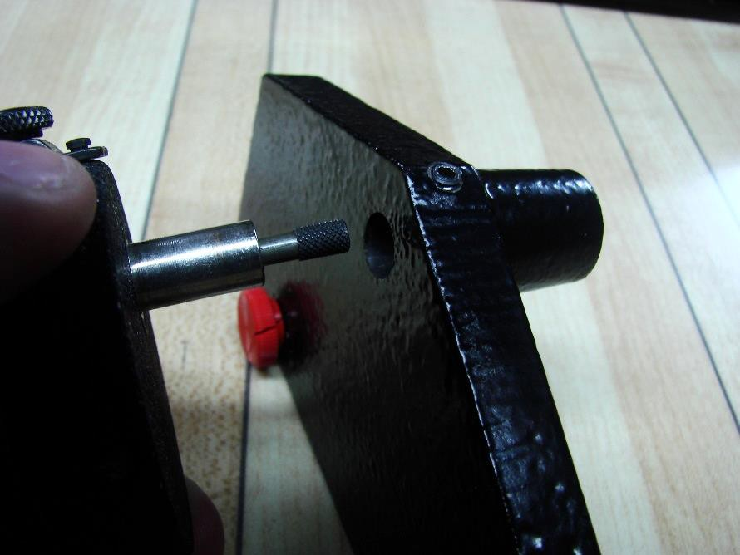
  - Tighten the set screw found on the front of the sled with the Allen wrench.

  - Check the dial indicator to ensure it is secured to the sled.

  - Lower the locknut on the plunger assembly to the bottom of the threaded portion of the assembly.

  - Insert the threaded portion of the plunger assembly into the bottom of the sled below the dial indicator.
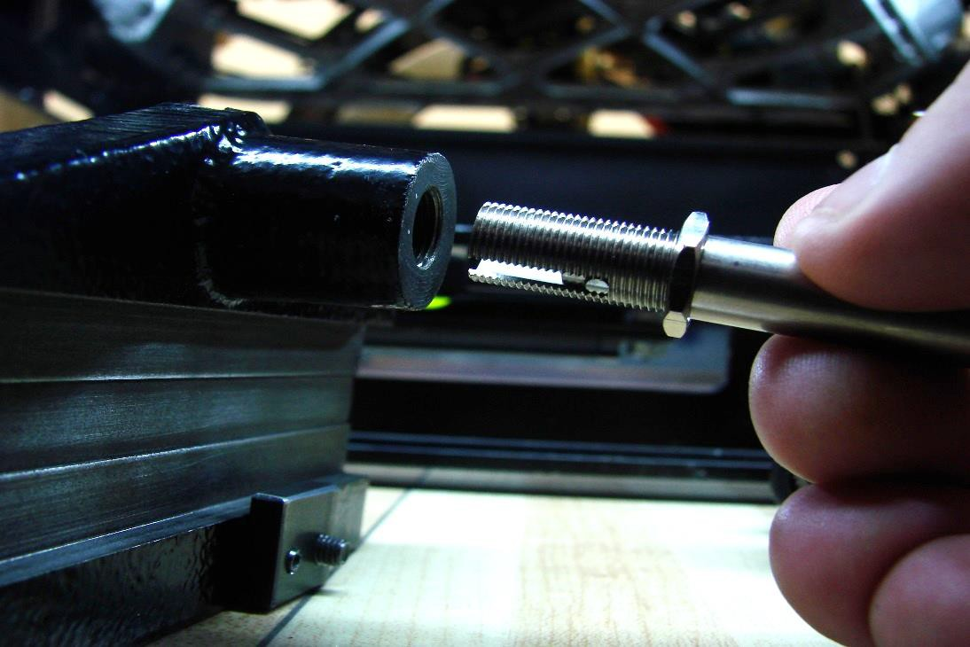

  - Screw the plunger assembly into the sled and continue to tighten until the dial on the indicator starts to move.
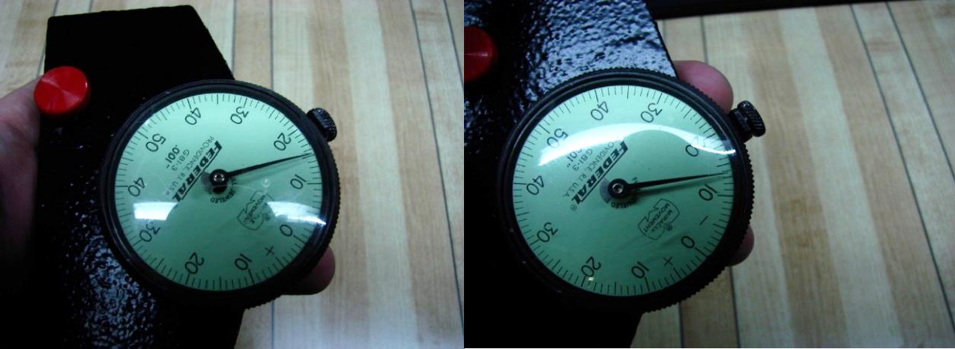

  - Tighten the locknut to the sled to hold the plunger assembly in place.
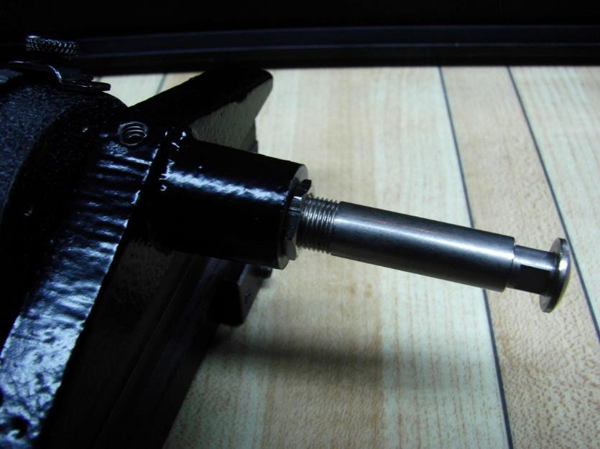

Attach the Sled with Dial Indicator to the CTF Lane Level
  - Loosen the thumb screw on the top of the sled to the open position.
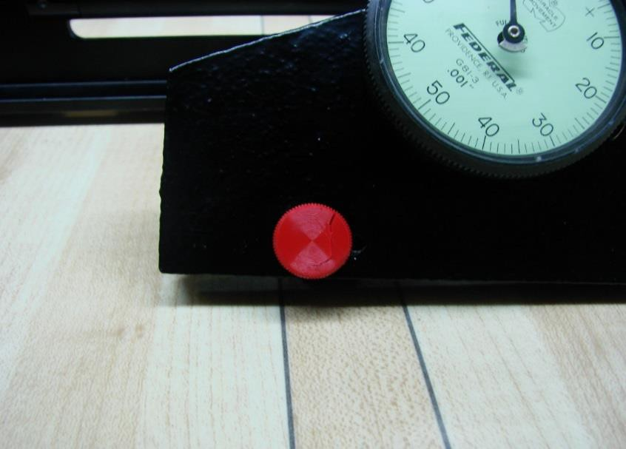

  - Place the sled on top of the level by joining the cut-out channel that is on the bottom of the sled to the top of the level, so it is flush with the level. The dial indicator should be on the same side of the level as the numbers that are engraved on the face of the level.
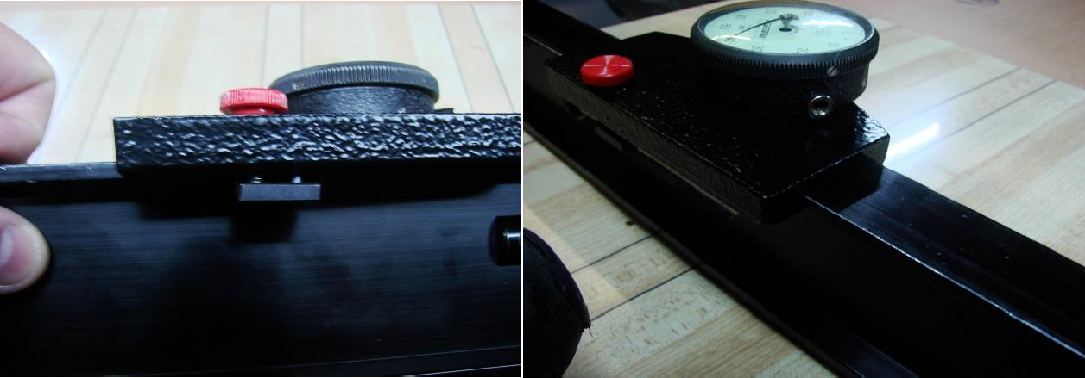

  - Tighten the thumb screw on the sled to fasten it to the level. The thumb screw should be tight enough so the sled does not fall off the level, but loose enough so the sled can slide freely along the length of the top of the level.

Measure Crowns and Depressions
To see how to measure crowns and depressions, click here.

Note: Beginning with inspections for the 2018/2019 season, all crown/depression measurements for the lane are to be taken as follows:

Wood Lanes
  - Three measurements (L10, C20, R10) from each of the following windows
    - 10’-15’
    - 30’-40’
  - Two measurements (L15, R15) from the following window
    - 50’-55’

Synthetic Lanes
  - Three measurements (L10, C20, R10) from each of the first 5 lane panels starting with the first panel from the foul line
  - No closer than 5’ together
  - Preferably within 3” of a screw row, but not directly on the
screw caps or panel edges

Multi-Surface Lanes
  - Where synthetic panels are used:
    - Three measurements (L10, C20, R10) from each of the lane panels starting with the first panel from the foul line
    - No closer than 5’ together
    - Preferably within 3” of a screw row, but not directly on the
screw caps or panel edges
  - Where lane is wood
    - Three measurements (L10, C20, R10) from each of the following windows:
      - 10’ – 15’
      - 30’ – 40’
    - Two measurements (L15, R15) from the following window
      - 50’ – 55’

Note: The official or compliance determining measurement is the initial measurement taken within these guidelines. It is not an accepted practice to move a measurement point to gain tolerance compliance.

Best Practice: It is a best practice to move annual measurements within the accepted windows to gain a more complete view of the entire lane. For example, if a measurement is taken at 11 feet this year, it would be a best practice to measure at 12 feet the following year and 13 feet the next.

Specification: .040” maximum. (.030” at time of installation)
  - Place the level on the lane at the distance where measurements are to be taken so it spans gutter to gutter and is parallel to the foul line. The side of the level with the numbers should be facing the approach.
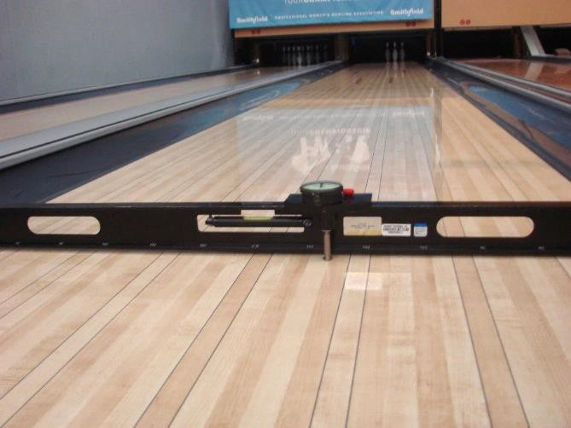

  - Do not stand on the lane while taking and reading measurements. Straddle the lane, or stand completely off to the side of the lane.

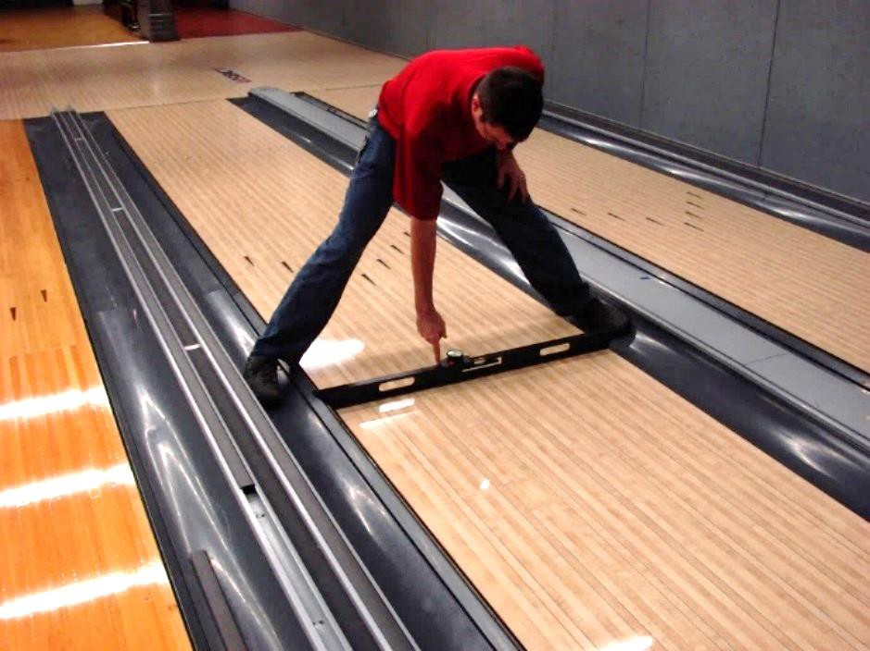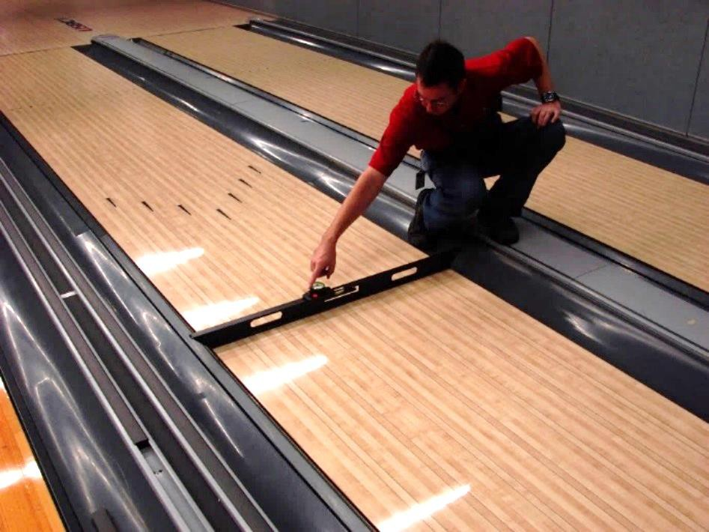

  - Slide the sled so the plunger of the dial indicator is on the first board on the 10-pin side of the lane (called R1 for right #1).
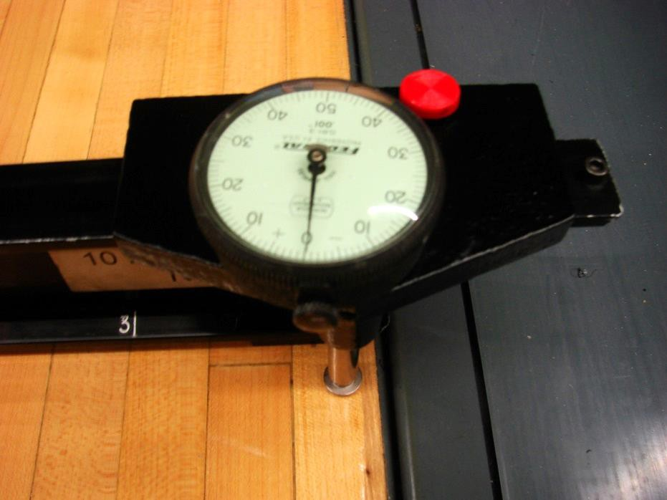

  - Loosen the thumb screw on the edge of the face of the dial indicator.
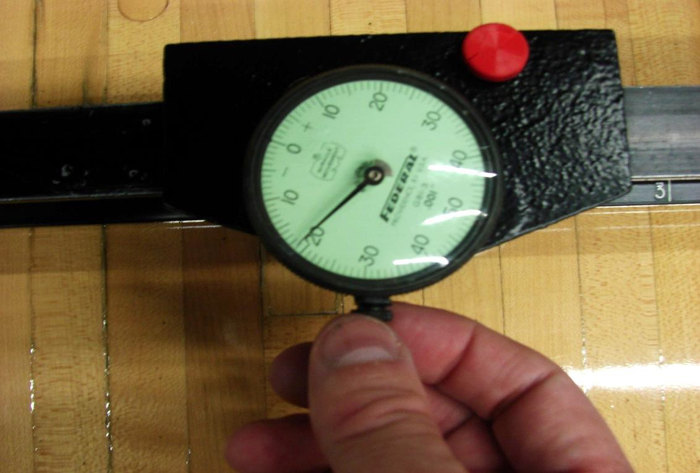

  - Rotate the face of the dial until the “0” is lined up with the needle of
the dial.
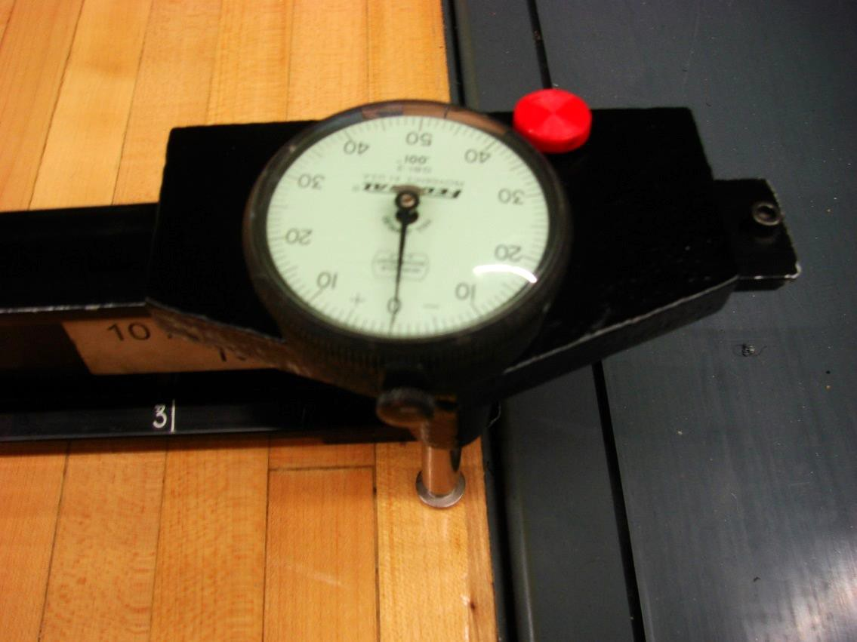

  - Tighten the thumb screw until lightly snug

  - Slide the sled so the plunger of the dial indicator is on the board to be measured

  - Read the measurement indicated by the needle of the dial

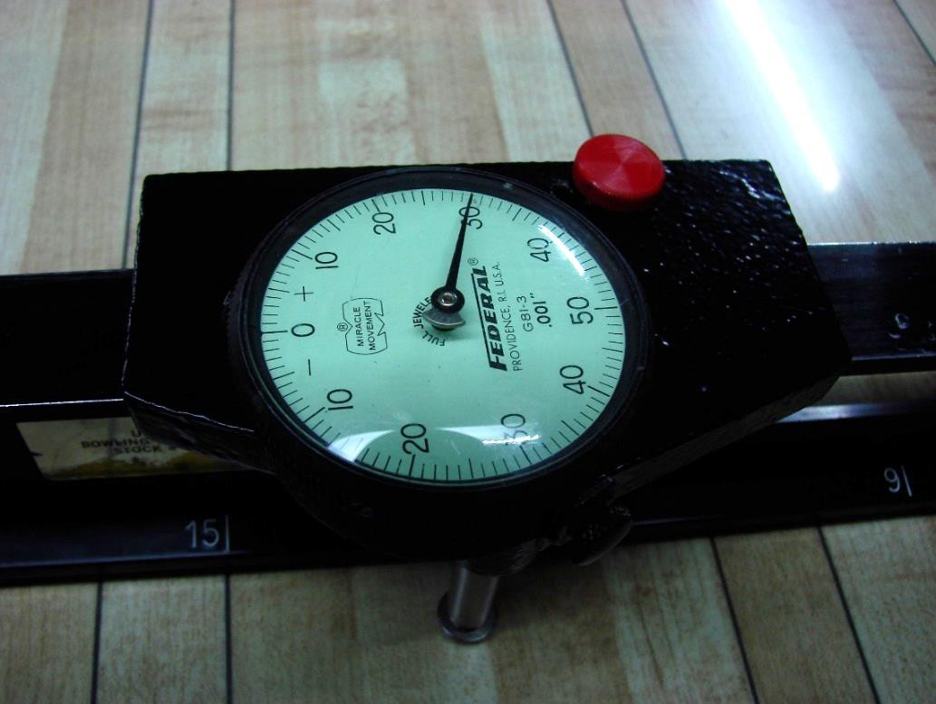

  - Record the measurement, ensuring the appropriate sign associated with the measurement also has been recorded based on the direction the needle has rotated on the dial

  - Repeat steps 3g-3i until all desired measurements have been taken for that distance on the lane

Measuring drop offs from trailing edge to leading edge for synthetic panels
To see how to measure panel drop offs, please click here.

  - Place CTF Lane Level with the dial indicator and sled attached across the joint of the panels, parallel to lane between R18 and L18 boards, avoiding any dowels
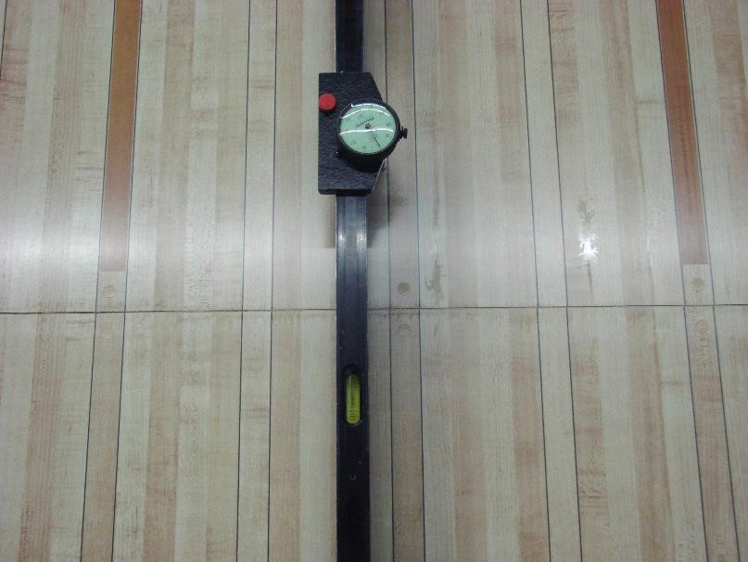

  - Slide gauge to point just before trailing edge of a joint, set dial to zero.
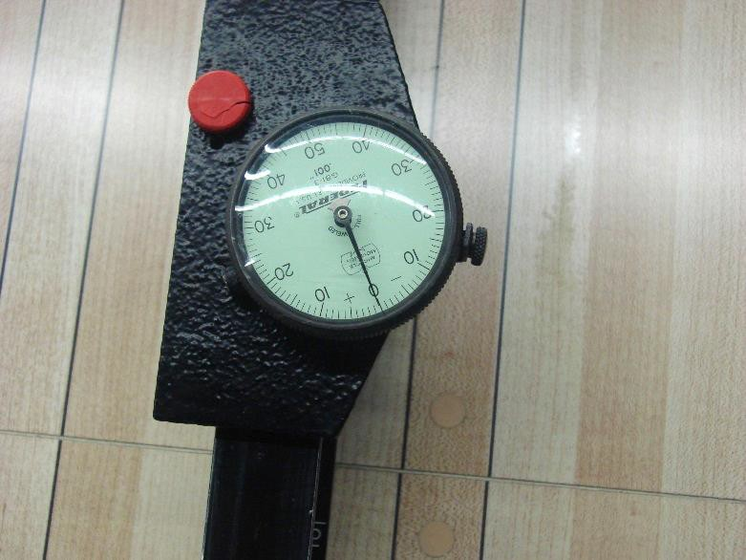

  - Slide gauge so that plunger moves across joint and onto leading edge, observing movement of needle.
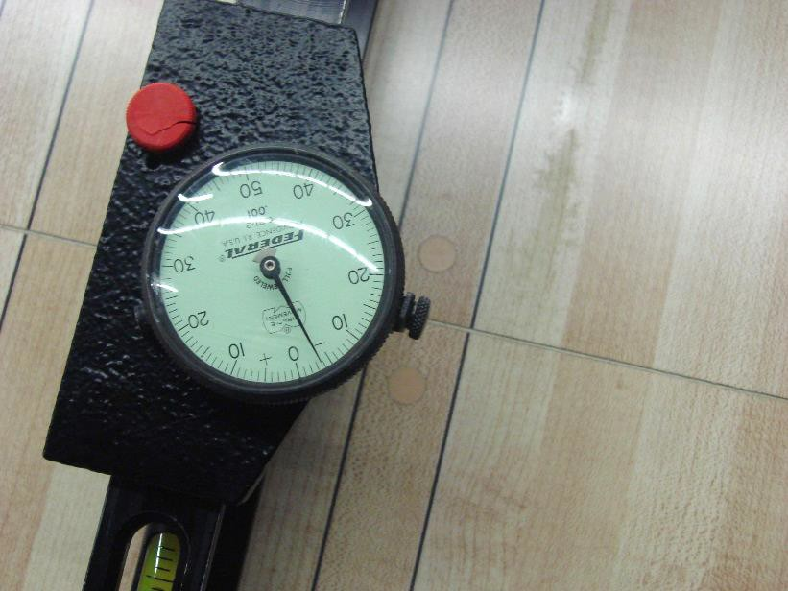

  - If needle moves to positive (+) side of dial, note lane number on item 2 of the Center Inspection Report

  - If needle moves to negative (-) side, and indicates depression of more than .040", note lane number on item 2 of the Center Inspection Report

  - Repeat for every panel joint

Standard Operating Procedure: SOP-CERT-8

Gutter Gauge

Purpose: How to use the gutter gauge to measure the following in the pin deck area:
  - The flat gutter depth
  - Pit length – taken on new installations only
  - Pit depth – taken on new installations only

Equipment:
  - Gutter Gauge
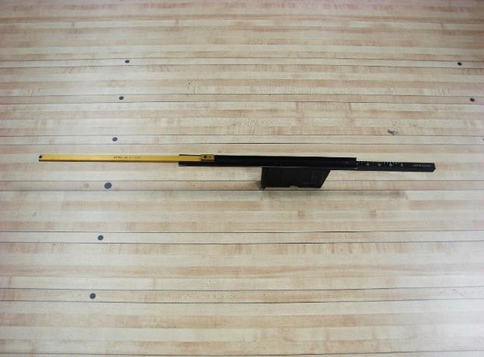
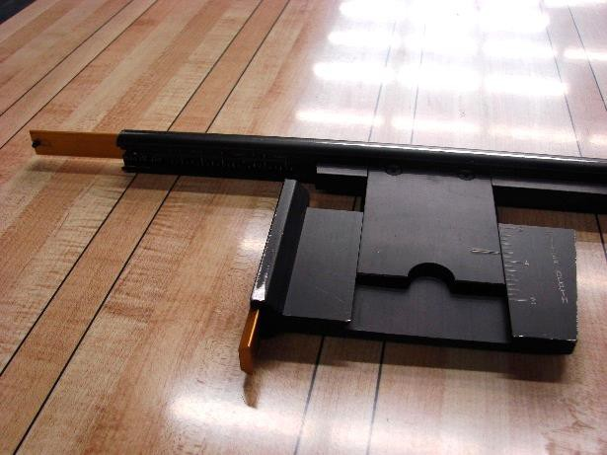
Figure 1 Figure 2

  - Head Lamp or another light source (optional)
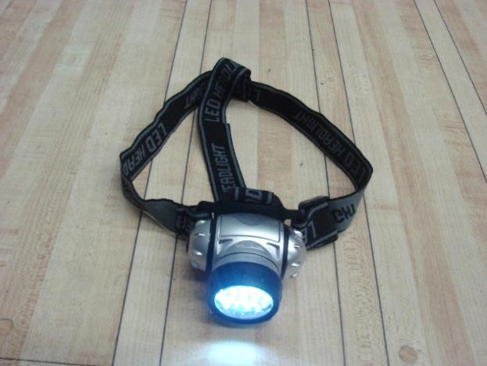

SAFETY NOTE: When taking measurements underneath a pinsetter, ensure the pinsetter is powered off and cannot be turned on by the front desk or anyone else while the operator is taking measurements. Unplug the main power supply to the pinsetter. The use of Lock-Out/Tag-Out is strongly recommended.
Tools:
The gutter gauge can be purchased from the USBC Bowling Store. Just go to usbcbowlingstore.com, and go to the section titled “Equipment”. The head lamp can be purchased at most hardware stores.

Procedure:

Measuring the depth of the flat gutter
To see how to measure the depth of the flat gutter, please click here.

  - Place the Gutter Gauge on the pin deck on the center of the 7-pin or 10-pin pin spot, depending on which flat gutter is being measured. The “Lane End” engraving should be aligned with the edge board on the pin deck.
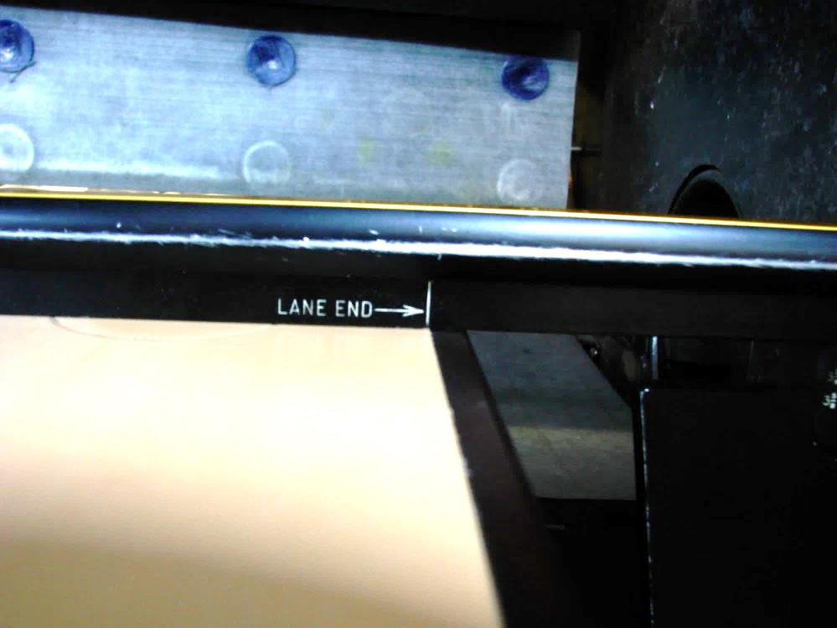

  - Hold the Gutter Gauge flat on the pin deck by placing your hand on top of the gauge over the pin spot, then lower the Gutter Depth slide until it contacts the flat gutter.
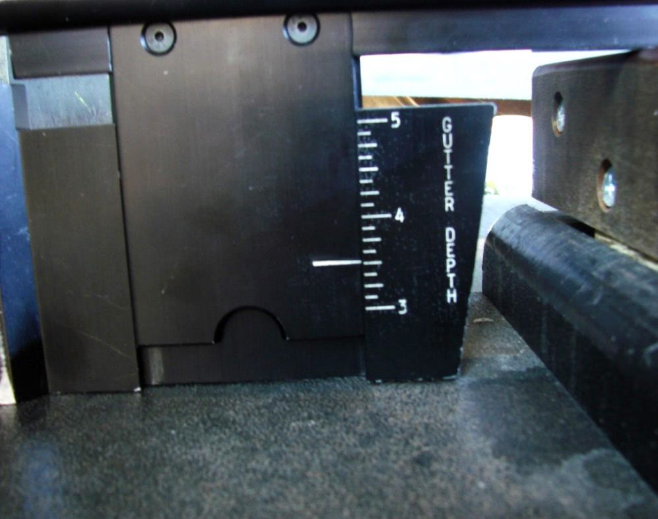
  - Record the measurement from the scale labeled “Gutter Depth”

  - Repeat steps 1a – 1c for opposite gutter

Measuring the pit depth
To see how to measure the pit depth, please click here.
  - With the Gutter Depth slide in the closed position, extend the small side (usually gold in color) on the edge of the Gutter Depth slide until it latches in place.
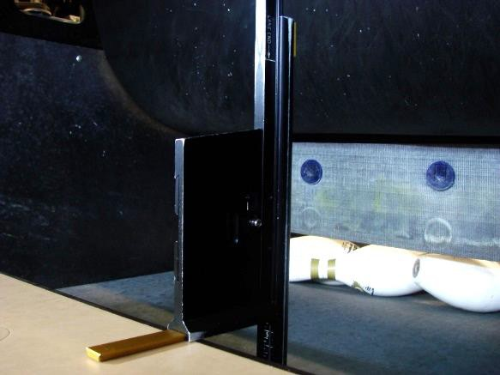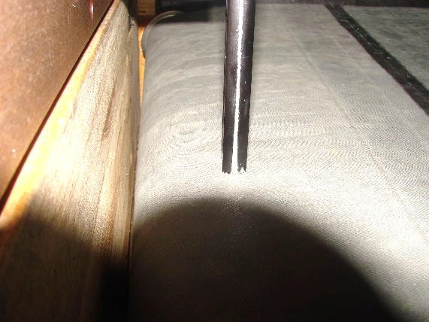
Figure 1 Figure 2

  - Stand the Gutter Gauge on its end so the small slide is sitting flat on the pin deck. Position the Gutter Gauge so the barrel is past the end of the pin deck toward the pit.

  - Extend the barrel of the Gutter Gauge until it contacts the pit carpet. Reference figure 2 (on previous page) to see the Gutter Gauge with the barrel extended. This measurement is to be taken at the shallowest location between the pit carpet and pin deck surface. If needed, move the gutter gauge along the back of the pin deck to find that location.

  - Carefully pick up the Gutter gauge and look at the scale on the inside of the barrel. The scale is labeled “Pit Depth.” Record this measurement.
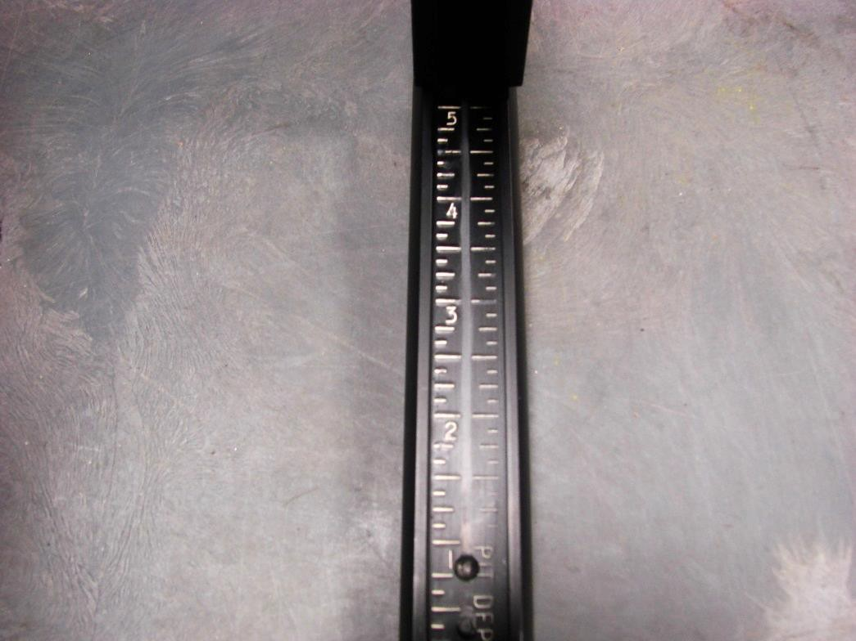

Measuring the pit length - distance from back end of the lane to the cushion
To see how to measure the pit length, please click here.

  - Ensure the Gutter Gauge is fully collapsed.

  - Extend the long slide (usually gold in color) that is on top of the barrel of the Gutter Gauge until it locks into place.

  - At the pit depth location from Step 2c, place the Gutter Gauge on top of the pin deck so the “Lane End” mark aligns with the etched line found at the back of a synthetic pin deck or the back end of the lane (minus the tail plank) of a wood pin deck. Figure 3 on the next page shows an example of alignment on a synthetic pin deck.
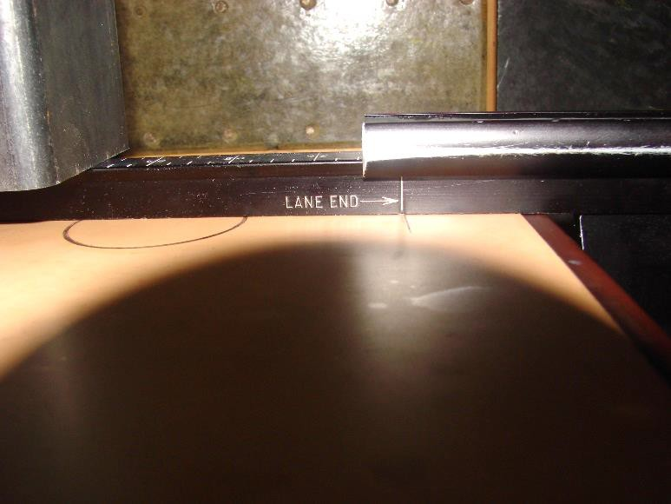
Figure 3

  - Extend the barrel of the Gutter Gauge until the long slide contacts the cushion

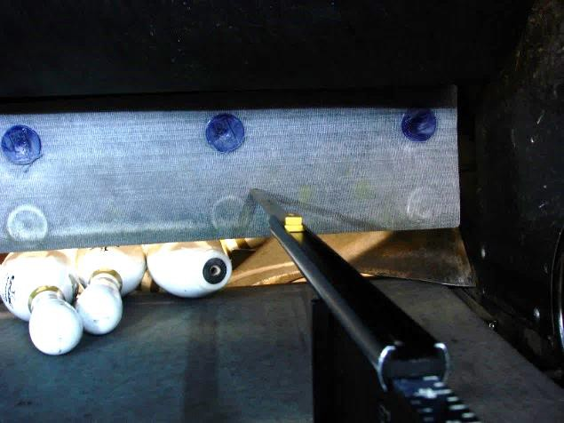
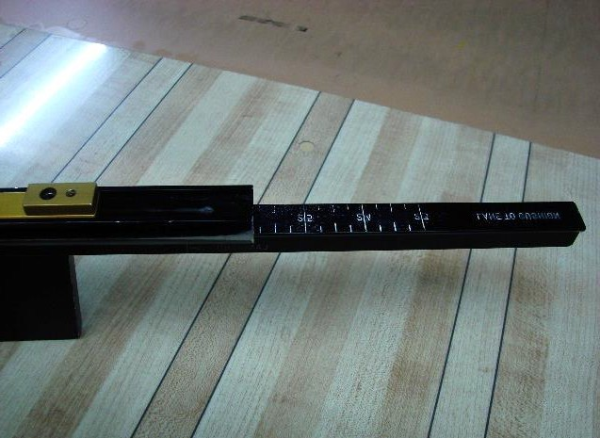

  - Carefully pick up and read the scale that is labeled “Lane to Cushion”

  - Record this measurement as the pit length.

Standard Operating Procedure: SOP-CERT-9

Pit End Gauge

Purpose: How to take the following measurements in the pit area of a bowling lane using the Pit End Gauge:
  - Kickback Plate to Kickback Plate
  - Lane Width
  - Gutter Width
  - Pin Spot to Edge of lane - taken on new installations with wood pin decks
  - Pin Triangle - taken on new installations with wood pin decks

Equipment:
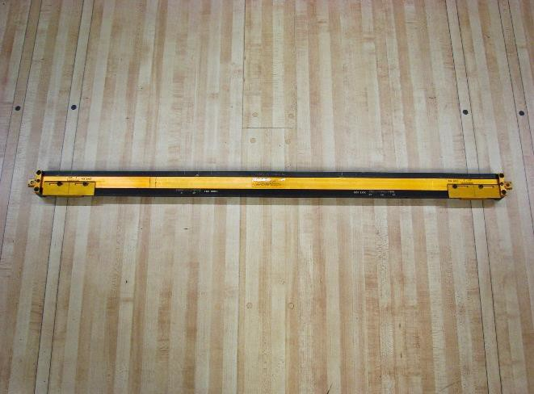
- Pit End Gauge

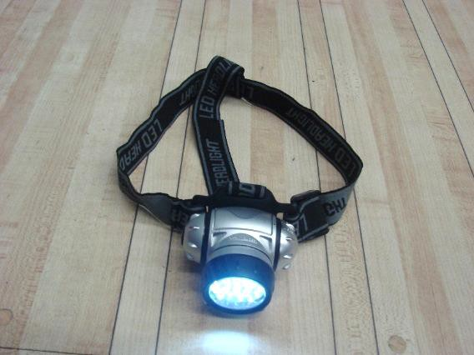
- Head Lamp or another light source (optional)

SAFETY NOTE: When taking measurements underneath a pinsetter, ensure the pinsetter is powered off. The use of Lock-Out/Tag-Out is strongly recommended. Ensure the pinsetter cannot be turned on by the front desk or anyone else while the inspector is taking measurements.
Unplug power supply line. Tools:
The pit end gauge can be purchased from the USBC Bowling Store. Just go to usbcbowlingstore.com, and go to the section titled “Equipment”.

Procedure:

Measuring the Kickback plate to Kickback plate distance.

To see how to measure the kickback plate to kickback plate, please click

here.
  - Place the pit end gauge across the last row (7-8-9-10-pin) pin spots. The engraved scale reading “Lane Width” and “Kick Back” should face towards the headpin spot.

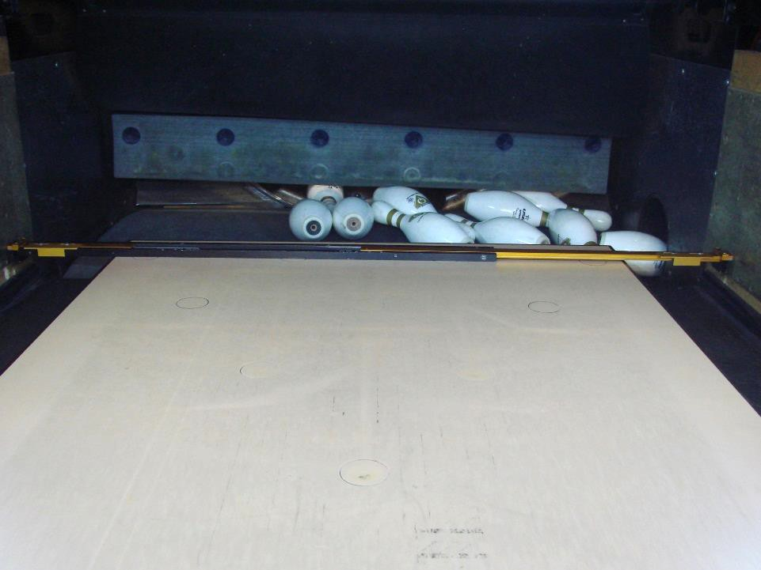

  - Expand the pit end gauge by sliding out the right side of the gauge and adjust until both ends of the gauge touch the kickback plates.
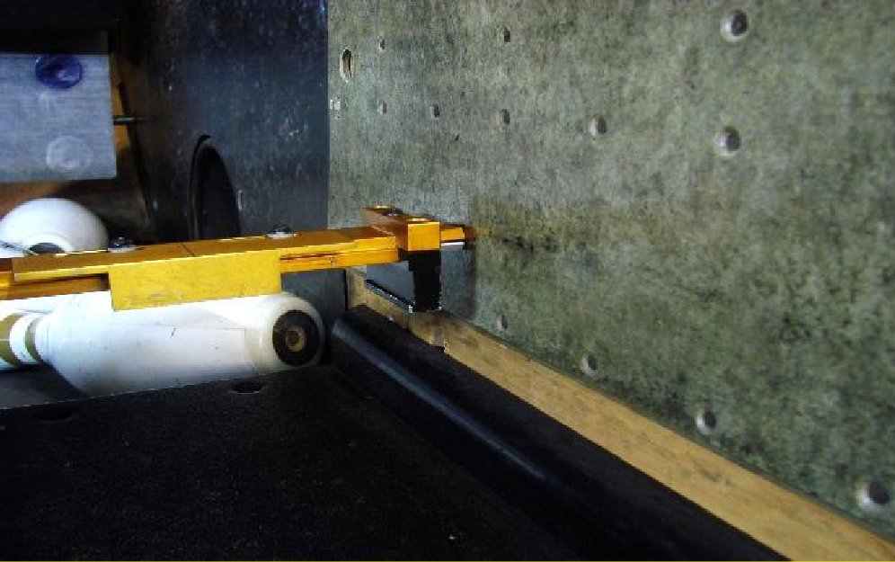

  - Read the scale labeled “Kick Back” on the Pit End Gauge. Record this measurement as kickback plate to kickback plate.

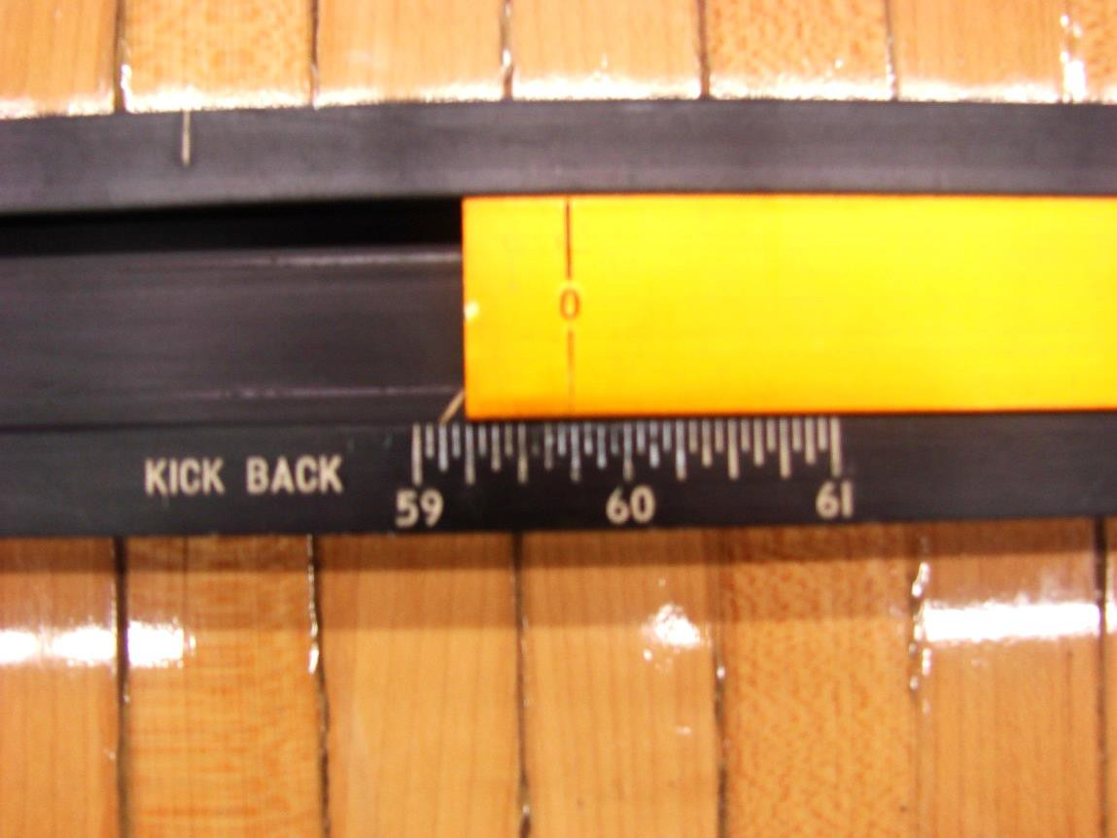
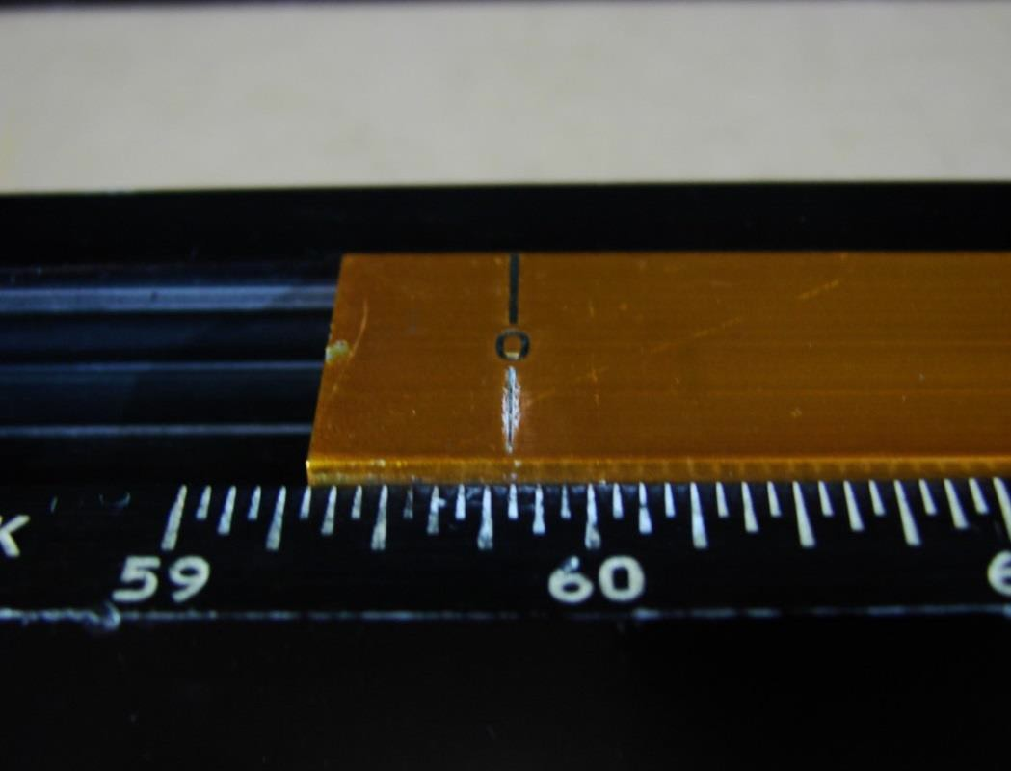

Measuring the Lane Width

To see how to measure the lane width, please click here.

  - With the Pit End Gauge positioned, as in step 1b, on the last row of pin spots, close the gauge by sliding the right side of the gauge

inward until the feet on both sides of the gauge are touching the edges of the pin deck.
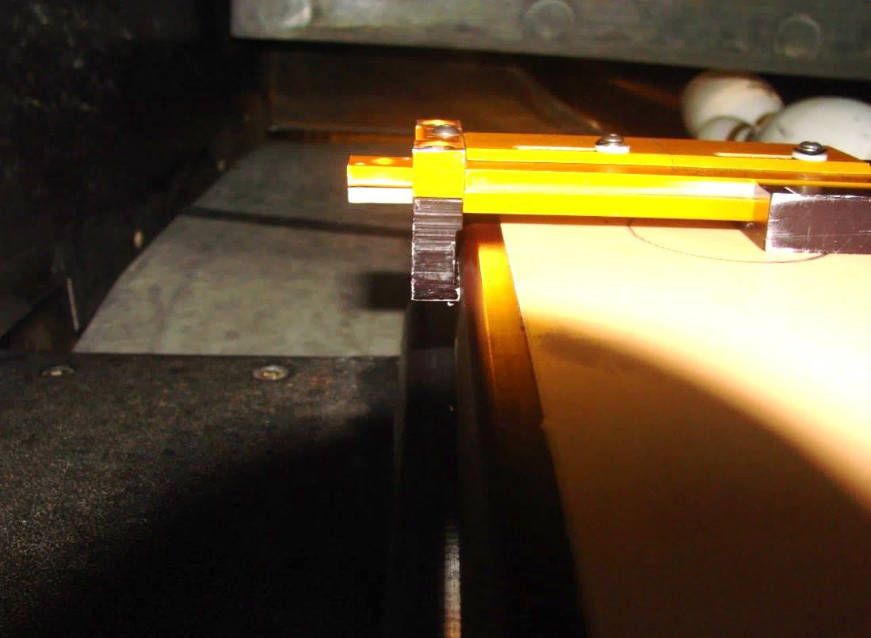
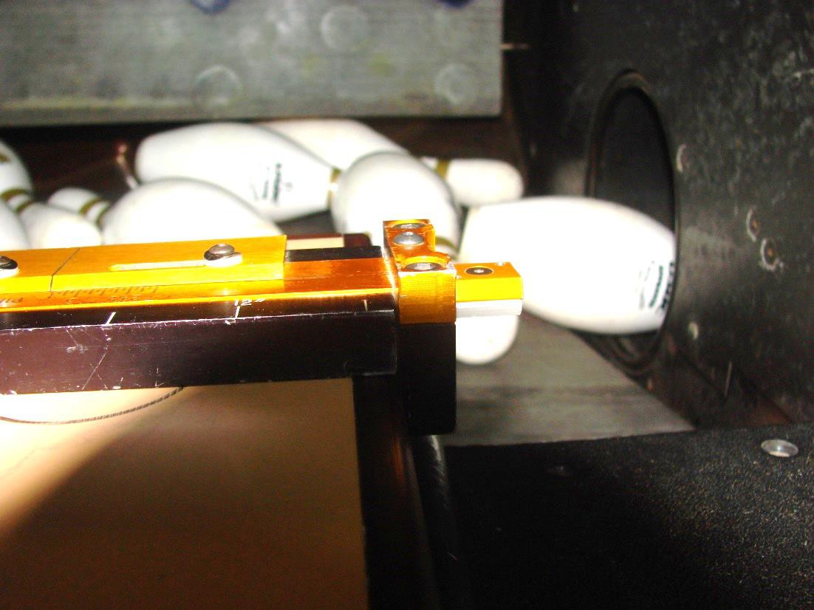

Read the “Lane Width” scale on the Pit End Gauge and record this
measurement.

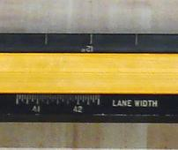

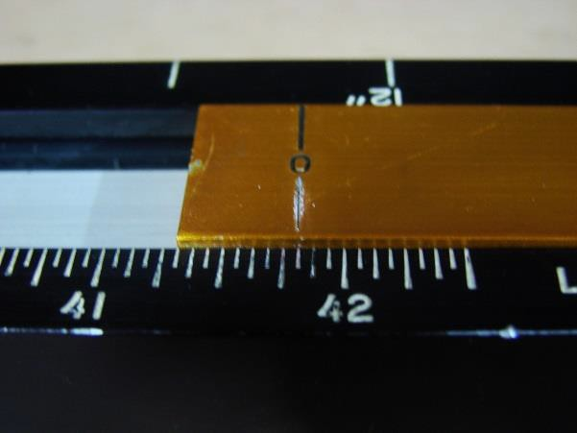

Measure the Gutter Width
To see how to measure the gutter width, please click here.

  - With the Pit End Gauge positioned, as in step 2b, on the last row of pin spots, extend the metal tabs located on each side of the gauge until they touch the kickbacks or kickback plates.

  - Read the “Gutter Width” scale for each side and record those values.

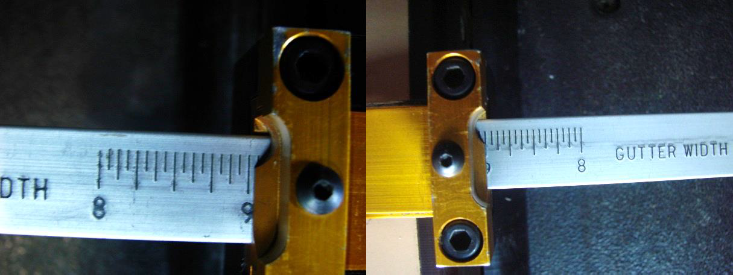

Measuring Pin Spot Location (For new wood pin deck installations only)
To see how to measure the pin spot locations, please click here.

For new wood pin deck installations, measure the distance from the pin spots to the edge of the lane.

  - With the position of the Pit End Gauge as in step 2b.

  - Slide the measuring guides located under the “Pin Spot” scale on both sides of the Pit End Gauge to the center of the diameter of both the 7- pin and 10-pin spots.

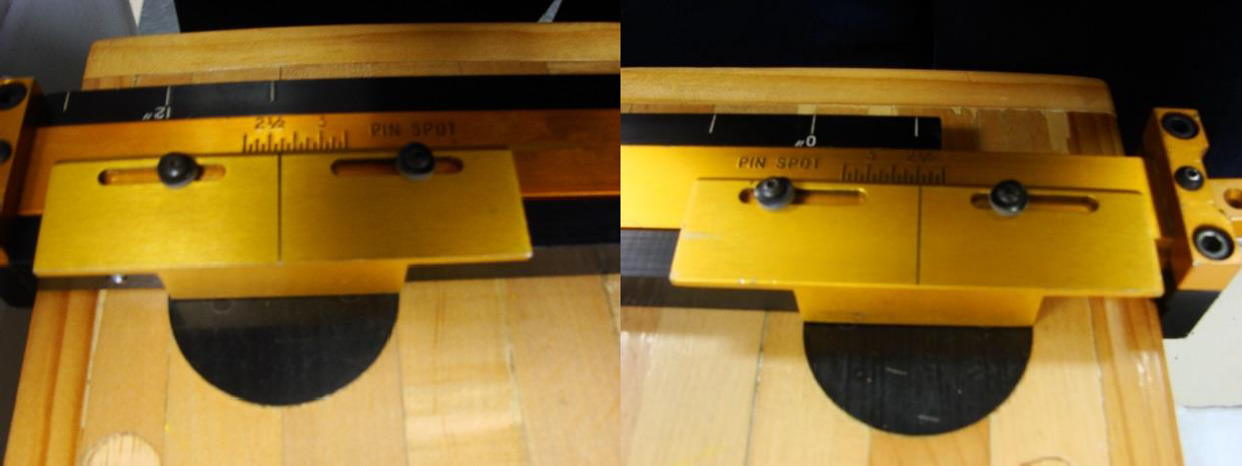

  - Read the “Pin Spot” scales and record both the measurement for the distance from the 7-pin spot to the edge and the 10-pin spot to the edge.
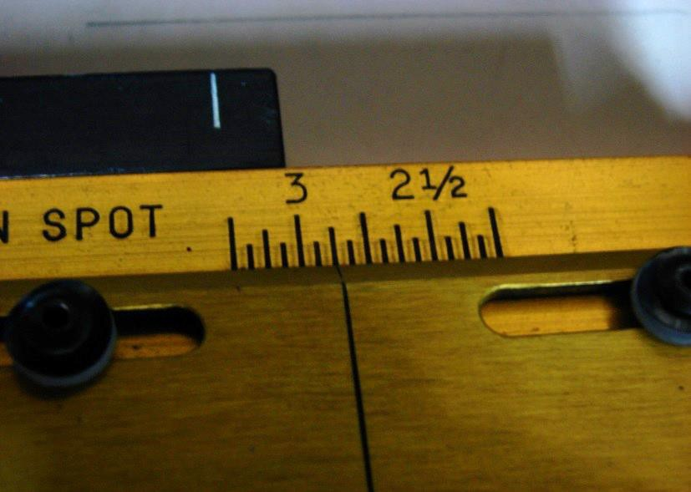

Pin Triangle (For new wood pin deck installations only).

  - Place the Pit End Gauge on the pin deck so it is standing on its edge
with the “Pin Triangle 36’’ Overall” scale on the bottom.

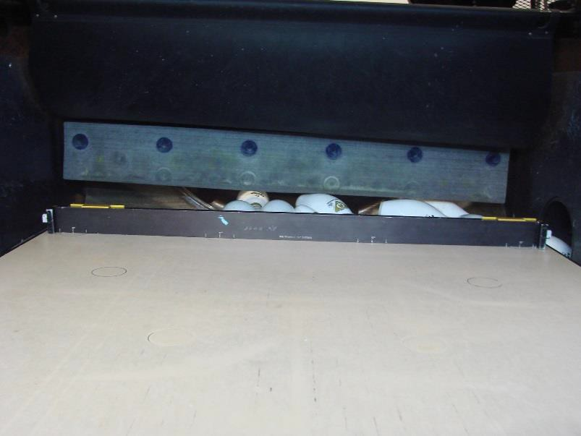

  - Move the gauge so the “Pin Triangle 36’’ Overall” scale is in line with the last row of pin spots. Center the “0” mark on the 7-pin spot. Align the remainder of the markings on the scale with the 8-pin, 9-pin and 10-pin spot from left to right.
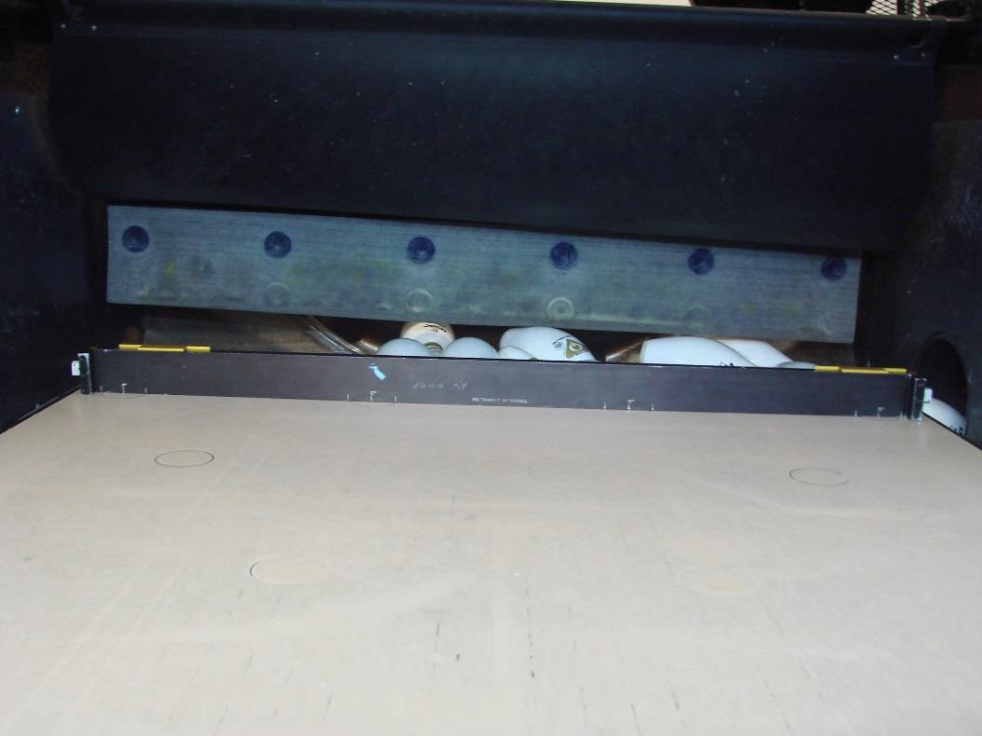

  - Check where the scale is compared to the pin spots. The pin spots should be 12” from center to center. If they are, record as such. If not, record all discrepancies.

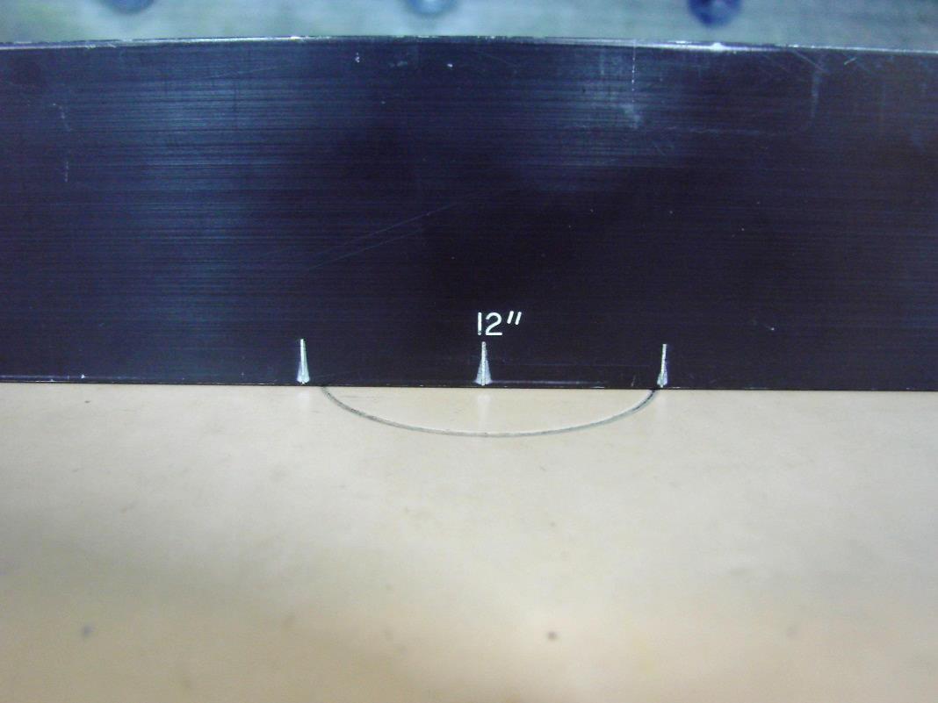
  - Move the gauge to center the “0” mark on the 1-pin spot. Align the remainder of the markings on the scale with the 3-pin, 6-pin and 10- pin spots.
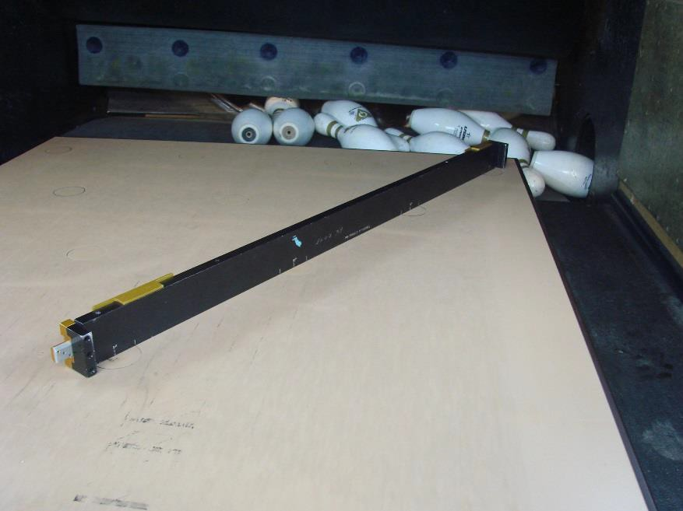

  - Check where the scale is compared to the pin spots. The pin spots should be 12” from center to center. If they are, record as such. If not, record all discrepancies.

  - Move the gauge to center the “0” mark on the 7-pin spot. Align the remainder of the markings on the scale with the 4-pin, 2-pin and 1- pin spots.

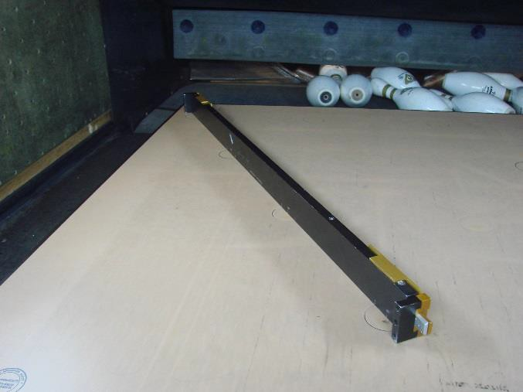

  - Check where the scale is compared to the pin spots. The pin spots should be 12” from center to center. If they are, record as such. If not, record all discrepancies.

  - Move the gauge to center the “12” mark on the 4-pin pin spot. Align the remainder of the markings on the scale with the 5-pin and 6-pin spot from left to right.
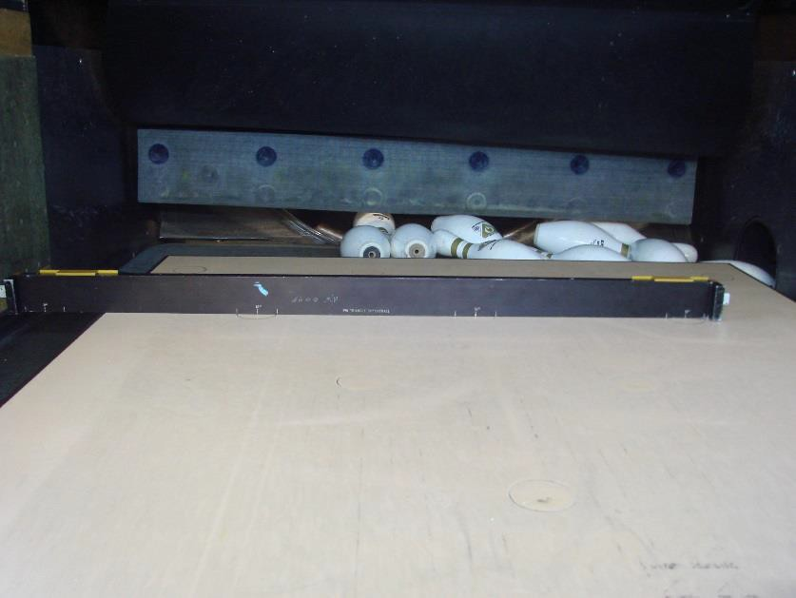

  - Check where the scale is compared to the pin spots. The pin spots should be 12” from center to center. If they are, record as such. If not, record all discrepancies.

Miscellaneous Tools

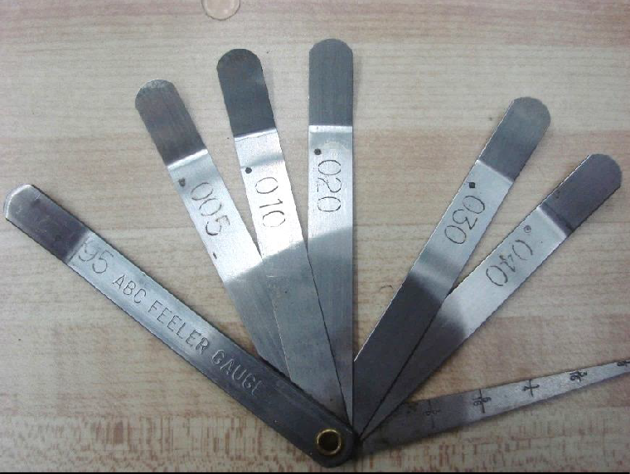
Feeler Gauge
This is a precision-made device with leaves of different thickness. Each leaf is marked with its thickness. The different thicknesses are:

.005” - 5 one-thousandths of an inch
.010” - 10 one-thousandths of an inch
.020” - 20 one-thousandths of an inch
.030” - 30 one-thousandths of an inch
.040” - 40 one-thousandths of an inch
.095” - 95 one-thousandths of an inch

The leaves can be used in combination for measurements different from what is available on a single leaf. For instance, the .010” and .005” leaves may be used together to measure a space of .015” (15-thousandths of an inch).

The gauge also has a blade that is tapered (graduated) for measurement of spaces larger than 0.200”.

Care:
Although the feeler gauge is made of quality hardened steel, it can rust. It should be lightly coated with oil from time to time, to prevent rust. Like all tools, it should also be wiped clean occasionally.

The measurements indicated on the blade are:
1/8” - one-eighth of an inch (.125”)
3/16” - three-sixteenths of an inch (.187”)
1/4” - one-fourth of an inch (.250”) 5/16” - five-sixteenths of an inch (.312”) 3/8” - three-eighths of an inch (.375”)
7/16” - seven-sixteenths of an inch (.437”)

To measure the space with the leaf, insert it flat on the surface being measured.

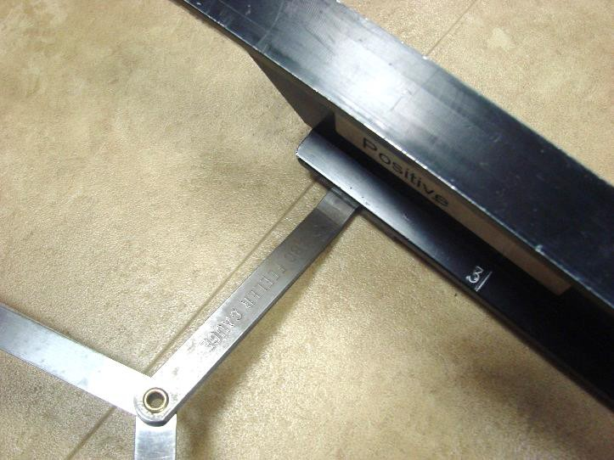

To measure space with the blade, insert it on edge perpendicular to the surface being measured.
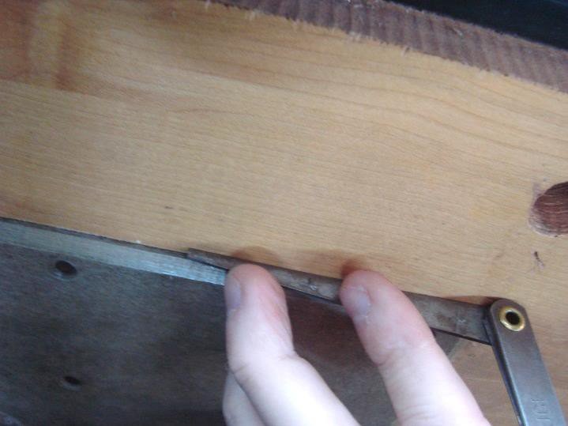

Tape Measure
A 100-feet steel tape is recommended. The long steel tape is used for measuring the length of approaches and lanes, and also can be used for measuring the width of the foul lines, even though they are not more than an inch across.
- Approach Length (measured on new installations only) Specification: Extending back from and exclusive of the foul line, there shall be a clear and level approach not less than 15’ in length.
  - Place the zero end at the foul line.
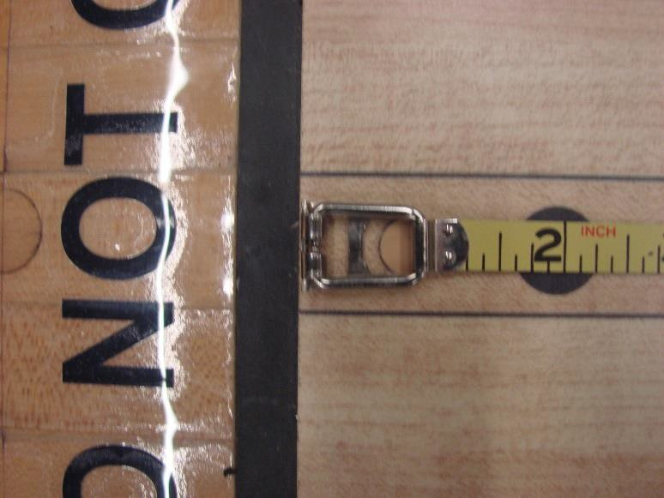

  - Extend the tape measure to the back of the approach
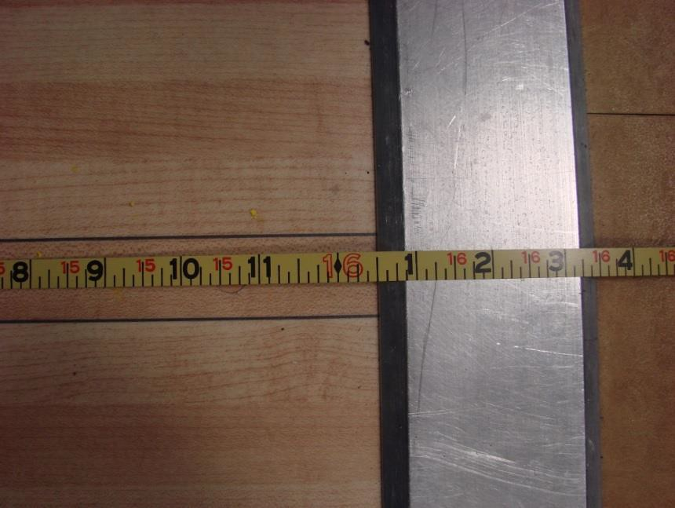

  - Read the measurement at the back of the approach. [Be sure not to include the width of the foul line in your measurement.]

  - If measurement is less than 15’, mark the "NO" box on the form, and record the measurement.
    - If you have a helper, he/she can hold the tape for you. If you have no helper, place a heavy weight near the zero end to keep it in place or use a piece of tape to temporarily hold it while you measure.

Foul Line Width Specification:
The minimum allowed thickness or width of the foul line is 3/8” and the maximum is 1”.
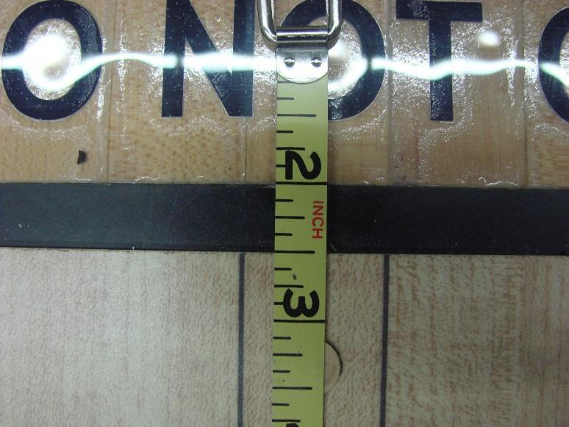
The foul line is distinctly marked or embedded between the lane and approach. It also may be required that the foul line be plainly marked on walls, posts, division boards or any other structure in a bowling establishment in line with the foul line on the lanes.
Place the tape measure over the foul line.
  - Measure its width (thickness).
  - Mark in appropriate spot on report.

Length of Lane
Specification:
It must be 60 feet from the foul line to the center of the No. 1 pin spot with a tolerance of ± 1/2”.

  - Place the zero end of tape measure at foul line’s lane edge. [DO NOT
include width of foul line in measurement.]
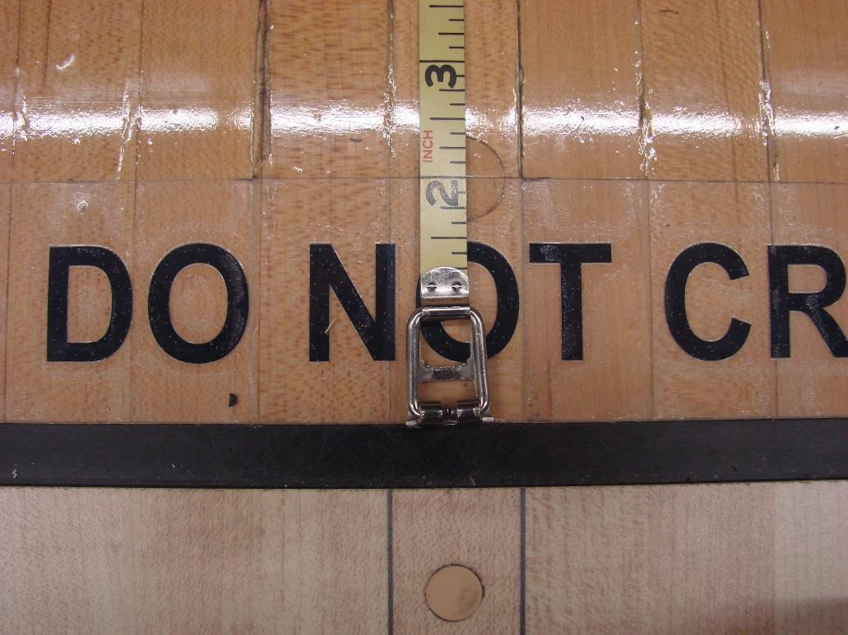

  - Extend tape to center of head pin (1-pin) spot.
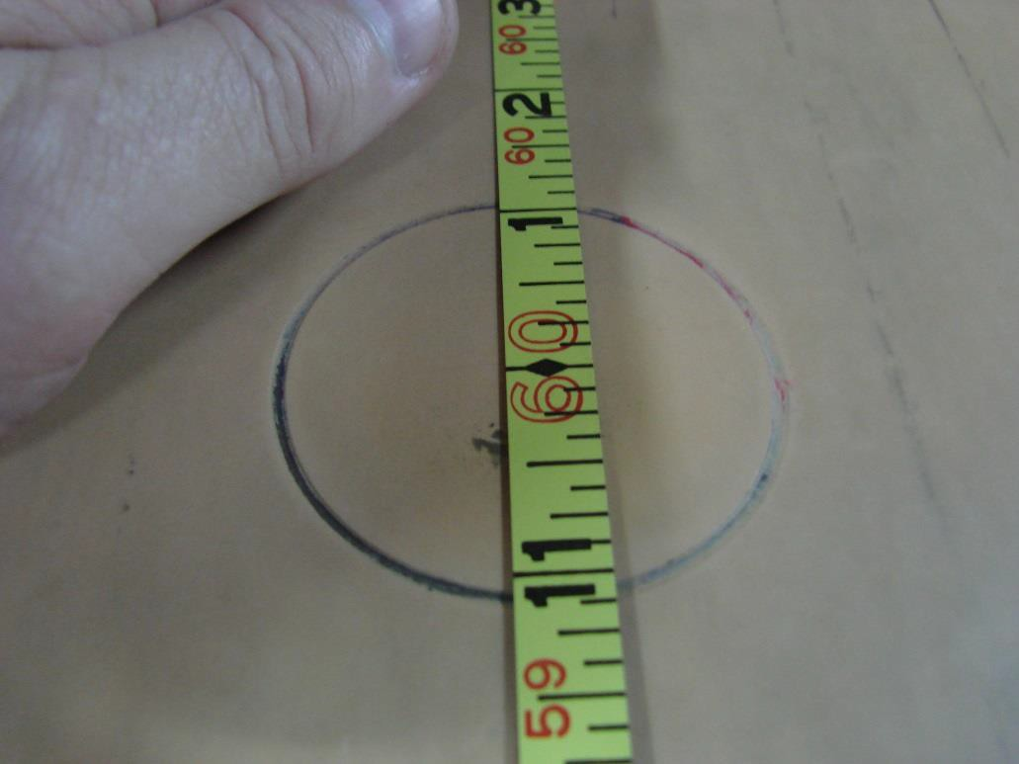

  - Measure its length

  - Mark measurement in appropriate spot on report

Miscellaneous Information

Fiber Edge Strips
Specification:
A fiber strip, measuring not more than 1/2” in thickness, and not less than 1-1/2” deep at the time of installation, may be attached to the side of the pin deck nearest the gutters and shall extend from a point opposite the 1-pin spot to the pit. Such fiber strip must be intact with a smooth, curved edge.
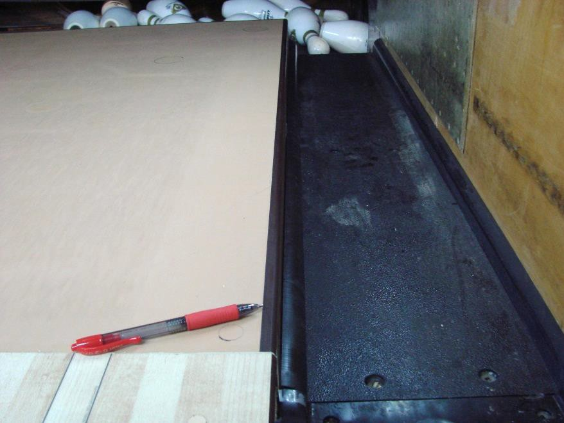
Instruction:
Fiber strips may be attached to the edge of the pin deck, to protect that edge from heavy wear and tear caused by balls and flying pins.

Note the surfaces of the strip are to be flush with the surfaces of the lane – on the top or the side of the lane. The curve on the edge of the strip (the "radius") is intended to avoid having a sharp edge which might damage pins and balls. Similarly, the screw heads are driven into a countersunk hole, so that they do not protrude and possibly damage balls and pins.

When lanes are sanded, the top part of these strips also are sanded. During this process, the radius is gradually removed, and therefore, it must be checked after resurfacing to be sure it is still rounded.

  - Look to see whether fiber strips are attached to the sides of the pin deck. If not, note on the paperwork

  - If there are fiber strips, measure their length, from pit end forward

  - Measure the thickness of the strip

  - Measure the depth of the strip

  - Gently run index finger alongside of strip, to determine whether screw heads are flush with the surface or recessed. If screw heads protrude, note that on inspection report

  - Gently run index finger along edge of strip. Strip edge should be smooth and curved. If the edge is square, rather than curved, note the lane number on item 3 of the Center Inspection Report

[Note: If there are not fiber strips, the outermost boards of the pin deck should be rounded as described above. Examine these edges as indicated in step 6, above.]

Pin spotting
Specification:
In establishments using pin-setting devices, such devices must be checked annually at the time lanes are being checked for certification to determine if pins are spotted correctly.
[All pins must be spotted correctly. Pin base must not be off spot.] After completing all other examinations of the pit end,
- Activate the pin-setting machine to set pins on first cycle.
- Observe the pins on the spots.

- If any pin is set in such a way that more than 1/4" of the outer edge of the pin spot is visible, make a record of it on your form.

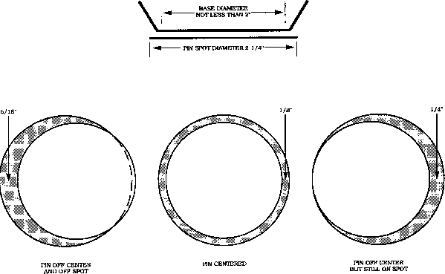

2 1/4” Pin Spot

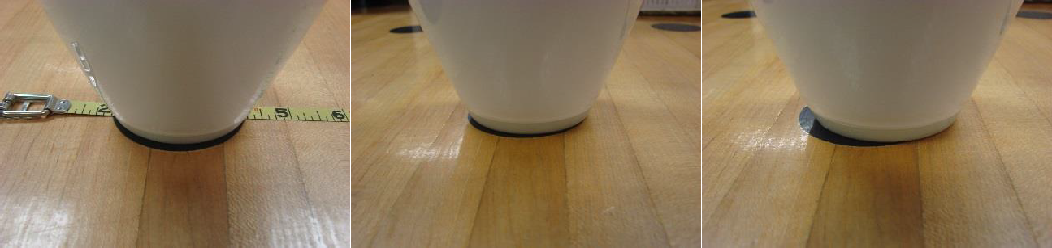

Pin on Center - On Spot Pin Off Center - On Spot Pin Off Spot

Tail Plank Specification:
A tail plank, not to exceed 2” in thickness, may be attached to the rear of the lane.

Instruction:
A tail plank is attached to the rear end of the lane to protect it from the wear and tear of ball and pin impact. It is not a part of the lane, and all lane measurements end at the point where the tail plank meets the end of the lane. On most synthetic pin decks, the tail plank section is designated by a scribe or line as in the photos below.
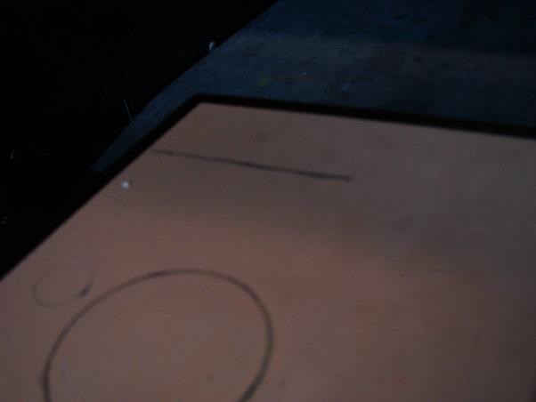

Measure the thickness of the tail plank. If it is greater than 2”, record the fact on the back of the Center Inspection Report, and notify the proprietor that this needs to be corrected.

Note: It is permitted that there be a fiber or phenolic reinforcing strip, on the top rear edge of the tail plank, to protect it. There are several acceptable methods for installing this protective strip, as indicated in the CTF Equipment Specifications and Certifications manual. The effect of the specification is that, with or without a fiber strip, the top surface of the tail plank must be level with or taper down from the surface of the pin deck. It must not be more than 2” in thickness, and it must be rounded.

- Look at the tail plank to determine whether it’s top is level with or slants down from the surface of the lane. If in doubt, place a level or other straight edge so that it rests on the pin deck and extends across the tail plank. The specifications do not indicate any minimum amount of downward taper for the tail plank.

- Run your finger along the top rear edge of the tail plank. It should feel rounded. If not, record this fact on your report.

Foul Detecting Device Specification:
Automatic foul detection devices must be equipped with a visible signal, clearly in the line of sight of the bowler and scorekeeper, and remain illuminated in case of a foul for at least 10 seconds and not more than 15 seconds. A sound signal also may be provided and should be audible at the bowler settee area.
If the center is equipped with automatic foul detection devices.

- Ask the proprietor to turn on the foul detection devices

- Gradually slide an object (such as your finger or a business card) across the center of the foul line from the approach side toward the lane

- Observe whether the foul signal (light) operates and is clearly visible to both the bowler and the scorekeeper

- Time the duration of the signal

- If the device does not operate properly, check the “No” box on item 1 of
the Center Inspection Report, and note the lane number

If the center is not equipped with automatic foul detection devices.

- Determine whether provisions have been made to station a foul judge in a position affording them an unobstructed view of vision of the foul line

- Record your finding on the back page of the Center Inspection Report

Note: When foul detection devices are not available or are temporarily inoperative, the following procedures shall be used to call fouls:

  - In tournament play, management shall assign a foul judge or have the official scorers call fouls.

  - In league play, the opposing team captains shall call fouls or a foul judge shall be appointed.

Failure to provide for the calling of fouls as specified shall disqualify scores bowled for CTF High Score Award consideration.

Targets and Designs – (Measured for New Installations Only) Specification:
Approaches:
  - Measured from the foul line, a maximum of seven guides may be embedded in or stamped on the approach at each of the following distances: 2”-6”; 3’-4’; 6’-7’; 9’-10’; 11’-12’; and 14’-15’.
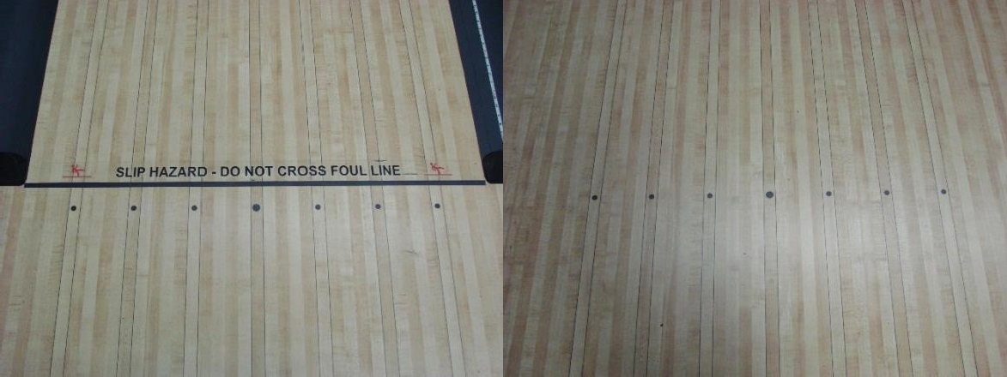
Each series of guides shall be parallel to the foul line and each guide shall be circular in shape and shall not exceed 3/4” in diameter.
All installations in any establishment shall be uniform as to design and measurement on each natural pair of lanes.
Markings are permitted, not required.

Lanes:
- At a point 6’-8’ beyond the foul line, and parallel thereto, there may be embedded in or stamped on the lane a maximum of 10 guides. Each guide shall be uniform, circular in shape, and shall not exceed 3/4” in diameter.
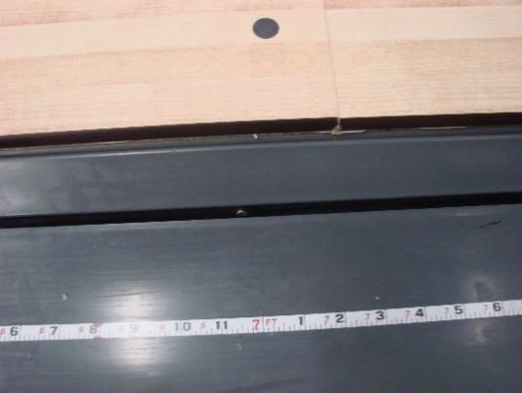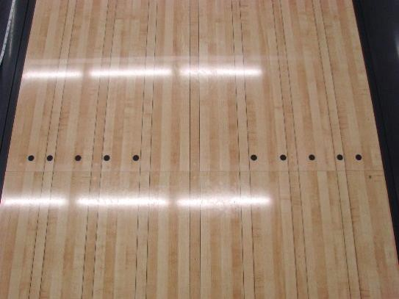

- At a point 12’-16’ beyond the foul line, there may be embedded in or stamped on the lane a maximum of seven targets. Each of the targets shall be uniform and may consist of one or more dowels, darts, diamond, triangles, or rectangular designs. The overall surface covered by each target shall not be more than 1-1/4” in width and 6” in length. Each target must be at equal distances from one another and set in a uniform pattern.
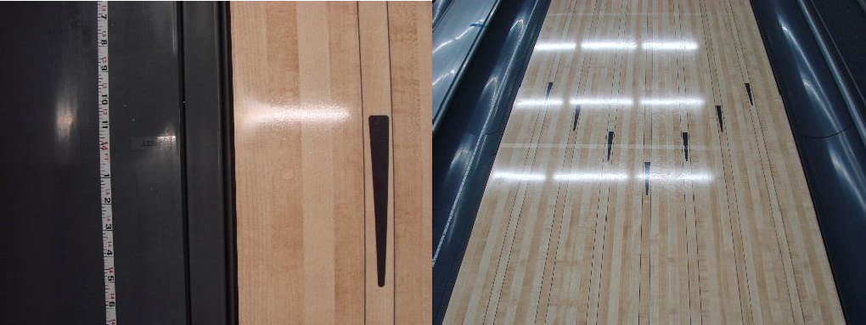

- At a point 33’-44’ beyond the foul line, there may be a maximum of four targets. Each target must be uniform in appearance and shall not be wider than a single board or longer than 36”.

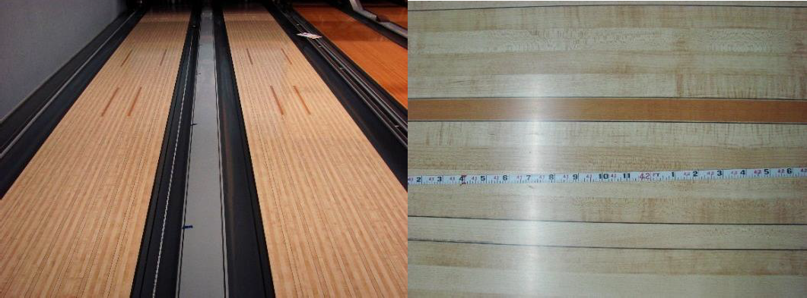

Decals and Advisories:
Advisories about crossing the foul line:
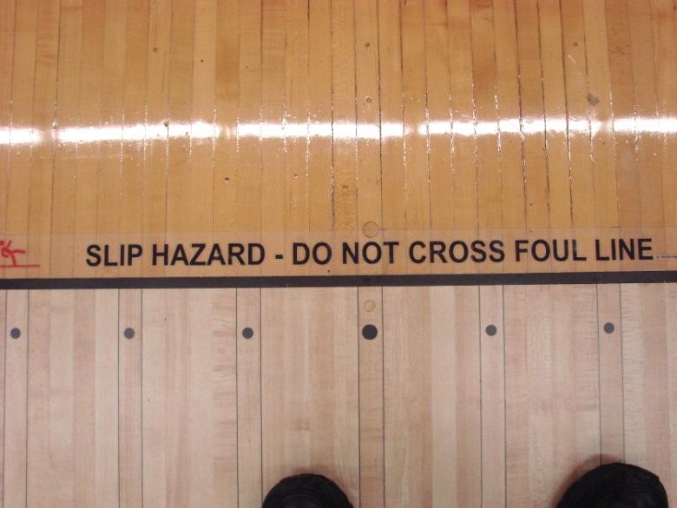

  - On-Lane Decals:

In an area within 2”, but not closer than 1/2” of the foul line, there may be an advisory about crossing the foul line. The wording/lettering/symbols of the advisory may be 1” to 1-1/2” tall. The advisory shall run parallel to, and shall not extend more than 2” from the edge of the foul line. The advisory must be first submitted to the CTF Specifications Department for prior approval.

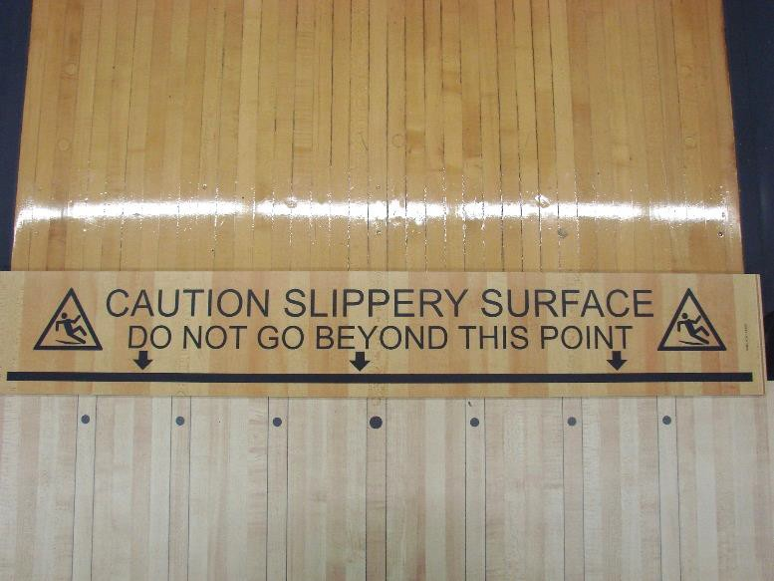

  - Embedded in lane panels:

In an area within 4-3/4” to the foul line, there may be an advisory about crossing the foul line embedded into the lane panel/surface. The wording/lettering of the advisory must be: 1” to 1-1/2” tall, oriented parallel to the foul line, and no more than two lines of text. Any caution or warning symbols may be no larger than 3-1/2” tall by 4” wide. The advisory must be first submitted to the CTF Specifications Department for prior approval.

High Round Gutters

The CTF Equipment Specifications and Certifications Manual makes little mention of the gutters on either side of a lane, except for those near the pin deck. The only provisions for rounded gutters are that they are to run from the foul line to where the square gutters begin, and are to be concave in shape, and at least 1-7/8” deep.
It is not normally a responsibility of the inspector to check the round gutters’ measurements or construction. However, there are exceptions. Most round gutters are made of synthetic materials molded or extruded to form the desired size and shape. At the time of their installation, they are usually fastened in their proper position. Because of wear and vibration, however, gutters may tend to move upward, relative to the rest of the lane. This may cause the edge of the gutter to be higher than the lane surface. In

such cases, they form ridges, or barriers that tend to keep the balls on the lanes. Such ridges or barriers are not acceptable.
The inspector should make a visual check of all gutters in a center. If a gutter edge appears to be level with or above the lane surface, run your finger along it to determine its actual position. If the gutter is too high, it should be recorded in your report, and brought to the attention of the proprietor. A center cannot be certified if these gutters extend above the lane surface.
The Center Inspection Report has no place for recording this information. It should be included in an accompanying narrative report, when appropriate.

Stamps or Stencils

Specification:
Each wood lane shall be stamped or stenciled with the name of the firm or individual who resurfaced each lane, the city in which such firm or individual is located, and the month and year of such resurfacing. The type of finish applied to the lane may also be indicated. (It is acceptable that the end lanes will have the stencil due to the fact a center will have all lanes resurfaced not just a few lanes)

The stamp or stencil shall extend across at least three boards and be placed on the bare wood surface in line with a point 5’ to 7’ in front of the head pin and approximately 2” to 5” from the 7-pin side of the lane.

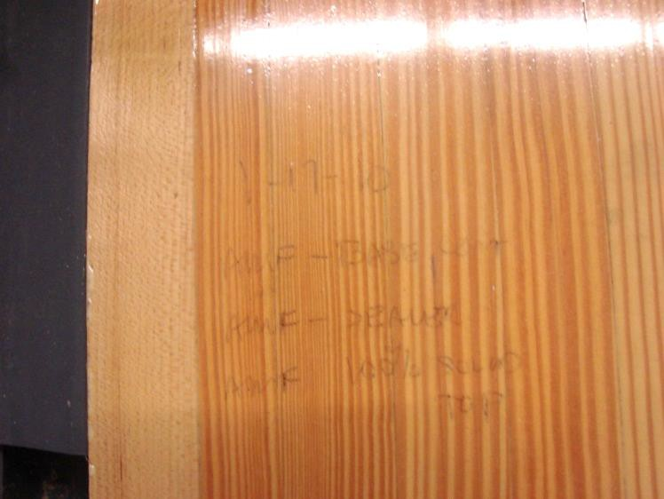

In the case of panelized (synthetic) lane surfaces, each panel shall be stamped or imbedded with a product identification code as assigned by CTF.

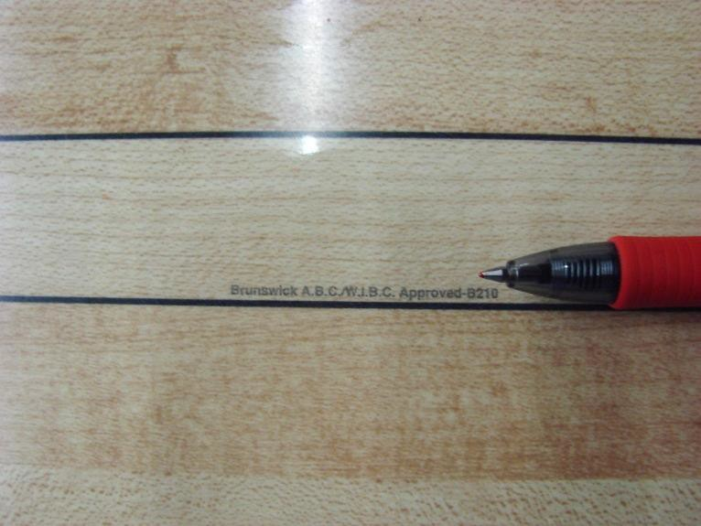

The CTF identification code shall be imbedded in the transparent surface. The stamp is imbedded at a distance of 2-5’ apart. Depending on the manufacturer, the stamp usually is located in 1 of 3 spots: Board R5, L5, or center of lane.

Also, in the case of Guardian Protective Lane Surface, the product identification code assigned by CTF must be stamped or stenciled beneath the area covered by this product. (Note: separate code for lane and pin deck)

Helpful Hints

You and Your Helper
The lane inspection process is much easier, and faster, if the inspector has a helper. The helper need not be a trained inspector, but should be a willing and reliable person. The helper does not do the inspection, but assists the inspector.
Here are some rules regarding the use of a helper:
  - The helper never makes the measurements: the inspector does
  - When working with a tape measure, the helper holds the end of the tape (the "zero end") and holds it where the inspector directs
  - The helper records the readings found by the inspector on the form. Ask your helper to repeat back to you each reading, after writing it on the form, to be sure it is correct
  - It is the inspector’s responsibility to be sure the helper writes the
findings in the right place

Ask the Proprietor
There are several items on the Center Information page of the inspection report that can easily be handled by asking the proprietor. These items

apply to all certification inspections. Make sure to complete this information as accurately as possible so the center records are correct.

Inspecting the Center
When defects are discovered during the inspection, they should be brought to the attention of the proprietor, who can then have the necessary corrections made. A further inspection is necessary to ensure that all repairs have been made. Once corrections are made, and re-inspected to insure all measurements meet CTF specifications, the Local Association Manager shall enter the information online to certify the center.
As an inspector, you will need to sign the report where it says, “Lead Inspector” after the inspection is completed, and obtain the signature of the center owner or authorized representative.
A final note: Even if the inspector is careful, it is likely the measurements recorded during the actual inspection will not be as neat and clear as they should be. So, it is recommended the inspector rewrite all the figures from the "working copy" of the report onto a clean copy, ensuring all entries are neat and legible. The final copy must be given to the Local Association Manager with the necessary signatures. The Association Manager can then process the certification and send a copy of the report to the center management with any discrepancies circled and explained to them. The Local Association Manager must submit a copy to CTF Headquarters
within 10 days of the center’s inspection date. The Local Association must keep the paperwork with the inspection report, and any re-inspection reports, for a minimum of two years.
Annual Inspection
For the annual inspection, complete the following items on the Center Inspection Report:
    - “Center Information” (bottom half only if different than previous inspection)
    - Section A, Items 1 - 8
    - Section C, Items 20 – 24 (exclude lengthwise tilt, complete items 23 - 24 depending on lane surface)
    - Report Authorization

New, Replaced or Resurfaced
In addition to items for the annual inspection, complete the following items on the report for new centers, or centers that have replaced or resurfaced their lanes:
    - Section B, Items 9-19 (only inspect affected areas)
    - Lengthwise Tilt for items 20-24 (23-24 depending on lane surface)

Note: The lengthwise tilt measurement is only for new center installation or replacement of lanes and cribbing. This measurement is to be taken between the L18 and R18 boards (turn level 90 degrees from the crosswise measurement, parallel to the boards). The level should not cross seams or be taken on any dowels.

Completing the Report
The CTF Center Inspection Report serves both as an application for certification and a detailed report of the inspection itself. The report is broken down into the following sections:
- Center Information
- Section A: Annual Specifications
- Section B: Additional Specifications
- Section C: Lane Topography
- Report Authorization Topography

Discuss Findings with Center Management
Your inspection is a confidential matter between you, the local association,
CTF and the proprietor/management.
To maintain a high degree of confidentiality, the results of the inspection should be discussed in the privacy of the proprietor/manager’s office or another suitable place where customers or other employees cannot overhear and possibly misinterpret the conversation.

Section IV - Guidelines for Inspectors, Public Relations

Guidelines
It is extremely important all inspectors do their jobs in a manner that is consistent, competent, confident and professional. This applies to all the technical aspects of your job. But it means more than just that.
It means being fair and impartial. It means reporting your findings with only one objective in mind: to uphold the standards of the bowling game and the integrity of your position as a lane inspector. Each inspector should be capable of doing a competent job on the lanes.

There will, almost inevitably, be times when you, as an inspector, will be on the receiving end of someone's bad temper. Or, perhaps worse, find someone begging for "just a little flexibility." You need to do all you can to keep these situations from arising, but, when they do, you need to be able to deal with them. The inspector needs to be not only a technically competent professional, but also a goodwill ambassador, representing the cause of fair standards, equally applied. You are not automatically an adversary of proprietors and high-scoring bowlers alike. Your role is to help both the proprietor and the bowler to accept and abide by the standards that benefit the entire bowling family.

Two important things for inspectors as goodwill ambassadors: One is that you can help proprietors who do not know the technical details to understand the importance of maintaining standards and often you can help them understand how to keep things in compliance with the rules. The second is that, since proprietors often have a lot on their minds, you should understand their time should not be wasted, and you should understand if they don’t see "what the fuss is all about."

The more a proprietor understands what you are doing, the more likely they will accept your findings. A proprietor may honestly be reluctant to accept your statement that the lanes are noncompliant if they do not know how you came to your conclusion. If there is such a problem, tell them you’ll be happy to go over it with them, on the lanes, so that they can see the issue. If you are competent and confident, they will more likely be convinced.

But what about those occasions when your findings are disappointing to the proprietor? While this should not be the rule, you should be prepared for such a thing to happen. The competent inspector reports accurately and honestly what they find, and stands behind their report.

These recommendations for goodwill ambassadors can require that you devote time to this business beyond what is required for inspections themselves. But the payoff can make your time investment well worthwhile.

In addition to these suggestions, you are encouraged to understand and abide by the following "rules of etiquette" that can help you maintain status, and respect, in the eyes of those you deal with.

Important Reminders for Inspectors

Never:
  - Cross the foul line without the proprietor’s permission
  - Discuss how the inspection is going with anyone other than the proprietor
  - Take up more of the proprietor’s time than necessary
  - Assume the proprietor knows all about certification inspections, specifications, etc.
  - Accuse the proprietor of deliberate violation of any rules
  - Withhold from the proprietor any information that may be helpful
  - Tell the proprietor how to run the center
  - Interfere with the center’s normal business activity any more than
necessary
  - "Bad-mouth" a proprietor/ manager/ center
  - Assume a superior or arrogant attitude in dealing with a proprietor or center staff
  - Refuse a legitimate request for help, in terms of correcting unsatisfactory conditions
  - Fail to be on time for inspections-or notify the proprietor if you are unavoidably detained
  - Be intimidated by anyone who dislikes your findings
Always:
  - Contact the proprietor and explain why you are there
  - Request permission to make the inspection
  - Receive permission before crossing the foul line
  - Invite the person in charge, or a designee, to observe the inspection
  - Explain any procedures, if the proprietor wants to know

  - Explain the form(s) you are completing, their purpose, and who gets copies
  - Get correct data-spelling of names, addresses, phone number
  - Answer proprietor’s questions about your inspection method and findings
  - If asked, give the proprietor the benefit of your knowledge of specifications
  - Keep to the absolute minimum your interference with the normal activity of the center
  - Remember that the proprietor has many things to worry about other than your inspection
  - Be prompt, efficient and professional in carrying out inspections

Section V - Lane Maintenance and Conditioning

Why Are Lanes "Oiled"?
The primary reason lanes are oiled is to reduce the friction between the ball and the lane. This serves the proprietor by preserving the finish on the lanes and protecting the surface.

How should oil be distributed on the lane?
CTF’s rules states:
If oil is used, it shall meet specifications and must comply with the following:
Oil must be distributed from edgeboard to edgeboard for the entire distance that oil is applied. (In the application of the rule, buffing the lane is considered applying oil.) Following any application of oil, the oiled portion of the lane requires a minimum of 3 units of oil at all points on the lane surface.
[Note: CTF considers the buffed area as being a part of the overall oiled area. Therefore, the buffed area must also contain a minimum of 3 units of oil at all points.]
A unit is defined as a measurement of oil film thickness equivalent to .0167 cubic centimeters of oil per square foot of lane surface as measured by
CTF approved lane oil measuring equipment.

Any stripping (cleaning) of oil from the lanes must be uniform from edgeboard to edgeboard and at least from the headpin to the distance to which oil has been applied.

Lane Oil Inspection Requirements

- Inspect only on a condition that is being used for CTF certified league/tournament competition
- A minimum of one complying inspection per season shall be required from each center (August 1 through July 31)
- Never inspect during the center’s annual certification inspection
- Inspect whenever a condition is reported as questionable or noncomplying
- DO NOT schedule or announce inspections to the centers in advance

Lane Dressing inspections are to be unannounced inspections of randomly selected lanes including measurement of lane oil applied before bowling.
Note: Although there is a requirement of one inspection per year, additional inspections can be performed at the discretion of the local association.
Should an inspection unveil noncompliance, additional inspections should be performed until compliance is met.

Lane Dressing Inspection Procedure

Upon arriving at the bowling center, contact the manager or person in charge of the center. Explain the purpose of your visit and ask for permission to make the inspection. You also may request a sample of the center’s lane oil if you have reason to believe the required additive has not been used. Do not interfere with the normal operation of the bowling center.
Once you have obtained permission to make the inspection, you can explain the CTF Lane Dressing Inspection Report, which can be found on tenpincanada.com. Point out that a separate report is completed every time an inspection is made and the center will be given an opportunity to review the report and make any written comments deemed necessary.

It also may be possible to complete a portion of the report such as when the lanes were last oiled/stripped. When you are ready to begin the actual inspection, ask the individual in charge if he/she or another individual, such

as the lane maintenance person, would care to accompany you on the inspection.
Inspections must be unscheduled and unannounced, i.e., the center must not know in advance when you will inspect.
Inspections must be performed before any bowling has taken place on freshly oiled lanes, i.e. zero lineage. Inspections do not need to be done on freshly stripped lanes.
- Select at least two (2) pairs of lanes – not adjoining lanes – and inspect at least one lane of each pair
- Measure the total distance that was oiled (this include both the oiled and buffed distance). The distance is determined by each individual proprietor. They can oil the lane to whatever distance they choose
- All readings are to be taken from the 10-pin side.
1. One reading must be taken at 3 feet prior to the end of the oiled/buffed area
The tape should verify a minimum of 3 units on all boards from edgeboard to edgeboard for the entire distance oiled

Note: A minimum of one tape is required from 2 different lanes. This does not limit an inspector from taking as many tapes as deemed necessary to ensure the lanes have the minimum requirement of 3 units on every board. Tapes should NOT be taken across footprints or other places where the oil has been disturbed.
Complete a CTF Lane Dressing Inspection Report form. A representative of the center and the lead inspector should sign the report form.
- Lane Dressing Inspection Report (LDIR) must be submitted to CTF
within 10 days by emailing to
ctf@tenpincanadal.com.

Note: The graph should include the Center’s name and certification number, Association name and number, date of tape, lane number, and the distance of the tape.
- Association manager retains one copy (report and tapes are to be kept for a minimum of two years), and one copy is given to the center.

Performing the Lane Dressing Inspection (SOP)

Introduction
There are three parts to the lane dressing inspection procedure to determine the distribution of oil:
- VISUAL - Note, measure and record distance oiled

- TAKE-UP - Remove a sample of oil (1” wide) on lane surface by encapsulating it between two pieces of 3M Lane Tape

- READER - Measures the amount of oil board by board by evaluating the amount of ultraviolet additive in the oil
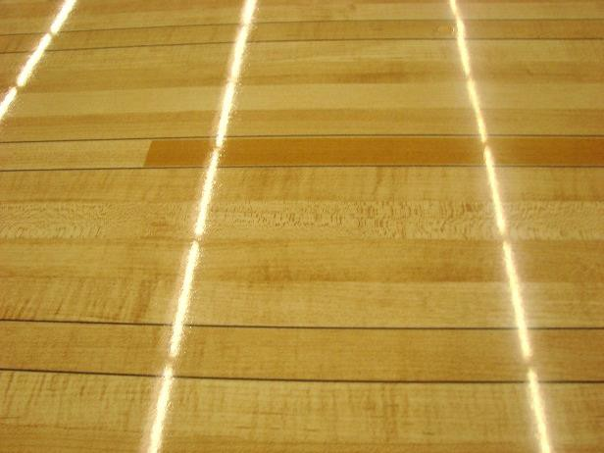

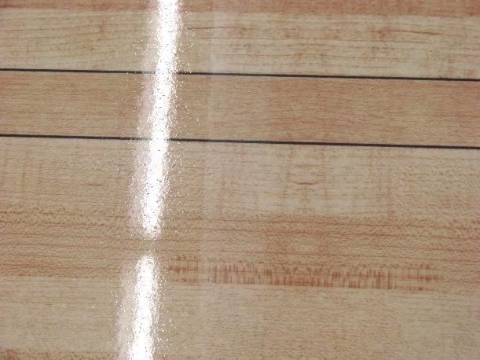

In most cases, proper execution of the tape take-up device and the visual tests will reveal whether oil applied to the lane surface complies with requirements.

Finding the End of the Pattern

To see how to find the end of the pattern, please click here.

Visual Observation
The inspector observes visually the oil line and measures (with a 100’ tape)
the distance this line is from the foul line.
  - Utilizing a 100’ tape, measure the distance from the foul line to the point at which the applied oil stops
o This is to include the buffed area
  - Report the findings on the Lane Oil Inspection Report

Take-Up Device and Reader

The take-up device and reader are designed to permanently collect oil between two pieces of UV-free scotch tape and then read the amount of oil present on the lane surface, provided the oil contains an ultraviolet- sensitive additive in compliance with CTF specifications. The system has two separate components:
  - Tape Take–up device

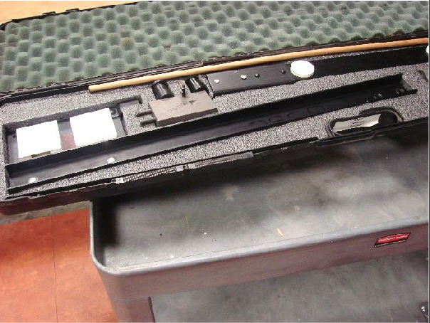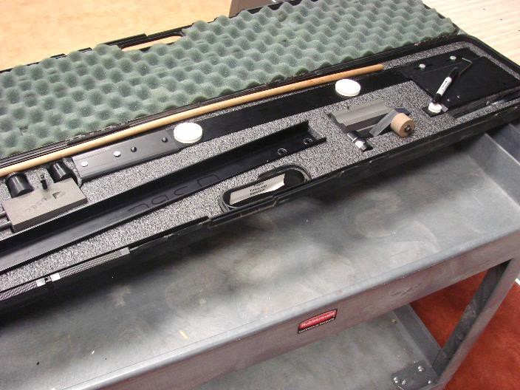

  - Computer Lane Monitor (Reader)
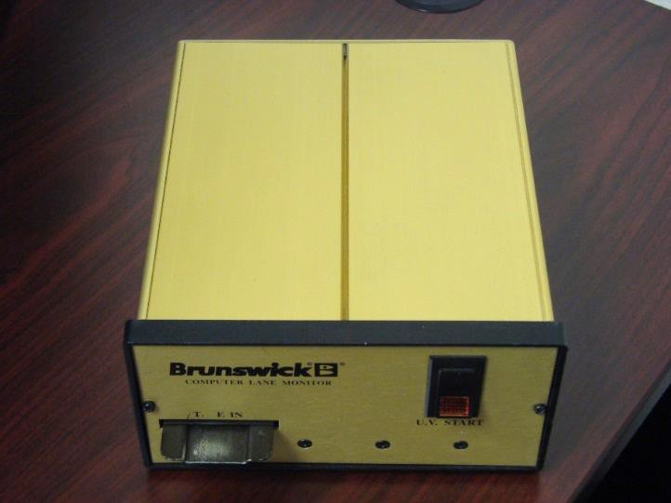

The tape take-up device consists of an aluminum track, two sliding tape carriages and a wooden push-rod. The device accepts one roll of special 1" wide transparent tape on each carriage. The applicator carriage is pushed from one side of the lane to the other, adhering a length of tape to the lane surface.

The oil from the lane is absorbed by the adhesive in the tape. When the second lifter carriage is pushed across the lane, which lifts the first length of tape and laminates it to a second length of tape. The oil is trapped between the two layers of tape which can be run through the reader to measure the oil quantity.

All tapes must include an identification label with the following information (use of a black marker on the leader side of the edgeboard):
- Date
- Certification No. or center name
- Lane No.
- Distance
- Inspector/Center Representative(s) Initials

If using a label, the label must be sealed between the tapes. This is accomplished by placing the label on the first board before running the first tape across the lane to pick up the oil. Then, when the second tape is run across the lane, the oil and the label will get trapped between the 2 tapes making a permanent label.

The edge of the lane must be marked on the tape. All tapes should be taken starting from the 10-pin side with the identification label placed on the edgeboard or by marking the edge board with some type of marker or pen.

NOTE: Avoid taking tapes where footprints or other similar marks appear in the oil as this can affect the results.

Upon request from the proprietor/manager, it will be necessary to take a second set of tapes. These tapes should be taken at the same time as the first set of tapes and approximately 3” from the first set. They should be identified and given to the center representative.

Tools:
The take-up device and computer lane monitor system can be purchased directly from Brunswick. You can either contact them by phone at 800-937-2695 or by email at inquiries@brunswickbowling.com. You can purchase 3M lane tape from
the CTF Store on-line or at most reputable bowling supply companies such as Buffa, Striker Bowling Solutions or Associated Bowling.

Taping the Lane

- Be sure the rubber roller is dry and free of oil. If not, clean with rubbing alcohol
- Combine tracks. Use Nut driver to tighten tracks together
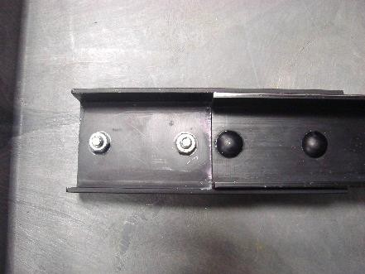
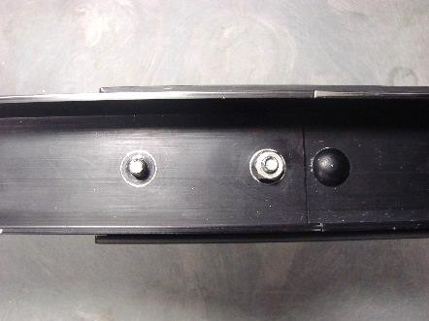
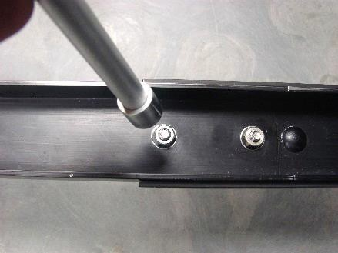

- Use Allen wrench to tighten post
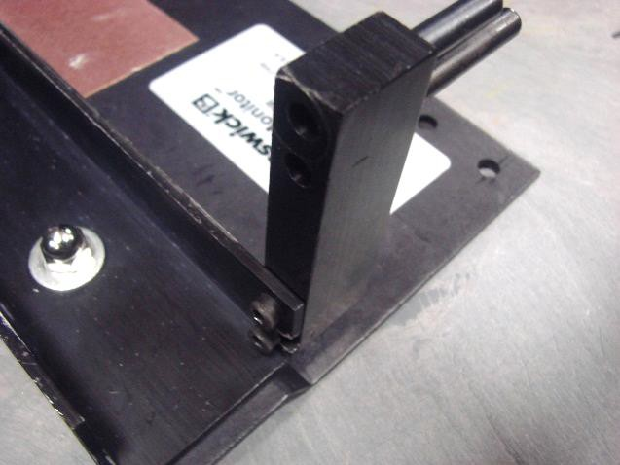
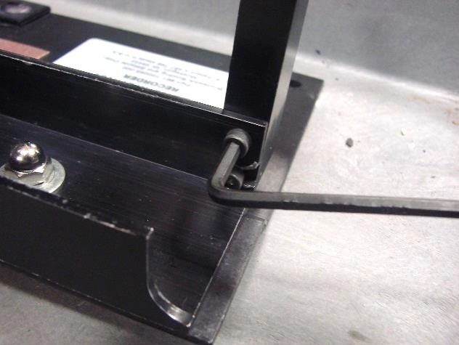

- Place track at foul line to verify that the device is snugged to the edge of the lane on both sides. Use Nut driver to adjust track

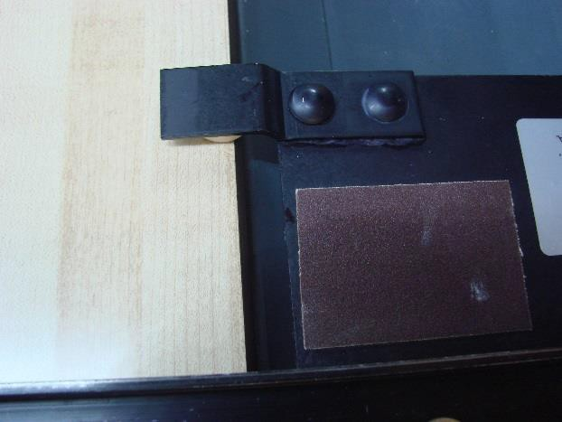
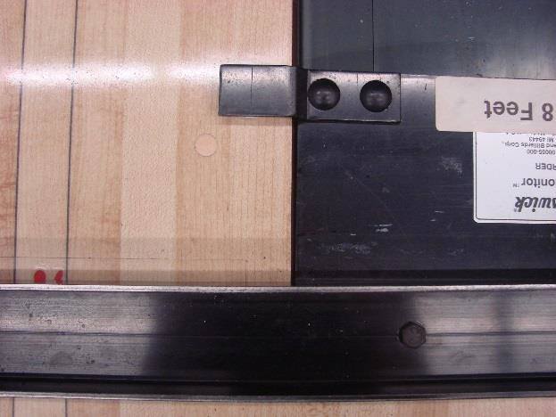

- Place one roll of tape to each carriage. Sticky side of tape (down) as tape will go under each roller.
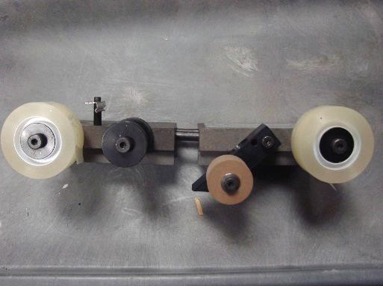
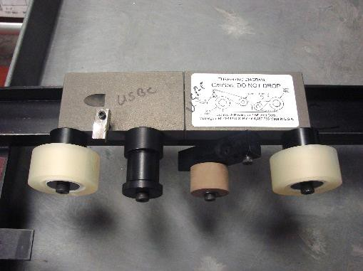
Loading the tape

To see how to load the tape on the sleds, please click here.

- Pull first tape under and around roller and lay on top off roll

- Pull second tape under and around roller and lay on top of first tape
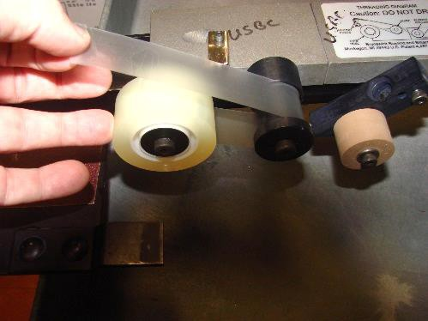
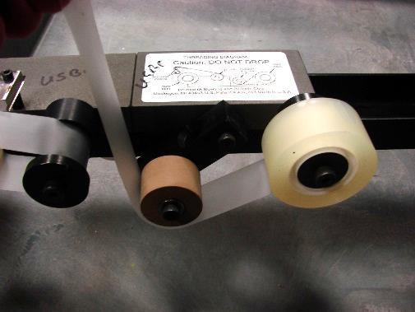

- Cut combined tape to get even edge.
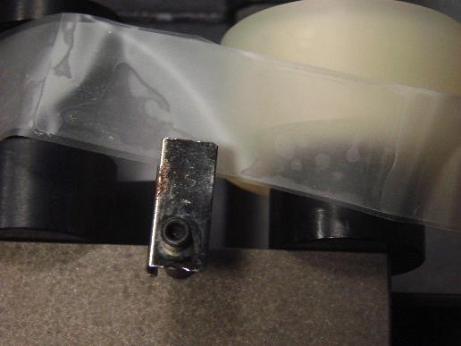

- Prep carriages by threading tape and fasten to post (See diagram on carriage unit also)
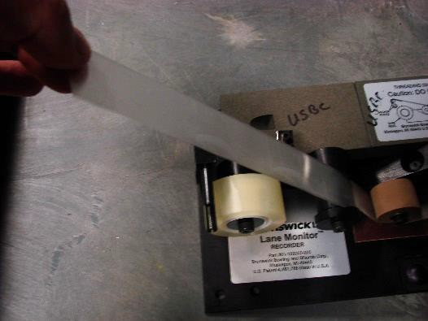
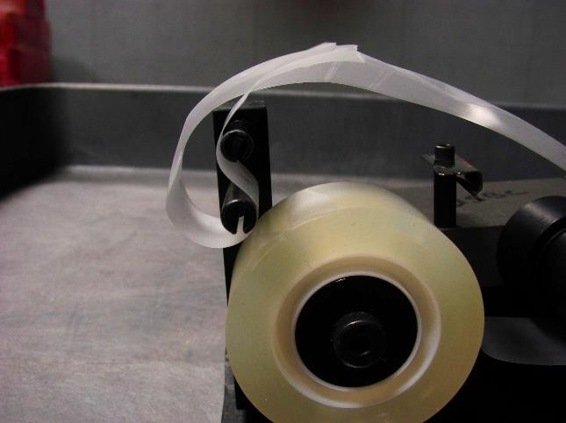
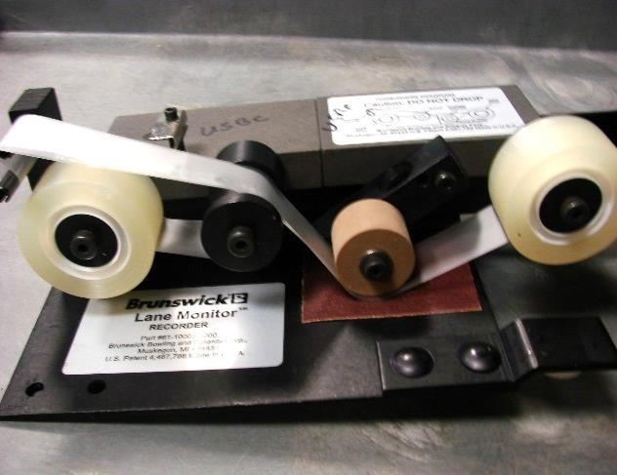
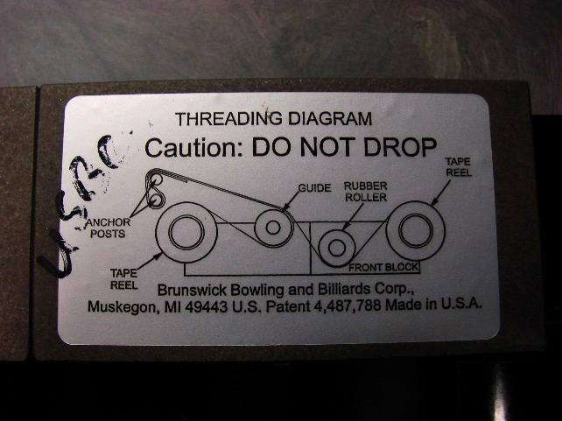

Marking the Edge of the Lane

To see how to mark the edge of the lane, please click here.

To see how to take the tape using paper to mark the lane edge, please click

here.

To see how to take the tape using a marker to mark the lane edge, please click here.

- Lay the device across the lane in the first reading location with the anchor post assembly on the 10-pin side of the lane

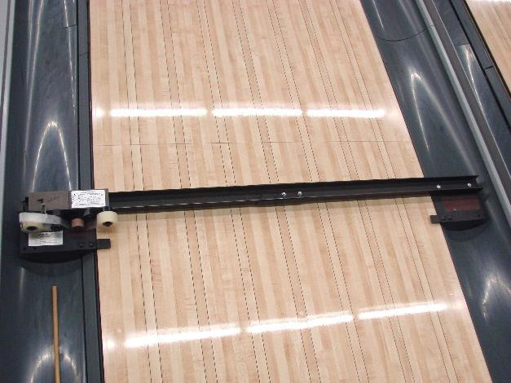

- Place the mated carriage assembly in the track with the lifter carriage tight against the anchor post. The tape reels and the rubber roller will be on the starting location for taking the tape, which should be on the outer edge of the first board

- Place a 1” square of thin paper tape on the outer edge of BOARD NO. 1 to mark the 10-pin edge of the lane or use black marker to mark tape where the edge of lane is located after first tape has been pushed across the lane (see
#14)
Caution: Do not cover any part of BOARD NO.2.

- Insert the wooden push-rod into the hole on the pivot arm of the applicator carriage and slowly push the carriage across the lane. This will cause a length of transparent tape to be adhered across the lane surface

Caution: Hold the rod at the correct angle (approximately 45-degree angle); too high or too low may cause problems

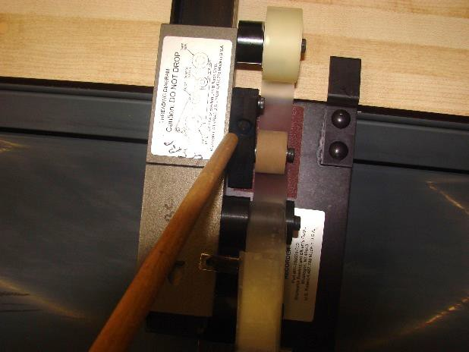

- Mark the edge board and lane information on leader side of tape (Not on lane)
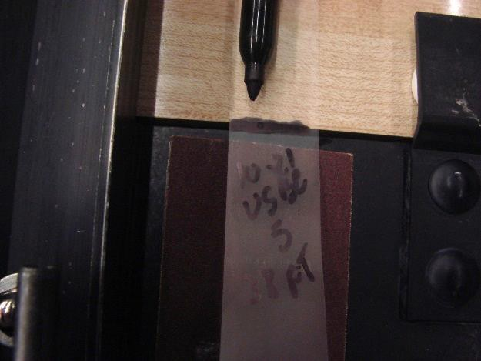

- Insert the push-rod into the recess on top of the lifter carriage and slowly push the carriage across the lane until it fully connects with the applicator carriage

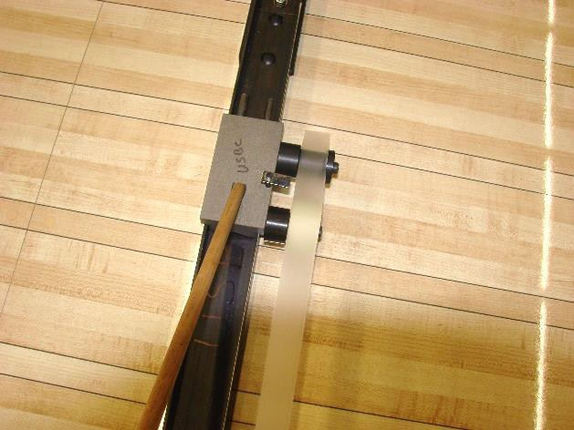

The final tape should now be a double thickness and the width of a single piece of tape. If the tape is wider then a single piece of tape, one of the rolls of tape might not be pushed all the way on the hub holding the spool of tape. Any misalignment of the tape can be fixed with correct positioning of the tape rolls on the two hubs. If the spool of tape wants to move on the hub, add a piece of tape onto the hub under the spool of tape to secure in place. The final tape will be suspended above the lane with the adhesive sides together. The oil should have been completely removed from the lane

- Raise the doubled tape slightly, nick it with the tape cutter, and tear it across.
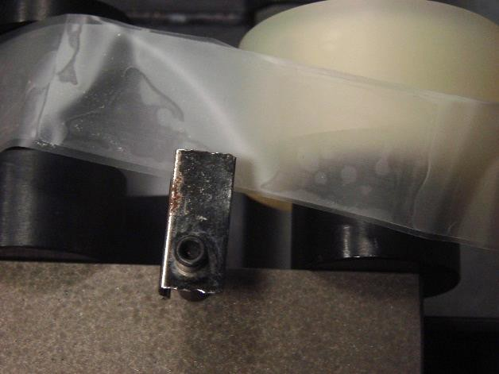

Removing the Tape

To see how to remove the tape, please click here.

- Raise the torn end upward at a 45-degree angle to free the tape from the anchor post, being careful to keep the tape clear of the lane surface so oil does not get onto the tape

- Pick up the connected carriages and return them to the starting position. Caution: If the rubber wheel makes direct contact with the oiled lane, it must be cleaned before the next use
- Repeat for additional tapes

- Put tapes on side for later reading
  - If the two tapes are mismatched (up to 1/8” of difference), trim along both edges to remove the overhang
  - If the two tapes are mismatched (more than 1/8” of difference), a new tape will have to be taken
  - Severely curled tape should be straightened out
  - If there is oil on the outside surfaces of the tape, it must be wiped dry so it does not affect the final readings
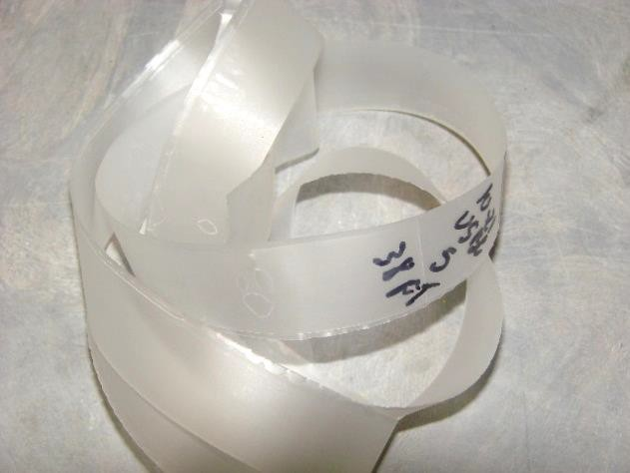

Bad Tape
To see what a bad tape looks like, please click here.

Storing the Tape
For directions on how to store the tape, please click here.

Reading the Tapes
- If a tape reader is available at the time of the inspection, tapes should be read and recorded

- If the association has a tape reader but it is not available for the inspection, the tapes should be read and recorded as soon as possible

- If a tape reader is not available, try to locate a reader from a neighboring association

- If that is not available, then the tapes are sent by the Association Manager to the CTF Certification Department. CTF advises that the tapes be folded gently with no creases and be sent in a regular envelope

All official tapes must be retained by the Association Manager for a minimum period of two years from the date they were taken unless:
  - There is reason to believe the required additive was not in the oil
  - A reader is not available and a regional site cannot be contacted
  - A center refuses to allow the inspection to take place

Should any of the above occur, contact CTF Certification Department for guidance.

Computer Reader: (Shown Gold Box)

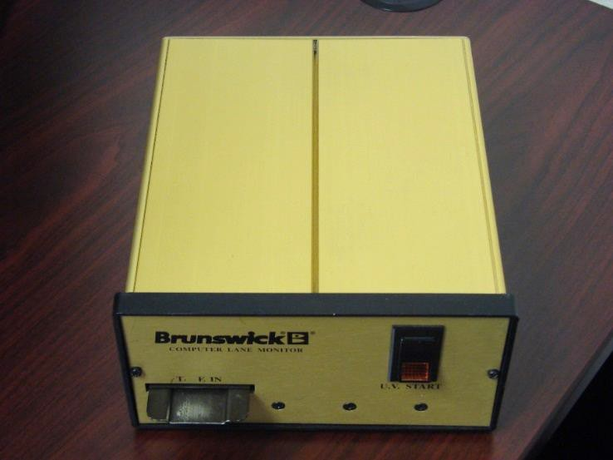

For those who have the new Computer Lane Monitor, please refer to the user guide for operation.

Should you have any problems, contact Brunswick directly at 800-937-2695 as they offer the only technical support for this equipment.

Lane Dressing Inspection Report (LDIR)

The Lane Dressing Inspection Report is to be completed on every occasion when a lane oil inspection is made. You can find the LDIR on the CTF website in the Center Certification section.

It is imperative that all information requested be obtained and provided on the report. Most of this information can be obtained from the center representative in charge at the time of the inspection. If any of the information requested is not available at the time of your inspection, do not assume or submit data based on your opinion.

Attention should be directed to the information regarding the oiling of the
lane, the visual observation, and the inspector’s comments.

Also, on the right portion of this report is the space for "Tape Reading" information. In this area, report the reader’s name, the reader’s association number, the reader’s telephone number and the appropriate date, the lanes on which the tape was pulled, the distance from the foul line that the tape was taken and the exact reading from board 2 on the 10-pin side to board 2 on the 7-pin side.

Under "Inspector’s Comments," provide pertinent information relative to
your findings. (Ex.: air conditioner or heater not working appropriately)

Center management or personnel also should be invited to offer their comments, though their comments may not agree with your findings or conclusions.

Have the proprietor or center representative sign the report. His/her signature on the LDIR attests only to the fact that a copy of the report was received.

Note: Original inspection report must be submitted to CTF
Certification Department within 10 days.

*All tape readings must be submitted to CTF Center Inspection Coordinator.

Whenever any area required for an inspection does not meet CTF
rules/specifications:

  - Association manager retains one copy (report and tapes are to be kept for two years)
  - One copy of report and copy of tape readings is given to the center

  - One copy of report and copy of tape readings is given to CTF

Note: that a copy of the report and tape reading can be the graph with the following information:

    - Center name and certification number
    - Association Number and Name
    - Date of inspection

Note: This does not include maintenance inspections. For example, the local inspector working with a proprietor to correct a non- complying condition, and/or an inspector working with a proprietor to improve the existing condition. In these instances, a report is not required to be filed with CTF.

Section VI - Glossary and Working with Fractions

Glossary

 | Word | Definition
 | Approach | The area, a minimum of 15 feet long, on which a player walks to the foul line
 | Arrows | Sighting targets imbedded in the lane to help a player align the starting position on the approach with the ball path to the pocket. Spaced on every fifth board across the lane
 | Boards | The individual boards which make up a lane. Normally a lane has 39 boards. Also, the aiming target in the delivery, such as "playing the 10th board," meaning the bowler rolls the ball over a designated point on the 10th board from the gutter.  Boards are counted to the center board. Thus, R10 is the 10th board from the right gutter (10-pin side) and L10 is the 10th board from the left gutter (7-pin side)

Certification | The issuance of an annual certificate to bowling centers after a successful check of measurements and maintenance of the approach, foul line, gutters, lane, pin spots and pit area
Channel | Drop-off area on either side of a lane. Also called the gutter
Complete Inspection  Conditioner | All measurements performed and recorded per Center Inspection Report  Also called oil or lane oil. The conditioner is applied to the front area of the lane to protect the surface. It also can be selectively applied on a lane to have drastic influence on the scoring potential
Crowning | Raising of the center of a lane, caused by expansion of boards. The term is also used referring to applying extra oil in the center of the lane
Decks | Pin decks
Dowels | Wooden pegs/discs imbedded flush in the approach and lanes to cover screw heads
Dovetails  Dressing | Area on lane where maple and pine boards are joined. Also, known as splice  See oil
Durometer  Endo | An instrument to test the hardness of materials  The process to calibrate a level
Finish | A clear, hard transparent film or coating applied to a wood lane after it has been resurfaced
Gutter | Rounded channel on either side of lane. Also known as channel. Also, flat gutters are used in the pin deck area
Heads/Headers | First 15-17 feet of a lane made up of hard maple boards to absorb the impact of the ball hitting the lane

High Board | An expanded or loose board in a lane that can cause a ball to veer from its intended course
Kickbacks | The divisions between lanes at the pin deck area onto which kickback plates are affixed. The kickbacks are the wood components
Kickback plates | The hard-volcanized fiber or hard protective plastic plate which covers the wood kickback to protect it from impacts from the pins. They are from 1/8” to 3/16” thick
Lacquer | A coating liquid that dries rapidly by solvent evaporation and contains cellulose esters or ethers as the basic film-forming ingredients
Maple  Oil | A very hard and durable wood used in construction of approaches, headers, pin decks and tenpins  The product that is applied to the surface of a lane to prevent damage from bowling ball friction
Partial Inspection | Only those measurements preceded by an asterisk (*) on Certification Inspection Form. Syn. Annual inspection
Pin Deck | Area of lane where pins are spotted
Pine | A soft wood that is used in the mid-portion of a bowling lane between the header and the pin deck. This is the area of the lane where the ball is rolling
Polyurethane | A moisture-or chemically-reactive resin of the diisocyanate family. A very hard finish
Resurface | Removal of finish from a lane by sanding to the bare wood in preparation for recoating the lane
Sanding | The procedure used on an annual or semi-annual basis to remove old lane coating and level the wood lanes
Splice | Same as dovetails
Spot | The sighting or target area on the lane where the player aims

Supplemental Inspection | Only those measurements affected by work/repairs performed that necessitate an additional inspection
Synthetic Lane | A lane surface that is covered with a high-pressure laminate or some other plastic material
Tail Plank | Board affixed to the back edge of the pin deck
Urethane | See Polyurethane
Water-Based | A generic type of lane coating that uses water as a solvent

Working with Fractions

You will find it necessary to work simple addition problems, including fractions, to record some of the measurements required for the lane certification inspection. In case you need to brush up on these procedures, here is a brief review.

Function | Examples / Instructions
Adding fractions with the Same Denominator (Bottom Number) | Example: 3/16 + 3/16 = 3/8  - Add the numerators (top numbers) across (3 + 3  =6)  - Carry the denominators across-do not add.  - Reduce the answer to its lowest terms by dividing both numerator and denominator by the largest number that will divide evenly into both (in the example, it’s 2)
Adding Fractions with Different Denominators | Example: 5/8 + 3/16 = 10/16 + 3/16 = 13/16  - Find the lowest common denominator (number that both denominators will divide into evenly). (In the example, it’s 16.)  - For fractions with a denominator other than the lowest common denominator (in the example, 5/8),  multiply the numerator by the same factor used to

convert the original denominator into the new one. (In
the example, it’s 2.)

Another example: 3/4 + 1/8 = 6/8 + 1/8 = 7/8
Converting "Improper" Fractions into "Mixed Numbers" | Example: 5/8 + 3/8 + 1/8 = 9/8 = 1-1/8  - Add the fractions as directed in A or B above.  - The answer, 9/8, is greater than 1 (8/8) and thus is an "improper fraction."  - Convert it into a "mixed number" by dividing the numerator by the denominator (9÷8= 1-1/8).
Adding Mixed Numbers and Fractions | Example: 59 5/8 + 3/16 + 5/16 = 10/16 + 3/16 + 5/16 = 18/16 = 1-2/16 = 1-1/8  59+ 1 1/8 = 60-1/8  - Setting aside the whole number (in the example 59), add the fractions as directed in A, B and C above.  - Add the sum of the fractions to the whole number (59 + 1-1/8).
Reduction of Fractions | 1/32
 | 2/32 = 1/16
 | 3/32
 | 4/32 = 2/16 = 1/8
 | 5/32
 | 6/32 = 3/16
 | 7/32
 | 8/32=4/16=2/8= 1/4
 | 9/32
 | 10/32 = 5/16
 | 11/32
 | 12/32 = 6/16 = 3/8
 | 13/32
 | 14/32 = 7/16
 | 15/32
 | 16/32=8/16=4/8= 1/2
 | 17/32
 | 18/32 = 9/16

19/32
20/32 = 10/16 = 5/8
21/32
22/32= 11/16
23/32
24/32 = 12/16 = 6/8 = 3/4
25/32
26/32 = 13/16
27/32
28/32 = 14/16 = 7/8
29/32
30/32 = 15/16
31/32

Section VII – Video Links
Center Inspection Measurements Crosswise tilt of the pin deck Crosswise tilt of the lane

Lengthwise tilt of the pin deck Lengthwise tilt of the lane Crowns and Depressions
Measuring synthetic panel drop offs Measuring the depth of the flat gutter Measuring the pit depth
Measuring the pit length
Measuring the distance from kickback plate to kickback plate Measuring the lane width
Measuring the gutter width Measuring pin spot location

Lane Dressing Inspections Finding the end of the pattern Loading the tape

Marking the Edge of the Lane
Taking the Tape 1 (Mark lane edge with paper) Taking the Tape 2 (Mark lane edge with a marker) Removing the Tape
Cutting the leader Storing the Tape Bad Tape

Bonus: How to Level a Lane

