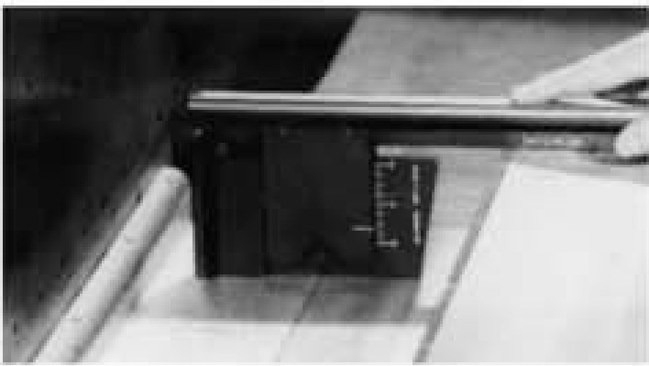

CANADIAN TENPIN FEDERATION
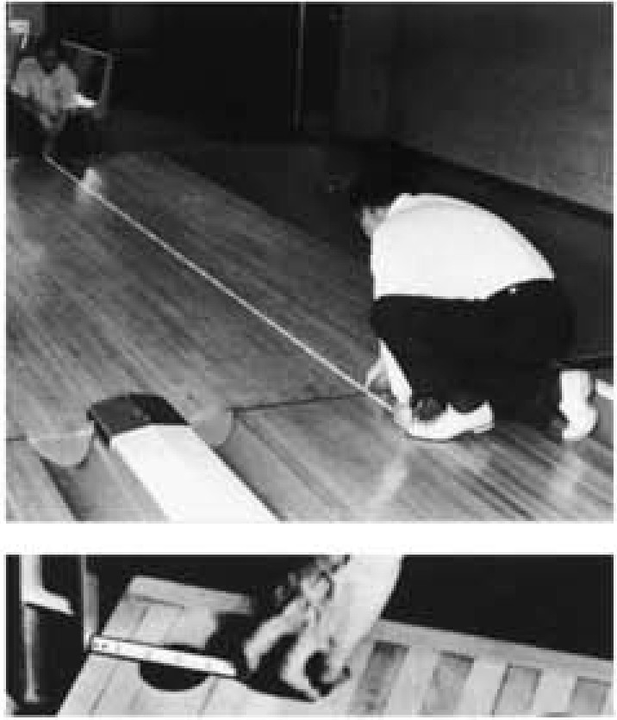
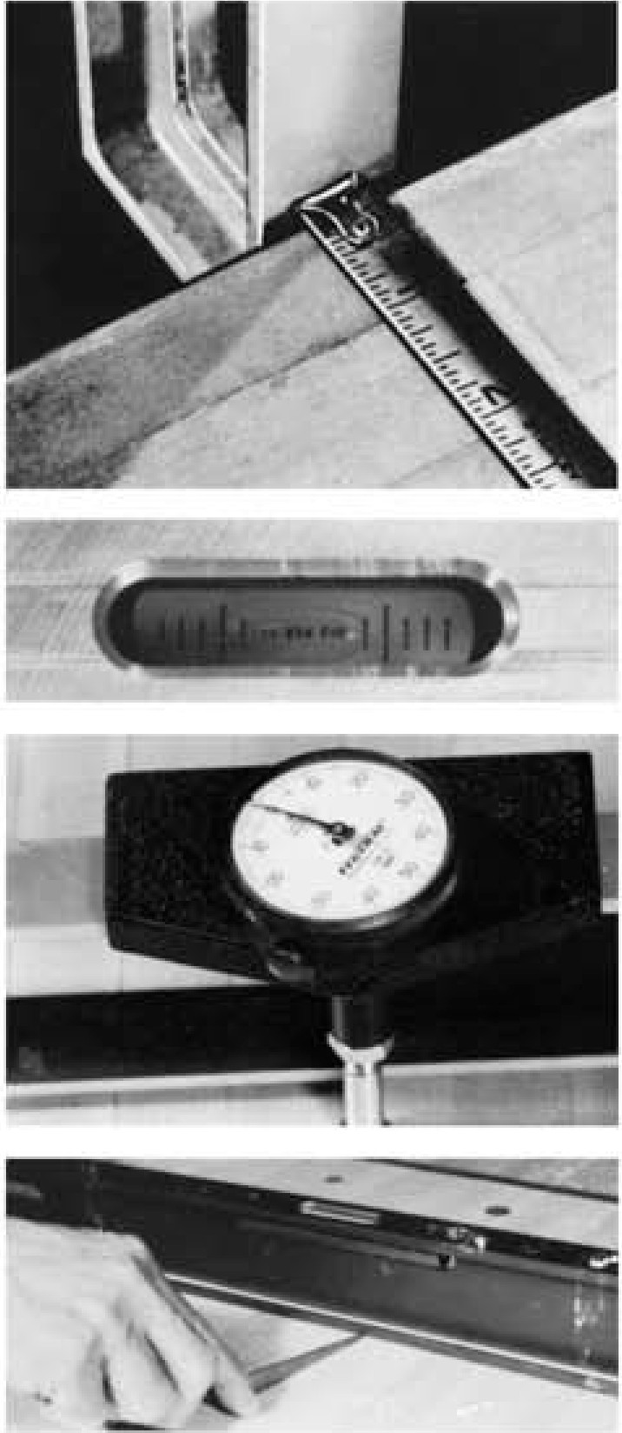
LANE MEASURING TOOL INSTRUCTION MANUAL
UNITED STATES BOWLING C,ONGRESS1

LA;NE MEASURING TOOL INSTRUCTION1 MANUAL
How to use US,BC Lane Measuring Tools.

How to use CTF LaneMeasuring Tools

HOW TO USE
BOWLING LANE MEASURING TOOLS

This manual assists the users of Bowling Lane Measuring Tools to obtain the maximum efficiency from their use and to accomplish accurate and time saving inspection of tenpin lanes.

INSTRUCTIONS IN USE OF BASIC
48 INCH LEVEL (LL928)
(Caution • bubble size will va,y if temperature isconsiderably under or over 70 degrees Fahrenheit.)

LANE TILT
STEP 1.
Place level on lane as shown below, at desired inspection points. If bubble is centered (See Drawing 1) lane is level.

STEP 2.
If bubble is not centered. read tilt according to total thick­ ness of feeler gauge leaf(s) used to center bubble.

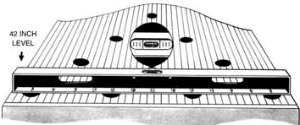
DRAWING 1

DEPRESSION IN LANE SURFACES

STEP 3.
Position level on lane as illustrated (See Drawing 2). Check lane depressions by inserting blade of feeler gauge under level at scale numerals shown on level base. Remove feeler gauge blade and read marked thickness to determine lane depression at specified check points.

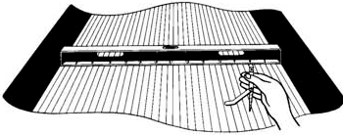
DRAWING 2

DEPRESSION IN APPROACHES
STEP 4.
Position level on approach as illustrated.

STEP 5.
Insert wedge shaped feeler gauge under level. Place thumb at intersection of gauge and level (See Drawing 3).

STEP 6.
Remove feeler gauge and read marked thickness (See Drawing 3-A).

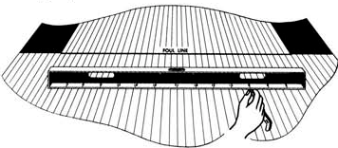
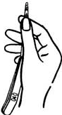
DRAWING 3

DRAWING 3-A

INSTRUCTIONS IN USE OF OFFICIAL BOWLING LANE LEVEL WITH DIAL INDICATOR (LL92A)
(Gaution - bubble size will va,y if temperature is considerably under or over 70 degrees Fahrenheit.)

IRREGULARITIES OR DEPRESSIONS
STEP 1.
Place gauge onlane as pictured below at desired inspection points (See Drawing 4).

STEP 2.

Place dial at right outside board, rotate race until needle registers zero (SeeDrawing 4-A) .

STEP 3.

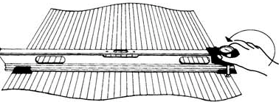Move indicator slowly across complete lane ror plus or minus measurements.
GAUGE VIAL

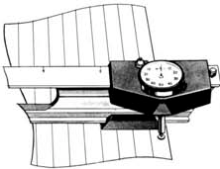
DRAWING 4

ORAWING 4•A

TILT OF LANE
STEP4.

Posiiton level as shown in Drawing 5, at desired inspection points. If bubble is centered (See Insert A) lane is level.

STEP 5.

II bubble is not centered, read tilt according to tolal thickness of feeler gauge leaf(s) used to center bubble.

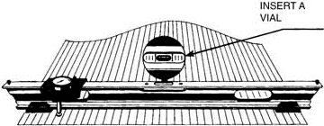
DRAWINGS

LENGTHWISE TILT OF PIN DECK
STEP 6.

Place gauge parallel to gutters, between 4-7 and 6-10 pin spots (SeeDrawing 6).

STEP 7.

II bubble is centered within large graduation marks, pin deck is level.

STEP S.

II bubble is not centered, read tilt according to total thickness of reeler gauge leaf(s) used to center bubble.
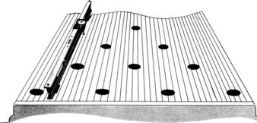
DRAWINGS

APPROACH DEPRESSION
STEP 9.

Read approach depression same as lane surtaces.

STEP 10.

If approach depressions exceed range of dial indicator remove dial and carriage rrom gauge.

STEP 11.

Till level so topof steel plate rests on approach (See Drawing 7).

STEP 12.

Insert wedge shaped feeler gauge under level. Place thumb at intersectionof gauge andlevel (See Drawing 7).

STEP 13.

Remove feeler gauge andread (See Drawing 7-A).

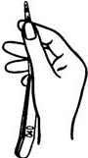
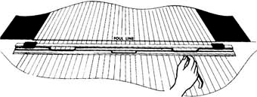
DRAW ING 7-A
DRAWING 7

INSTRUCTIONS IN USE OF GUTTER, PIT AND PIT CUSHION CHECKING GAUGE (GG83)

GUTTER DEPTH

10-PIN SIDE

STEP 1.
Place handle of gauge on pin deck, with slide end resting in gutter (See Drawing 8).

STEP 2.
Extend slide marked "Gutter Depth" to flat gutter boards.
7-PIN SIDE STEP 3.
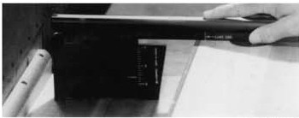
Same as above.

DRAWING -9 A

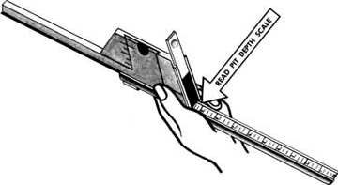
DISTANCE FROM END OF
LANE TO PIT CUSHION

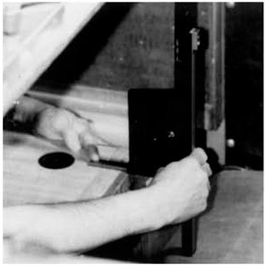
DRAWING 9

DEPTH OF PIT
STEP 4.

DRAWING S
STEP 8.
Extend top slide marked Gutter and Pit Gauge to stopposition.

STEP 9.
Place gauge at end of lane with handle resting on lane (See Drawing 10).

Extend small slide at large end of gauge to stop position.

STEP 5.
Place gauge at end of lane with handle facing up (See Drawing 9).

STEP 6.
Extend complete slide on handle to pit carpet.

STEP 7.
Remove gauge, read scale on underside marked "Ph Depth" in inches (See Drawing 9-A).

STEP 10.
Extend bottom slide to pit cushion.

STEP 11.
Read scale marked "Lane to Cushion· in inches.
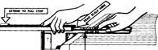
NOTE- " Lane End " does not
Include tail plank.

DRAWING 10

INSTRUCTIONS IN USE OF PIT END GAUGE (PP83)

TO MEASURE DISTANCE BETWEEN KICKBACK PARTITIONS
STEP 1.
Extend gauge so both ends are firmly against k.ickback plates (See Drawing 11). Be sure gutter width slides are retracted completely within the gauge body.
STEP 2.
Read measurements in inches at "Kickback" markings (See Drawing 11). Add thickness of both kickback plates to deter­ mine total distance between wood partitions.
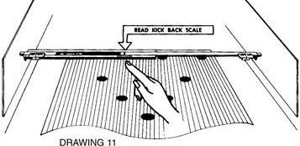

PIN DECK WIDTH
STEP3.
Place gauge over back row of pin spots (7, 8, 9, & 10), so sliding pin spot measuring devices at each end are facing inspector (See Drawing 12).
STEP 4.
When clamping feet of the gauge be sure to properly con­ tact pin deck edges. Watch for lacquer drippings, nails, etc.
STEP 5.
Read scale marked "Lane Width" for width of pin deck (See Drawing 12).
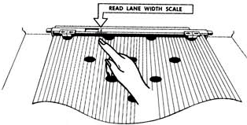Do Not change postion gauge until steps 6, 7, 8 and 9 are completed.
DRAWING 12
STEP 7.
Read each sliding rod scale in inches. Add thicknessof kick­ back plate for gutter width (See Drawing 13).

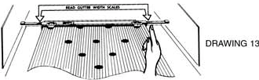

DISTANCE OF 7 AND 10 PIN SPOTS TO EDGE OF PIN DECK
STEP S.
Adjust sliding "Pin Spor measuring devices so outside edges are covering width of 7 and 1O spots.
STEP9.
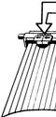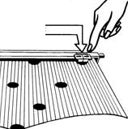Use red line of slidingpin spot device to read inch rule on inner bar for distance of 7 and 1O pin spots to edge of pin deck (See Drawing 14).

IIAO PIN SfOT SCAUS

DRAW IN G 14

DISTANCE BETWEEN PIN SPOTS
STEP 10.
Place gauge on edge so the bottom of gauge is facing inspector (See Drawing 15).
STEP 11.
To measure 7, 8, 9 and 10 pin spots, "O" marker should be laying across number 1O pin spot. The extreme left 12 inch marker should be placed on opposite corner pin spot. One glance will determine whether or not pin spots are 12 inch­ es apart (See Drawing 15).
STEP 12.
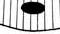
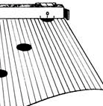To find the distance between all other combinationsof adja­ cent pin spots, repeat the procedure in step number 11.
"
"

GUTTER WIDTH
STEPG.
Extend both sliding end rods until they touch kickbacks.

DRAW IN G 15

Bowling Lane Measuring Tools
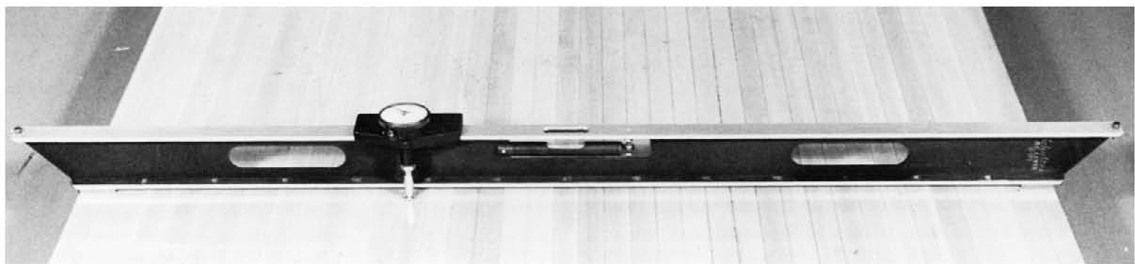
specially developed for accurate and time saving inspection of tenpin lanes
The "BOWLING LANE GAUGE" is a quality Instrument manufactured expressly for the UNITED STATES BOWLING CONGRESS.

LL92A

Bowling Lane Gauge

CONSTRUCTION/SPECIFICATIONS
All extruded aluminum, with carriage rail 48" in length, scaled in 3" graduations die stamped and easy reading numerals. Weight of gauge 5 1/2 lbs. and warranted by manufacturer to be accurate within .01O" parallelism or less.
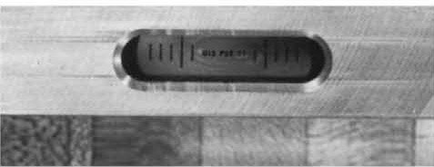

SENSITIVE BUBBLE VIAL
Glass vial has .040" graduations marked in black lines on yellow for easy reading, centered in gauge body for maxi­ mum protection against breakage.

DIAL INDICATOR
Federal 2 1/4" clock type dial indicator with graduations in
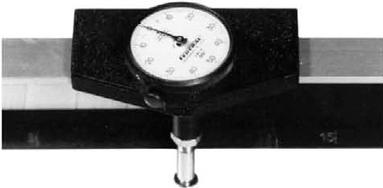
.001" (1/1,000"}, plus or minus up to .100" or total spindle travel of .200".

GAUGE FEATURES
BOWLING LANE GAUGE is a serviceable , prescision tool that speeds up inspection of tenpin lanes with ease and accuracy. Shows at a glance levelness of lane and clock­ type dial indicator measures high or low point in lane sur­ face.
Set dial at zero in center of right edge board at each point of inspection, slide indicator across lane for reading of sur­ face conditions.
Indicator shows plus or minus in .001" (1/1,000") up to .100"
- .200" spindle travel. A time saving tool to obtain accurate dial reading of lane surface conditions at exact points of test prescribed by CTF specifications
USBC specifications.

CARRYING CASE
Polyethylene carrying cases tor the level and the dial indicator assembly. Total delivered price of Lane Gauge, Feeler Gauge and carrying case.

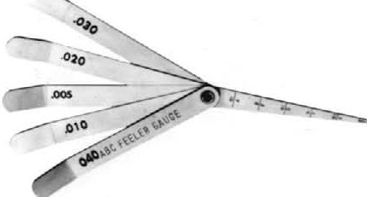

FEELER GAUGE
Tool Steel Gauge of five leafs .005", .010", .020", .030", .040" and .095" thickness with separate leaf of rule graduations from 1/8" to 7/16" for use with Bowling Lane Level to measure approach surface.

..
Bowling Lane Level

SPECIFICATIONS
LL928
LEVEL FEATURES

A true level 42" long (bottom measuremen)t made of high tensile strength rigid extruded aluminum. Weight 3 1/2 lbs.
It is equipped with same type recessed sensitive bubble vial of .040" graduaitons as on the Bowling Lane Gauge.
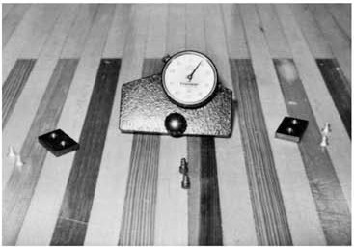
Scaledin 3• graduation diestamped in easy reading numerals. Level is finished in non-glare black.
Sensitive bubble vial of .040" graduations provides quick check of lane levelness, and use of Feele r Gauge with level straightedge is accurate methodof determniing surface condi­ tions of lanes.
Feele r Gauge has special leaf to check lane approaches with levelstraightedge.
Strong, durable, polyethylene carrying case furnished with gauge.
Level, Carrying Case and Feeler Gauge.

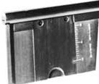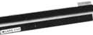Gutter, Pit and Pit Cushion Checking Gauge

GG83

LANE GAUGE
Conversion Package
LL92C
This aluminum gaugeis designed to measure depthof left and right gutters, pit depth and distance from end of lane to pit cushion for bowlinglanesequippedwith any type of pinsetting machines. This three purpose measuring gauge has easy

Dial Indicator,Carrie,rFoot Assembly and required hardware to convert basic level (S-81-B) to Bowling Lane Gauge (S- 81-A)
reading die stamped rule scales in hard anodized finish. Durable vinyl carrying case furnished with gauge.

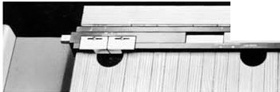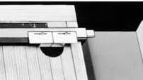
-4 •
--
\

Pit End Gauge
PP83

FUNCTIONS OF PIT END GAUGE

The Pit End Gauge is an engineered tool for multiple uses. Constructed of durable aluminum, anodlzed finish. with all measurni g scales die stamped into metalandnumerals repro­ duced in easy reading colors.
Gauge weighs 5 lbs. and strong, durable, polyethylene carry­ ing case furnished with gauge.
Measure distance betweenkickbacks
Width of Gutter and also Gutter Depth with use of rule or tape
Width of Lane
Distance between Pin Spots
Distance from center. 7 and 1O pin sp ots to lane edge

