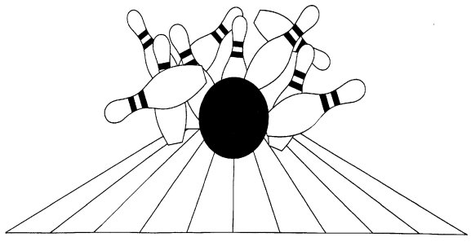
Canadian Tenpin Federation-Board Application

Men, Women and Youth.
Help promote ort of bowling.

Name: Address:
City / Postal Code:

Phone Number / Email Address: Association:
- Indicate by placing a check mark in the appropriate box what position you are submitting these credentials
for:

Committee Member: Board Member: Either:

Any candidate applying for a Board member must be a member of a local CTF association at the time of election and throughout their term.
Will you be interested to be on a Committee if not Elected? YES NO

- How long have you bowled:

- Please provide a list of any bowling organizations you have been a member of and any offices that you have held in those organizations (League, Association, and Tournaments) and for how long. Attach a separate sheet of paper if required.

- Please provide a list of any non-bowling organizations (civic, fraternal, professional, and social) you have been a member of in those organizations. List any offices you have held and the term of office. Attach a separate sheet of paper if required.

- List your business or professional experiences (Computer, Marketing, Etc.). Attach a separate sheet of paper if required.

- What qualifications you personally think you have that can benefit this organization. Attach a separate sheet of paper if required.

- Why are you interested in applying for this position?

- Any Comments you wish to add:

This form must be returned, post, or email, to:

Charlotte Konkle
Chair, CTF Nominating Committee
4536 Dufferin Ave Beamsville ON L0R 1B5

Email:ckonkle@tenpincanada.com

